Just In Time Quick Check

Standard of Learning (SOL) 6.11a
Strand: Probability and Statistics

Standard of Learning (SOL) 6.11a
The student will represent the mean of a data set graphically as the balance point.

Grade Level Skills:
- Represent the mean of a set of data graphically as the balance point represented in a line plot.
Just in Time Quick Check
Just in Time Quick Check Teacher Notes

Supporting Resources:
- VDOE Mathematics Instructional Plans (MIPS)
  - 6.11a - Balancing Act (Word) / PDF Version
- VDOE Word Wall Cards: Grade 6 (Word) | (PDF)
  - Mean
  - Median
  - Mode
  - Range
- VDOE Rich Mathematical Tasks: Screen Time Task
  - 6.11 Screen Time Task Template (Word) / PDF Version
  - 6.11 Screen Time Student Version of Task (Word) / PDF Version
  - 6.11 Screen Time Anchor Papers (Word) / PDF Version
  - 6.11 Screen Time Anchor Papers Scoring Rationales (Word) / PDF Version
- VDOE Instructional Videos for Teachers
  - Mean as Balance Point (grades 5-6)
Supporting and Prerequisite SOL: 5.17a, 5.17b

SOL 6.11a - Just in Time Quick Check

- Kyle played in seven basketball games for his team. He recorded how many points he scored in each game in the table below. He wants to represent the mean as a balance point for this data.

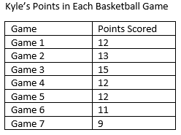
- Use this data to create a line plot.
- Find the balance point for the data.
- Explain how you found the balance point using the line plot.

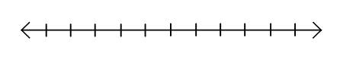
- Emma created a line plot to represent her first four test grades in History. Where would she place the balance point to represent the mean of her four grades?
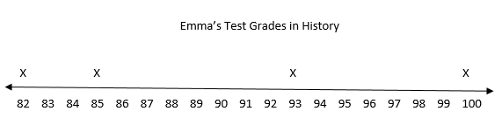
Each X represents one test grade.

- Ms. Rogers made a line plot of how many hours each of her students read during the week. She organized the data into the line plot below. What is the balance point for the data?
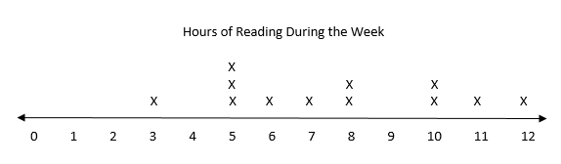
Each X represents one student.
SOL 6.11a - Just in Time Quick Check Teacher Notes
Common Errors/Misconceptions and their Possible Indications
- Kyle played in seven basketball games for his team. He recorded how many points he scored in each game in the table below. He wants to represent the mean as a balance point for this data.

- Use this data to create a line plot.
- Find the balance point for the data.
- Explain how you found the balance point using the line plot.

A common misconception students may have relates to the mean as a balance point. While students may understand how to find the mean, they may not understand how to represent this as a balance point on a line plot. They simply may place a balance point in the middle of the line plot without considering the distances of the data points on each side of the balance point. This indicates a lack of understanding of the intent of representing a balance point for the given data.
The student’s explanation describing how to find the balance point will give the teacher insight to misconceptions. Students who understand the idea of data distribution may realize that the balance point can be determined in this particular example by just looking at how the data is distributed on the number line without having to “move” any of the X’s to balance the data.
- Emma created a line plot to represent her first four test grades in History. Where would she place the balance point to represent the mean of her four grades?
Each X represents one test grade.

A student may find the balance point by identifying the middle number between 85 and 93, not taking into account that 82 and 100 are not equidistant from those points. This indicates that the student may not understand the idea that the data distribution must be balanced. They may also not understand that the sum of the distances from the mean of all the points above the mean is equal to the sum of the distances from the mean of all the data points below the mean.
To help students better understand balance points, provide them several examples of data and manipulatives such as two colored counters. Have students physically place the counters in the correct locations for a line plot and move them as needed to find the balance point of the data. When introducing this concept, teachers may wish to create a class sized line plot and have the students represent the data points. Having the students move themselves to find the balance may help make a connection to the skill. Relating this idea to students and their weights on a seesaw may also help cement this understanding.
- Ms. Rogers made a line plot of how many hours each of her students read during the week. She organized the data into the line plot below. What is the balance point for the data?
Each X represents one student.
Some students may identify the balance point as 7 or 8 not realizing that it could be a decimal. In this particular example, the balance point lies between 2 of the points on the line plot, 7.5. Provide students with experience locating a balance point in which the result is not always a whole number.
Students also may find the mean using computation or a calculator and note the balance point using that quotient. While the balance point does represent the mean, the intent of this standard is for students to define mean as the balance point as it is a prerequisite for understanding standard deviation, which is addressed in high school level mathematics. Hands-on practice as noted above will help students conceptualize this idea of balance point.

