Just In Time Quick Check

Standard of Learning (SOL) 6.10c
Strand: Probability and Statistics

Standard of Learning (SOL) 6.10c
The student, given a practical situation, will compare circle graphs with the same data represented in bar graphs, pictographs, and line plots.

Grade Level Skills:
- Compare data represented in a circle graph with the same data represented in bar graphs, pictographs, and line plots.
Just in Time Quick Check
Just in Time Quick Check Teacher Notes

Supporting Resources:
- VDOE Mathematics Instructional Plans (MIPS)
  - 6.10abc - May I have Fries with That? (Word) / PDF Version
- VDOE Algebra Readiness Remediation Plans
  - Analyzing Graphs (Word) / PDF
  - Data Organizers (Word) / PDF
  - Interpreting Graphs (Word) / PDF
- VDOE Word Wall Cards: Grade 6 (Word) | (PDF)
  - Circle graph
  - Comparing Graphs: Circle and Bar Graph
  - Comparing Graphs: Circle and Pictograph
  - Comparing Graphs: Circle and Line Plot
Supporting and Prerequisite SOL: 6.10a, 6.10b, 5.16c, 4.14c

SOL 6.10c - Just in Time Quick Check

- John’s teacher gave him the circle graph below that represents 40 students’ choices for their favorite sport. John made the bar graph below to represent the same data. Use the graphs below to answer the questions.

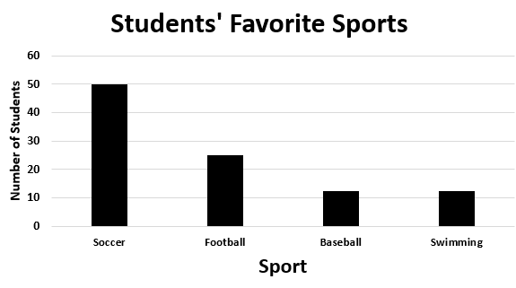
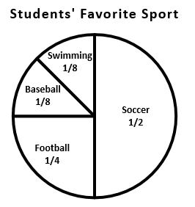

- What do you notice about the bar graph that John made in comparison to the circle graph?

- What advice would you give to John when he creates the bar graph using the information from the circle graph?

- The circle graph and the line plot below represent the same data for number of pets that each of the students in Mrs. Jones’ class has. Use the graphs to answer the questions below.

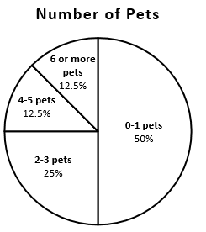

Number of Pets
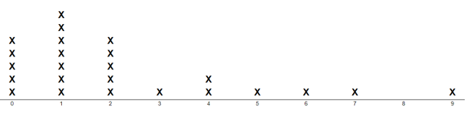

- How many students have 1 pet? Which graph did you use to figure out that answer?

- How many students have 4 or more pets? Which graph did you use to determine your answer?

- The largest portion of students have between _____ and _____ pets. Which graph did you use to determine your answer?

- Compare the circle graph to the line plot. How are they similar? How are they different?

- Olive asked her friends to name their favorite type of pizza. She organized the data into the circle graph and pictograph below. Use the graphs to answer the questions.

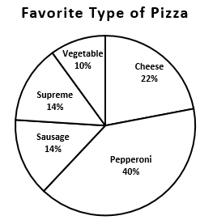
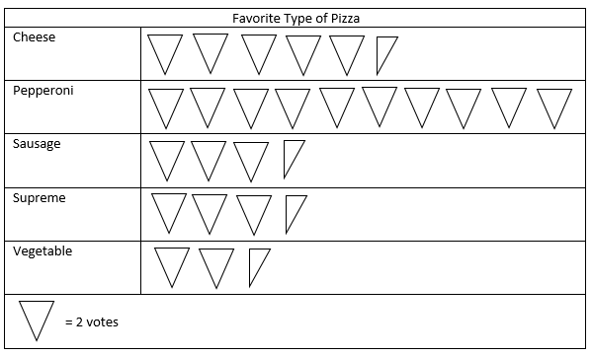
- How many students chose cheese as their favorite pizza? Which graph did you use to determine your answer?

- Most of the students chose what kind of pizza as their favorite? Which graph did you use to determine your answer?

- Which graph helps you better understand how many students chose each type of pizza? Explain your thinking.

SOL 6.10c - Just in Time Quick Check Teacher Notes
Common Errors/Misconceptions and their Possible Indications

- John’s teacher gave him the circle graph below that represents 40 students’ choices for their favorite sport. John made the bar graph below to represent the same data. Use the graphs below to answer the questions.

- What do you notice about the bar graph that John made in comparison to the circle graph?
- What advice would you give to John when he creates the bar graph using the information from the circle graph?

A common misconception students have about circle graphs is that the data represented is always out of 100 data points. While the information for the circle graph indicates that the data represents 40 data points, the bar graph reflects the equivalents of the fractional portions out of 100 on the circle graph rather than the actual number of students represented in each section. Teachers may wish to provide students with examples of circle graphs representing data sets of less than 100 and more than 100 to build flexible thinking about circle graphs. It may also be beneficial to provide manipulatives for students to use to model the number of students out of 40 for each category on the circle graph.
Students may have difficulty giving advice to “John” with his bar graph as they may not see an error at first, or they may not know how to verbalize their thinking about the noticeable error. To foster mathematical discourse and explanations, hold frequent discussions with students about graphs using formal mathematics vocabulary. Additionally, teachers may want to support struggling students by providing sentence starters such as “The circle graph shows me ________, while the bar graph shows _________” or “I figured out my bar graph numbers by __________.”

- The circle graph and the line plot below represent the same data for number of pets that each of the students in Mrs. Jones’ class has. Use the graphs to answer the questions below.

Number of Pets

- How many students have 1 pet? Which graph did you use to figure out that answer?
- How many students have 4 or more pets? Which graph did you use to determine your answer?
- The largest portion of students have between _____ and _____ pets. Which graph did you use to determine your answer?
- Compare the circle graph to the line plot. How are they similar? How are they different?

A common misconception students may have is thinking that data in a line plot cannot be represented in categories as well. The data in a line plot is numerical data, but can be grouped into categories as it is in the circle graph. Students may not be able to clearly see the relationship between the two graphs as the circle graph is broken into sections or categories for different ranges of the numerical data. When asked to compare the two graphs, students may respond that they do not actually represent the same data as stated due to this misconception. Teachers may wish to provide examples of circle graphs with ranges for categories of numerical data to help them become familiar with this representation of data. Students could collect their own data (examples: number of minutes read, number of books read, number of points scored by basketball players during a game, etc.) to first represent as a line plot, then organize into categories to create a circle graph. Experience in reading and creating circle graphs in this manner will help build conceptual understanding.
Additionally, students’ responses to the last question will indicate if they understand the similarities and differences between both types of graphs. Both circle graphs and line plots can be used for categorical or discrete numerical data. Circle graphs are used for data showing a relationship to parts to the whole while line plots are used to show frequency. Some students may benefit from additional discussions comparing and contrasting these two types of graphs.

- Olive asked her friends to name their favorite type of pizza. She organized the data into the circle graph and pictograph below. Use the graphs to answer the questions.

- How many students chose cheese as their favorite pizza? Which graph did you use to determine your answer?
- Most of the students chose what kind of pizza as their favorite? Which graph did you use to determine your answer?
- Which graph helps you better understand how many students chose each type of pizza? Explain your thinking.
A common error that students sometimes make is overlooking the key on a pictograph or the partial pizzas. Some students may answer that six students chose cheese instead of 11 students. Another misconception some students may have is to use the circle graph for the first question and state that 22 students chose cheese based on the circle graph percentages. This may indicate that some students do not take into account that the whole group is not always out of 100. It is important for students to understand that the pictographs can provide specific numbers of data while circle graphs provide a comparison of each category to each other and to the whole group.

