Just In Time Quick Check

Standard of Learning (SOL) 6.10b
Strand: Probability and Statistics

Standard of Learning (SOL) 6.10b
The student, given a practical situation, will make observations and inferences about data represented in a circle graph.

Grade Level Skills:
- Make observations and inferences about data represented in a circle graph.
Just in Time Quick Check
Just in Time Quick Check Teacher Notes

Supporting Resources:
- VDOE Mathematics Instructional Plans (MIPS)
  - 6.10abc - May I have Fries with That? (Word) / PDF Version
- VDOE Algebra Readiness Remediation Plans
  - Circle Graph Pieces (Word) / PDF
  - Circle Graphs (Word) / PDF
  - Data Organizers (Word) / PDF
- VDOE Word Wall Cards: Grade 6 (Word) | (PDF)
  - Circle graph
Supporting and Prerequisite SOL: 6.10a, 5.16b, 4.14b

SOL 6.10b - Just in Time Quick Check

- Tony collected data on what types of pets sixth grade students owned. He asked 80 students to create his graph. Use the circle graph Tony made to answer the following questions.
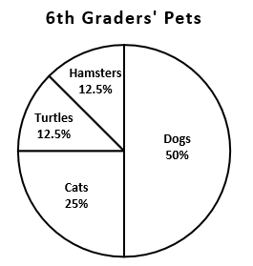

- How many students own a dog? Explain how you know.

- How many more students own a dog than a cat? Explain how you know.

- How many students own a turtle? Explain how you know.

- Serena asked 40 of her classmates what dessert they chose for a meal. She organized her data in the circle graph below. Ten students chose cake as their dessert. The same number of people chose pie, brownies, and cookies as a dessert. Use the circle graph to answer the questions.

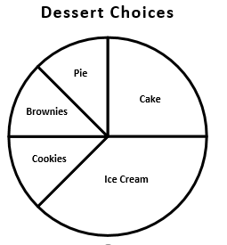

- How many students chose ice cream? How do you know?

- Identify two desserts that could represent the choices for exactly 10 students. Explain how you know.

- Explain what the graph tells you about the students’ choices for desserts.

3. Raul’s monthly budget of $2000 is the same for one year. The circle graph represents how much he spends each month for various expenses. Approximately, how much money does he spend on rent for the entire year?
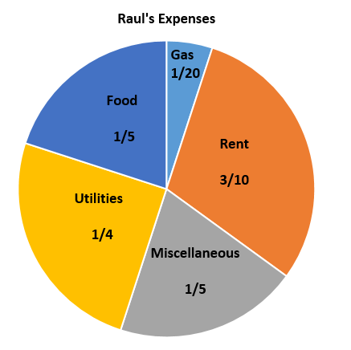

4. Mr. Lee needs to determine the best day for club meetings. He asked students to make their choice for the best day. He represented the data in the circle graph below. Use the graph to answer the questions.

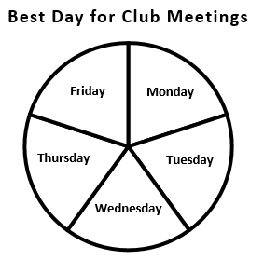

- What can you infer from the data in this graph?

- Will the information in this graph help Mr. Jackson select a day for club meetings? Why or why not?

SOL 6.10b - Just in Time Quick Check Teacher Notes
Common Errors/Misconceptions and their Possible Indications

- Tony collected data on what types of pets sixth grade students owned. He asked 80 students to create his graph. Use the circle graph Tony made to answer the following questions.

- How many students own a dog? Explain how you know.
- How many more students own a dog than a cat? Explain how you know.
- How many students own a turtle? Explain how you know.

A common misconception that some students may have is to think that the circle graph represents 100 students or data points. In this case, they will state that 50 students own a dog and 25 students own cats. Likewise, they may round 12.5% to 12 students or to 13 students for hamsters and birds. Students are not taking into consideration that 80 students participated in the data collection and that the whole is out of 80, not 100. This may indicate that the students need more experiences with modeling and conceptualizing percents with their equivalent fractions. They also may need more experiences with finding fractional parts of numbers using a set model (i.e. finding $\frac{1}{2}$ of 80, $\frac{1}{8}$ of 80, etc).
Teachers may wish to expose students to various graphs and situations where the data set reflects a number of responses other than 100. Encouraging students to write the number of data points next to the graph and then finding the number representing each section and writing it on the graph will provide a visual reminder as they analyze the graph.

2. Serena asked 40 of her classmates what dessert they chose for a meal. She organized her data in the circle graph below. Ten students chose cake as their dessert. The same number of people chose pie, brownies, and cookies as a dessert. Use the circle graph to answer the questions.

- How many students chose ice cream? How do you know?
A common misconception that a student may have is difficulty determining that the ice cream portion is $\frac{3}{8}$ of the whole circle since it is not represented by a unit fraction. Encourage students to start with what they know. Some students may be able to identify that cake, brownies, and pie make up $\frac{1}{2}$ of the circle, or cake is $\frac{1}{4}$ of the circle. They may be able to then determine that pie and brownies are then $\frac{1}{8}$ of the circle. Students could also be encouraged to draw additional lines to see if they can create equal sized pieces. This may help them visualize that ice cream is $\frac{3}{8}$ of the whole.
When students are able to determine the correct fraction of $\frac{3}{8}$, they may then be unable to determine $\frac{3}{8}$ of 40. Again, encourage students to start with what they know. What is $\frac{1}{2}$ of 40? If $\frac{1}{2}$ of 40 is 20, what would $\frac{1}{4}$ of 40 be? How about $\frac{1}{8}$ of 40? Encouraging them to write the number of students on the pieces will also reinforce the idea that the sum of all the pieces is 40. Additionally, some students may benefit from using manipulatives with fractional set models to assist them in understanding.
- Identify two desserts that could represent the choices for exactly 10 students. Explain how you know.
A common error that some students may make is to state a correct answer only based on the size of the portions of the circle without any supporting explanation. This may indicate that a student cannot provide evidence through a verbal description to support their understanding. If they are unable to provide a reasonable explanation, they may need additional instruction and experiences determining fractional pieces and the part of the whole they represent.

- Explain what the graph tells you about the students’ choices for desserts.
Most students will be able to share the most popular to the least popular choice of desserts. However, a common misconception that some students may have is difficulty stating the comparison that the same number of students chose ice cream as the cumulative total for pie, brownies, and cookies. If they do not include information in regards to comparisons of the portion sizes or numbers (i.e. cake was twice as popular as pie), they made need additional prompts and teacher led conversations about comparisons of the categories.

3. Raul’s monthly budget of $2000 is the same for one year. The circle graph represents how much he spends each month for various expenses. Approximately, how much money does he spend on rent for the entire year?
A common error that a student may have is determining the amount of rent for the year in a multiple step problem. This may indicate that a student can use fractional amounts to find a monthly expense value but fails to use that monthly value to determine the yearlong expense for rent. Teachers may find it beneficial to provide additional practice where students have to complete multiple steps to derive at an answer. Teachers may find the Algebra Readiness Remediation Plan, Analyzing Graphs, to be helpful for this particular skill. In particular, problem number two.

4. Mr. Lee needs to determine the best day for club meetings. He asked students to make their choice for the best day. He represented the data in the circle graph below. Use the graph to answer the questions.

  - What can you infer from the data in this graph?
  - Will the information in this graph help Mr. Jackson select a day for club meetings? Why or why not?

A common misconception that some students may have is difficulty finding or stating evidence to support their answers when making inferences about graphs. This may indicate that a student recognizes that each day had the same number of votes, but may not be able to make other more in-depth inferences. Examples of other inferences could be that there was not a trend in the data, that there was not a consensus among students for a club day, or that this might indicate most students have other commitments that conflict with others’ commitments. Students may also have difficulty finding or stating evidence to support their answers.
To assist students in making inferences, provide real world examples of graphs for them to discuss in small groups or with peers before holding a class discussion. Remind them to find evidence in the graph for their inferences. Holding a discussion will help those students who are unsure of how to make inferences as they hear others’ ideas. Additionally, the real world connection will make the skill meaningful and relevant to students.

