Just in Time Quick Check

Standard of Learning (SOL) 6.10a
Strand: Probability and Statistics

Standard of Learning (SOL) 6.10a
The student, given a practical situation, will represent data in a circle graph.

Grade Level Skills:
- Collect, organize and represent data in a circle graph. The number of data values should be limited to allow for comparisons that have denominators of 12 or less or those that are factors of 100 (e.g., in a class of 20 students, 7 choose apples as a favorite fruit, so the comparison is 7 out of 20, $\frac{7}{20}$, or 35%).
Just in Time Quick Check
Just in Time Quick Check Teacher Notes

Supporting Resources:
- VDOE Mathematics Instructional Plans (MIPS)
  - 6.10abc - May I have Fries with That? (Word) / PDF Version
- VDOE Algebra Readiness Remediation Plans
  - Circle Graph Pieces (Word) / PDF
  - Circle Graphs (Word) / PDF
  - Data Organizers (Word) / PDF
- VDOE Word Wall Cards: Grade 6 (Word) | (PDF)
  - Circle graph
Supporting and Prerequisite SOL: 6.2a, 5.16a, 4.3d, 4.14a

SOL 6.10a - Just in Time Quick Check

- Ramon asked students in his school to name their favorite sport. The data he collected is shown below.
- 20 students chose basketball.
- 10 students chose baseball.
- 5 students chose football.
- 5 students chose swimming.

Create and label a circle graph to display the data Ramon collected.
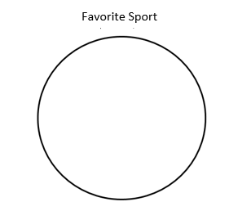

- The Uptown Movie Theater sold 300 tickets for the Saturday morning summer movies.

Movie | Number of Tickets
Super Heroes | 150
Scary Movie | 100
Cute Animals Movie | 50

Create and label a circle graph to represent the data for the number of movie tickets sold.

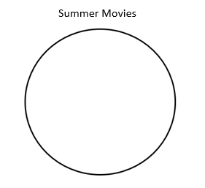

- Create a survey question. You could ask about favorite ice cream flavors, favorite type of music, or favorite subject, for example.
- Collect data from 20 people.
- Organize your data into a table or chart.
- Represent your data using a circle graph.

SOL 6.10a - Just in Time Quick Check Teacher Notes
Common Errors/Misconceptions and their Possible Indications

- Ramon asked students in his school to name their favorite sport. The data he collected is shown below.
- 20 students chose basketball.
- 10 students chose baseball.
- 5 students chose football.
- 5 students chose swimming.

Create a circle graph to display the data Ramon collected.
Some students may attempt to convert the fractions to equivalent ratios with denominators of 100 in an attempt to find the equivalent percentages for each category. In this example, they may try to convert fortieths to hundredths, rather than finding the simplified fraction for each category and realizing they are actually friendly fractions ($\frac{1}{2}$,$\frac{1}{4}$ , and $\frac{1}{8})$ for circle graph creation.
Teachers may wish to provide students with many different examples of data sets that do not equal a total of 100, keeping the standard parameter in mind that the simplified fractions need to have a denominator of 12 or less or are factors of 100. Some students may prefer creating the circle graph with the fractions in mind, while others may prefer to think about the percentages, but it is important to make connections between both representations. Utilizing the Circle Graph Pieces Algebra Readiness Remediation plan could assist students in making these connections. Students may also benefit from using manipulatives to model the data set in order to see the fractions of the whole that each category represents.

- The Uptown Movie Theater sold 300 tickets for the Saturday morning summer movies.

Movie | Number of Tickets
Super Heroes | 150
Scary Movie | 100
Cute Animals Movie | 50

Create and label a circle graph to represent the data for the number of movie tickets sold.

A common error some students may exhibit is having difficulty with data sets of more than 100. This may indicate that students struggle with conceptual understanding of percents and that the whole (100%) can be out of a total of any number. Additionally, students may be able to determine the circle size portions from the simplified fractions, $\frac{1}{2}$,$\frac{1}{3}$ , and $\frac{1}{6}$, but may struggle with percent equivalencies for the $\frac{1}{3}$ and $\frac{1}{6}$ . In either of these cases, students may need additional instruction in fraction, decimal, and percent equivalency (6.2a), particularly in modeling to assist with conceptual understanding.

- Create a survey question. You could ask about favorite ice cream flavors, favorite type of music, or favorite subject, for example.
- Collect data from 20 people.
- Organize your data into a table or chart.
- Represent your data using a circle graph.

A common error some students may have is struggling with representing the data in the circle graph when the denominator exceeds a value of 12 but is a factor of 100. This may indicate that students have difficulty determining equivalent percents. If students have difficulty determining the equivalent percents, this may indicate they need more instruction with finding equivalent fractions. Utilizing manipulatives such as fraction bars or 100 grids may assist students in seeing the connections between the fractions and percents. Students should be familiar with forming a survey question and collecting data. If they are having trouble thinking of a question, work with them to determine a question appropriate for categorical data, or even provide them a set of data if needed.

