Just In Time Quick Check

Standard of Learning (SOL) 6.6a
Strand: Computation and Estimation

Standard of Learning (SOL) 6.6a
The student will add, subtract, multiply, and divide integers.

Grade Level Skills:
- Model addition, subtraction, multiplication and division of integers using pictorial representations or concrete manipulatives.
- Add, subtract, multiply, and divide two integers.
Just in Time Quick Check
Just in Time Quick Check Teacher Notes

Supporting Resources:
- VDOE Mathematics Instructional Plans (MIPS)
  - Operations with Integers (Word) / PDF
- VDOE Algebra Readiness Formative Assessments
  - 6.6a (Word) / PDF
- VDOE Algebra Readiness Remediation Plans
  - Operations with Integers Addition- (Word) / PDF
  - Operations with Integers Division- (Word) / PDF
  - Operations with Integers Multiplication- (Word) / PDF
  - Operations with Integers Subtraction- (Word) / PDF
- VDOE Word Wall Cards: Grade 6 (Word) / PDF
  - Integer Operations- Addition and Subtraction
  - Integer Operations- Model Addition and Subtraction
  - Integer Operation- Multiplication and Division
- Desmos Activity
  - Adding Integers
Supporting and Prerequisite SOL: 6.3a, 5.4, 4.4a

SOL 6.6a - Just in Time Quick Check
- Use the key to write an equation that represents the model. Then solve.
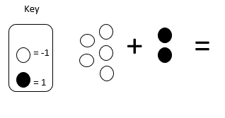

- Use the key to write an equation that represents the model.

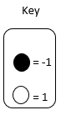
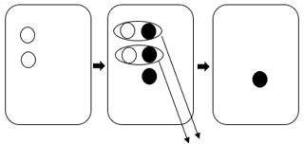

- Write the equation modeled. Explain your reasoning.

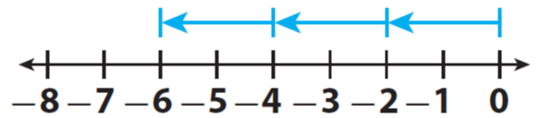

- Simplify each expression.

- (-4) - 12 b. The product of -6 and 4

c. $\frac{-54}{-9}$ d. (-6) + (-8)

- Model this expression using a number line or integer chips. Then simplify the expression.
(-6) + 4

- Choose each number from the table that, when placed in the blank, will result in an expression with a negative value.
-8+_______

-9 | 9 | 6
-14 | 12 | 8

SOL 6.6a - Just in Time Quick Check Teacher Notes
Common Errors/Misconceptions and their Possible Indications

- Use the key to write an equation that represents the model. Then solve.
One common mistake that students may make is ignoring the color of the chips and achieving an answer of 7. This may indicate that the student has not had enough exposure to modeling integer operations using integer chips. Engage the student in hands-on practice utilizing integer chips (or virtual integer chips) to conceptualize what it means to add a positive number to a positive number, a positive number to a negative number, and a negative number to a negative number. Hands-on practice will also assist the students in conceptualizing the idea of zero pairs.
- Use the key to write an equation that represents the model.
Students who write 2+2+(-3)= -1 may not understand the actions modeled in the second cell. In this cell, the two positive chips are shown, three negative chips have been added, two zero pairs have been circled, and arrows indicate that the zero pairs have been removed or subtracted from the equation mat. Students having difficulty interpreting this model may benefit from first using models that show each of these changes separately and from acting out the steps in the model shown using manipulatives (integer chips and an equation mat).
Often students may look at the model as a whole instead of looking for changes that occur from one cell to the next. Ensure that students understand that the model represents actions taken with the integer chips and the actions indicated by different symbols in the model (e.g., the circles indicate grouping into zero pairs, the long arrows indicate the zero pairs will be removed), and that the arrows between cells show the order of the progression. Encourage students to describe the changes they see from one cell to the next and provide manipulatives as a tool to support thinking.
As students begin exploring with integer chips to represent and solve equations involving integers, encourage them to draw a picture for every action they do with the chips to assist them with understanding similar models as they move from concrete to abstract representations.

- Write the equation modeled. Explain your reasoning.

This model could represent a multiplication or a division equation. The student’s explanation should support the operation they chose.
A common error that students make is to represent this model as -2 x -3 = -6 or -6 ÷ -2 = -3. This may indicate that the students assume that since all movement is on the negative side of the number line, all the factors will be negative. Some students may interpret the model as two groups of negative three, i.e., 2(-3)=-6, rather than three groups of negative two. Help these students conceptualize that the length of each blue arrow represents a quantity or group of 2, and there are 3 of these equal-sized arrows pointing in a negative direction.
- Simplify each expression.

- (-4) – 12 b. The product of -6 and 4

.
c. $\frac{-54}{-9}$ d. (-6) + (-8)

Students frequently use the incorrect sign for the result of computation with integers. This may indicate that students need additional experience modeling operations with integers in order to build conceptual understanding for “rules” they are applying incorrectly or inconsistently. These errors may also indicate that students are applying their understanding of operations involving positive numbers and zero- the only numbers with which students have operated before sixth grade- to problems that now include negative integers. For example, students’ prior knowledge that adding or combining quantities results in a larger quantity has been based only on work with positive numbers, so it must be re-examined now that negative numbers are also involved. Supporting students’ thinking about operations with integers using concrete, pictorial, and abstract representations, especially alongside practical problems, helps students make meaning for operations with this set of numbers.
- Please model this question using a number line or integer chips. Solve.
(-6) + 4
Students who have difficulty with modeling this expression may not have had enough experiences with modeling with number lines and integer chips. Allow them many opportunities to model with both integer chips and number lines. Utilizing the Concrete-Representational-Abstract approach to teaching integer operations will assist students in making connections between the modeling and “rules.”
- Choose each number from the table that, when placed in the blank, will result in an expression with a negative value.

-8+_______

-9 | 9 | 6
-14 | 12 | 8

Students may have a misconception that all the choices also have to be negative and only choose -9 and -14. This may indicate that students need more experiences with modeling with integer chips and number lines to understand that the sum of a negative and a positive is sometimes negative. Have students think about all of the numbers that, when placed in the blank, result in an expression with a negative value (or, all of the numbers that would result in an expression with a positive value) and explain their reasoning using models may build conceptual understanding and establish a connection to graphing.

