Just In Time Quick Check

Standard of Learning (SOL) 6.2b
Strand: Number and Number Sense

Standard of Learning (SOL) 6.2b
The student will compare and order positive rational numbers.

Grade Level Skills:
- Compare two percents using pictorial representations and symbols (<, ≤, ≥, >, =).
- Order no more than four positive rational numbers expressed as fractions (proper or improper), mixed numbers, decimals, and percents (decimals through thousandths, fractions with denominators of 12 or less or factors of 100). Ordering may be in ascending or descending order.
Just in Time Quick Check
Just in Time Quick Check Teacher Notes

Supporting Resources:
- VDOE Mathematics Instructional Plans (MIPS)
  - 6.2b - Compare and Order Rational Numbers (Word) / PDF Version
- VDOE Co-Teaching Mathematics Instruction Plans (MIPS)
  - 6.2ab - Order Rational Numbers (Word) / PDF Version
- VDOE Algebra Readiness Formative Assessments
  - SOL 6.2b (Word) / PDF
- VDOE Algebra Readiness Remediation Plans
  - Index Card Game (Word) / PDF
  - Zero, Half, Whole? (Word) / PDF
- VDOE Word Wall Cards: Grade 6 (Word) | (PDF)
  - Equivalent Relationships
- VDOE Instructional Videos for Teachers
  - Models for Teaching Fractions
- Desmos Activity
  - Ordering Fractions, Decimals, and Percents on a Number Line
Supporting and Prerequisite SOL: 6.2a, 6.3b, 5.2a, 5.2b, 4.1b, 4.2a, 4.2b, 4.2c, 4.3a, 4.3c, 4.3d

SOL 6.2b - Just in Time Quick Check

- Name the percent shown in each model. Use <, >, or = in the empty box to compare the models below. Explain your thinking.

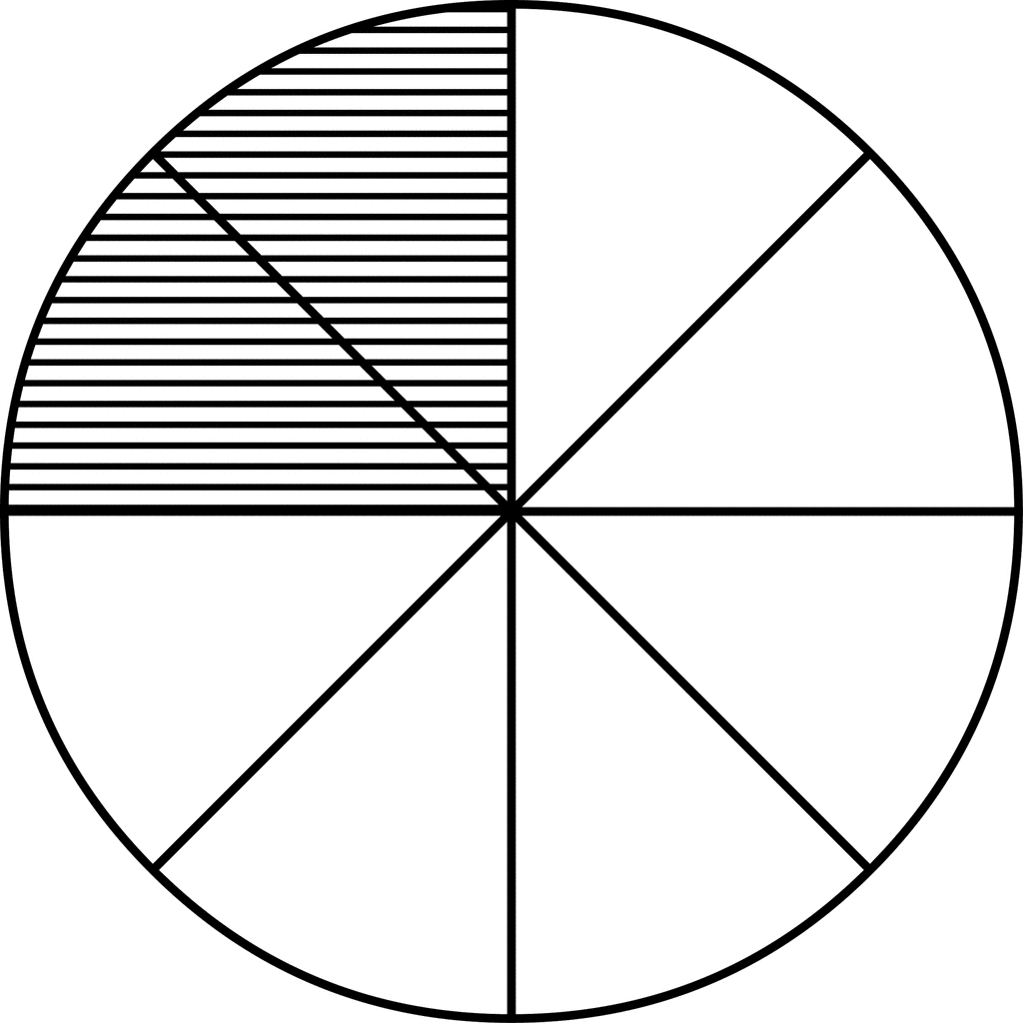

- Place the fractions and decimals on the number line in the correct location. Explain your thinking.
- $\frac{10}{8}$
- 1.2
- 0.556
- 0.8%

- Put these numbers in descending order: $\frac{17}{4}$, 1 $\frac{1}{4}$, 4.75%, 4.748.

- Place these numbers in ascending order: $\frac{2}{3}$, 66%, $\frac{3}{4}$, 0.67.

SOL 6.2b - Just in Time Quick Check Teacher Notes
Common Errors/Misconceptions and their Possible Indications

- Name the percent shown in each model. Use <, >, or = in the empty box to compare the models below. Explain your thinking.

Some students may indicate that both models are 2% and equal to each other since two portions are shaded in each model. Additionally, some students may have the misconception that percents can only be modeled on a 100-grid. If students are able to identify the correct fraction, some may be unable to convert the fractions to percents.
It may be helpful to provide opportunities to model percentages using a hundred grid to reinforce the connection between percents and 100 as a whole. While modeling on the hundred grid, teachers may wish to reinforce the connection between percents, decimals, and fractions. As students gain more understanding of the meaning of percent, transition to examples of other fractional representations that are not out of 100.
Teachers may also wish to begin with concrete models of percents before making connections to pictorial models. Students then may benefit from practice with a variety of pictorial models of percents, beginning with the 100-grid and transitioning to other representations. Some possible models may include fraction circles, number lines, colored counters, and shaded figures or grids.

- Place the fractions and decimals on the number line in the correct location. Explain your thinking.
- $\frac{10}{8}$
- 1.2
- 0.556
- 0.8%

Students may create a zero to 1 number line, not recognizing that some of the numbers are greater than 1. Another common error for some students is to place 0.8% as if it were 8% or 80%. Some students may focus on the digit when interpreting percents rather than thinking of it in relationship to the whole percent.

Teachers may wish to encourage students to think of fractions, decimals, and percentages in terms of their relationships to the benchmarks of 0, $\frac{1}{2}$ , 1, or more than 1, placing these on the number line based on the benchmark. Multiple experiences with benchmarking discussions about fractions, decimals, and percents can help students build these connections.

- Place these numbers in descending order: $\frac{17}{4}$, 1 $\frac{1}{4}$, 4.75%, 4.748.

Some students may place 4.75% after $\frac{17}{4}$ and 4.748. These students may think that if there is a decimal point in the percent, it is a decimal representation, and they do not realize it is actually a portion of a percent. Other students may also place the 4.75% after$1\frac{1}{4}$ , again not thinking the 0.75 in 4.75% is a portion of a percent. Students would benefit from a variety of experiences with modeling fractions, decimals, and percents that are less than 1% and greater than 100%. Begin student experiences with concrete modeling using base ten blocks, and then transition to pictorial models and number lines to assist students with conceptualizing the relative sizes of the fractions, decimals, and percents.

- Place these numbers in ascending order: $\frac{2}{3}$, 66%, $\frac{3}{4}$, 0.67.

Because $\frac{2}{3}$ is a repeating decimal, some students may struggle with where to place it in relation to 66% and 0.67. This may indicate that these students may need more experiences with fractions that convert to repeating decimals and what that really means. Teachers may wish to have the students repeat the 6 until the thousandths or ten thousandths place and adding zeros to 0.67 and 66% to the same place value so the students can visualize the relative size comparison. Pairing this visual with matching thousandths grids and placement on a number line would help students understand the difference that exists between these values.

