Just In Time Quick Check
Standard of Learning (SOL) 6.1
Strand: Number and Number Sense

Standard of Learning (SOL) 6.1
The student will represent relationships between quantities using ratios, and will use appropriate notations, such as $\frac{a}{b}$ , a to b, and a:b.

Grade Level Skills:
- Represent a relationship between two quantities using ratios.
- Represent a relationship in words that makes a comparison by using the notations $\frac{a}{b}$ , a:b, and a to b.
- Create a relationship in words for a given ratio expressed symbolically.
Just in Time Quick Check
Just in Time Quick Check Teacher Notes

Supporting Resources:
- VDOE Mathematics Instructional Plans (MIPS)
  - 6.1 - Field Goals, Balls, and Nets (Word) / PDF Version
- VDOE Co-Teaching Mathematics Instruction Plans (MIPS)
  - 6.1 - Ratios (Word) / PDF Version
- VDOE Algebra Readiness Formative Assessments
  - SOL 6.1 (Word) / PDF
- VDOE Algebra Readiness Remediation Plans
  - Ratios with Color Tiles (Word) / PDF
- VDOE Word Wall Cards: Grade 6 (Word) | (PDF)
- Ratio
- Desmos Activity
- Visual Ratios
Supporting and Prerequisite SOL: 5.2a, 4.2b, 4.3d

SOL 6.1 - Just in Time Quick Check

- The Golden Rods Basketball Team wins 28 of the games they play. They play a total of 36 games. What is the ratio of the games they win to the games they lose? How do you know?

- Patti collects 12 rocks at the lake. She collects 67 seashells at the beach. What is the ratio of rocks to the total number of items she collects? How do you know?

- Create a set of items with squares and stars. The set of items should represent a 2:3 ratio for the number of squares to the number of stars. The sets you create should have different quantities.

- A student describes the relationship between two groups of objects at school with the ratio 3:7. Use words to describe what the student may be describing.

- There are 4 red marbles and 2 blue marbles shown in the bag. What is the least number of red and blue marbles that can be added to the bag to create a ratio of 3 red marbles to 1 blue marble? Explain how you know.
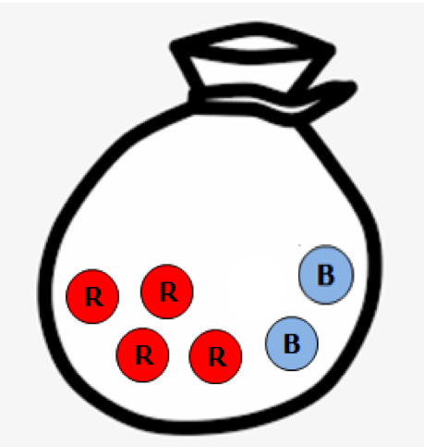 Key: = red 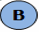 = blue

SOL 6.1 - Just in Time Quick Check Teacher Notes
Common Errors/Misconceptions and their Possible Indications

- The Golden Rods Basketball Team wins 28 of the games they play. They play a total of 36 games. What is the ratio of the games they win to the games they lose? How do you know?

A common error for some students is to describe a part-to-whole relationship rather than a part-to-part relationship. These students may have the misconception that all of the numbers used in the ratio will be included in the problem. They may not realize that they need to use the details in the problem to determine how many games were lost.
Provide students with opportunities to explore ratio relationships with counters and part-part-whole mats to model scenarios concretely and then write statements to represent them. As students model different part-part-whole combinations, ask them to use ratios to describe part-to-part relationships and part-to-whole relationships. This will help students develop the understanding that ratios can reflect different types of relationships.

- Patti collects 12 rocks at the lake. She collects 67 seashells at the beach. What is the ratio of rocks to the total number of items she collects? How do you know?

A common error for some students is thinking that the context in this problem represents a part-to-part ratio rather than a part-to-whole ratio. This may be due to the misconception that all numbers used in a ratio will be included in the problem.
Students may benefit from exploring ratio relationships with concrete materials. It may help to use real world objects from the classroom or home to create these relationships. Describe the relationships from both a part-to-part and a part-to-whole perspective.
Another strategy is to provide students with a ratio and ask them to create either a part-to-part example or a part-to-whole example using concrete materials. Developing a situation to match a specific ratio relationship helps students to focus on the type of relationship and what each of those relationships represents.

- Create a set of items with squares and stars. The set of items should represent a 2:3 ratio for the number of squares to the number of stars. The set you create should contain more than 5 items.

A common error for some students is to switch the order of the ratio when representing the relationship presented. These students may have the misconception that the order of the numbers or items doesn’t matter. Additionally, some students may be able to create a 2:3 ratio with 5 counters, but may struggle to extend it to a larger set of items.
It may be helpful for these students to use concrete objects to represent relationships, focusing on matching the objects named to a ratio relationship. Then ask students how they could extend this ratio relationship to a larger set. As students become more confident, they may build several different sets of items showing the same ratio relationship.

- A student describes the relationship between two groups of objects at school with the ratio 3:7. Use words to describe what the student may be describing.

A common error for some students is to describe a part-to-whole relationship rather than describing the relationship between two groups of objects as stated in the example. For example, a student may describe the relationship by saying that there are 3 red pencils and 7 pencils altogether.
These students may benefit from using concrete objects to create the relationships first and then using words to describe the concrete model. Teachers can provide practice with a variety of different types of relationships to continue to help students develop an understanding that different types of relationships exist.

- There are 4 red marbles and 2 blue marbles shown in the bag. What is the least number of red and blue marbles that can be added to the bag to create a ratio of 3 red marbles to 1 blue marble? Explain how you know.

Key: = red = blue

In this scenario, the least number of marbles needed to create a 3 to 1, red to blue ratio, would be two red marbles and zero blue marbles.
Some students may reverse the order of the ratio to blue to red, and then add items to the set to support the reversal. In this case students might add ten blue marbles and zero red marbles.
Some students may also add more red and/or blue marbles than needed and disregard the “least” criteria to create a 3 to 1 (or incorrectly create a 1 to 3 ratio).
It may be helpful for students to arrange concrete counters linearly to see the proportional relationship they are creating. Example concrete solution for question 5:
Given set before creating a red to blue 3 to 1 ratio:

Linear concrete arrangement to see the least amount needed (2 more red marbles) to create a
red to blue, 3 to 1, ratio:

