Just In Time Quick Check

Standard of Learning (SOL) 5.17c
Strand: Probability and Statistics

Standard of Learning (SOL) 5.17c

The student, given a practical context, will describe the range of a set of data as a measure of spread.

Grade Level Skills:
- Describe and determine the range of a group of numbers representing data from a given context as a measure of spread.
Just in Time Quick Check
Just in Time Quick Check Teacher Notes

Supporting Resources:
- VDOE Mathematics Instructional Plans (MIPS)
  - 5.17 What’s the Data All About? (Word) / PDF Version
- VDOE Word Wall Cards: Grade 5 (Word) | (PDF)
  - Range: Measure of Spread

Supporting and Prerequisite SOL: 4.4b, 3.3a, 3.3b

SOL 5.17c - Just in Time Quick Check

1. Mr. Roger’s math class took a test. Each test was worth 100 points. The scores for twelve students are listed below. Describe a method for finding the spread of the scores for this test.
90, 89, 76, 88, 95, 94, 83, 62, 97, 98, 87, 75

2. Five students threw a basketball at the hoop. Each student threw the basketball 25 times. The bar graph shows how many times each student threw the basketball through the hoop. Complete the statement: “The range is 10 because it represents the ________________________________________________________________________________”.
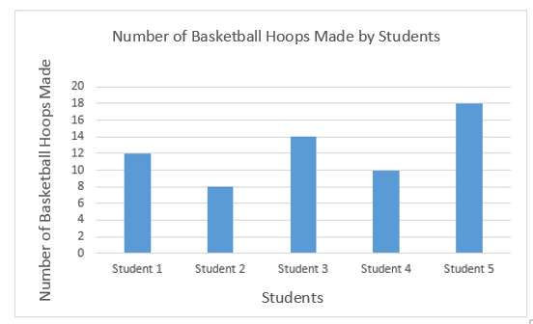

3. Kristy took five quizzes in her history class. Each quiz was worth 100 points. Her scores for four of the five quizzes are shown below.
85, 83, 86, 73
The spread of the quiz scores was 19. The score on the fifth quiz was either ________ or __________.

SOL 5.17c - Just in Time Quick Check Teacher Notes
Common Errors/Misconceptions and their Possible Indications

1. Mr. Roger’s math class took a test. Each test was worth 100 points. The scores for twelve students are listed below. Describe a method for finding the spread of the scores for this test.
90, 89, 76, 88, 95, 94, 83, 62, 97, 98, 87, 75
A common misconception some students may have is when describing a method for finding the range of the data is they incorporate ideas for finding the mode of the data set. This may indicate that a student believes the range can be determined by ordering the values in the data set from least to greatest and find the middle number in the ordered list. It might be helpful for a teacher to use graphs of practical situations related to topics of interest for students to describe the range.
2. Five students threw a basketball at the hoop. They each threw the basketball 25 times. The bar graph shows how many times each student threw the basketball through the hoop. Complete the statement: “The range is 10 because it represents the ________________________________________________________________________________”.
A common misconception some students may have is stating that 10 represents the number of times student 4 put a basketball through the hoop. This may indicate that students are identifying a specific value in the bar graph obtained by one of the five students. It may be helpful to work with students to identify each of the five data values in the bar graph and order those five data values from least to greatest. A helpful strategy for teachers to incorporate might be to use the word wall cards as an anchor chart and provide students with a context to associate range as a measure of spread.

3. Kristy took five quizzes in her history class. Each quiz was worth 100 points. Her scores for four of the five quizzes are shown below.
85, 83, 86, 73
The spread on the quiz scores was 19. The score on the fifth quiz was either ________ or __________.
A common error students may make is finding the fifth quiz score using the range value provided and the greatest possible score (100) a student could receive on a quiz. This might indicate that a student uses the greatest possible value of the practical situation rather than the greatest value contained in the data set. Students might subtract 19 from 100 to find 81 as a possible fifth quiz score. In this case, it may be helpful to support students by providing them several practice sets of data to compare that the greatest value possible of the context to the greatest value contained in the data set.
Another common error students might make is subtracting 19 from both the first score and the last score in the data set to determine the fifth quiz scores. This may indicate that a student neglects to take into account that the first and last score in the data set do not represent the greatest and least scores earned. In this case, it might be beneficial to provide students additional practice ordering data points from least to greatest before starting any computation to find the range or statistical measure. In addition, it might be helpful to provide students with several real life examples of grades, sports, scores, etc. with a missing value and a given spread of values.

