Just In Time Quick Check

Standard of Learning (SOL) 5.14b
Strand: Measurement and Geometry

Standard of Learning (SOL) 5.14b
The student will investigate and describe the results of combining and subdividing polygons.

Grade Level Skills:
- Investigate and describe the results of combining and subdividing polygons.
- Compare and contrast the characteristics of a given polygon that has been subdivided with the characteristics of the resulting parts.
Just in Time Quick Check
Just in Time Quick Check Teacher Notes

Supporting Resources:
- VDOE Mathematics Instructional Plans (MIPS)
  - Combining and Subdividing Shapes (World) | (PDF)
- VDOE Word Wall Cards: Grade 5 (Word) | (PDF)
  - Subdivide
  - Combine
Supporting and Prerequisite SOL: 3.12a, 3.12b, 3.12c

SOL 5.14b - Just in Time Quick Check

- David cut this polygon on the dotted line.

  - Name the original polygon.

  - Name the two polygons David created when he cut the original polygon on the dotted line.

- A teacher gave a student these three polygons.

The student combined these three polygons to make a new polygon. Describe the new polygon the student could have made. Use pictures, numbers, and words to explain your thinking.

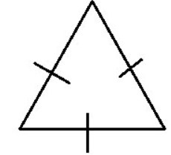 | 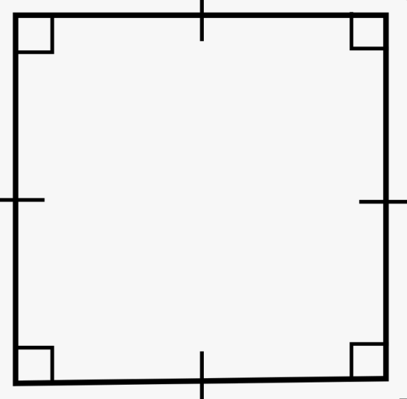

- A square is composed of combined polygons. Each polygon is labeled with a letter. Use this square to answer the following questions.
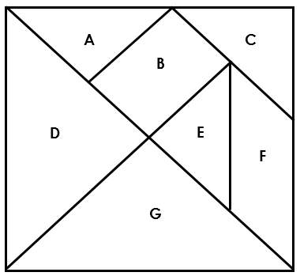

A student combined only polygons B, E, and F and shaded them with a pencil.
- Name each of the three polygons the student used to combine and shade with a pencil.

- What new figure did the student create?

SOL 5.14b - Just in Time Quick Check Teacher Notes
Common Errors/Misconceptions and their Possible Indications

- David cut this polygon on the dotted line.

  - Name the original polygon.
Some students may have difficulty identifying and recalling the names of polygons due to a lack of experience with them. Teachers may wish to have an anchor chart of different polygons accessible for students to refer to as they explore combining and subdividing shapes. Additionally, teachers can utilize the Grade 4 Vocabulary Word Wall Cards to review the names and characteristics of polygons.

  - Name the two polygons David created when he cut the original polygon on the dotted line.
Some students may have difficulty visualizing polygons within a polygon. Teachers may wish to have students use manipulatives that allow them to subdivide polygons and have students identify the characteristics of the original polygon and then the new polygons.

- A teacher gave a student these three polygons.

The student combined these three polygons to make a new polygon. Describe the new polygon the student could have made. Use pictures, numbers, and words to explain your thinking.

Some students may create images that are not considered polygons. This may indicate that students need additional instruction on what makes a figure a polygon. Teachers also may wish to have students use manipulatives that allow them to combine polygons and have students identify the characteristics of the polygons and the new polygon.

- A square is composed of combined polygons. Each polygon is labeled with a letter. Use this square to answer the following questions.
A student combined only polygons B, E, and F and shaded them with a pencil.
- Name each of the three polygons the student used to combine and shade with a pencil.
Some students may have difficulty visually separating and thinking of polygons B, E, and F as three distinct polygons. These students may benefit from cutting apart the square and separating the different polygons. Other students may struggle recalling the names of polygons due to a lack of experience. These students would benefit from an anchor chart of polygons and their names. The Grade 4 Word Wall cards may be used as a resource for these students.
- What new figure did the student create?
Some students may have difficulty combining polygons to create a new polygon because of the open nature of this task. They may not visualize the many possibilities of polygons that can be combined. Students could be encouraged to cut the square into the polygons, and physically manipulate the polygons to investigate what polygons could be made. Teachers may wish to have students use tangrams or other manipulatives to allow for student exploration of decomposing and composing specified shapes when transformations are required. It may also be beneficial to have students trace shapes and color code original polygons. The MIP, Combining and Subdividing Shapes, provides guidance on creating a set of tangrams and activities to use with students.

Teachers may wish to challenge students to use many different polygons and create as many different new polygons as possible.

