Just In Time Quick Check

Standard of Learning (SOL) 5.14a
Strand: Measurement and Geometry

Standard of Learning (SOL) 5.14a
The student will recognize and apply transformations, such as translation, reflection, and rotation.

Grade Level Skills:
- Apply transformations to polygons in order to determine congruence.
- Recognize that translations, reflections, and rotations preserve congruency.
- Identify the image of a polygon resulting from a single transformation (translation, reflection, or rotation).
Just in Time Quick Check
Just in Time Quick Check Teacher Notes

Supporting Resources:
- VDOE Mathematics Instructional Plans (MIPS)
  - Slides, Flips, and Turns (Word) | (PDF)
- VDOE Algebra Readiness Remediation Plans
  - Reflections (Word) | (PDF)
  - Transformations (Word) | (PDF)
  - Translations (Word) | (PDF)
- VDOE Word Wall Cards: Grade 5 (Word) | (PDF)
  - Translation
  - Reflection
  - Rotation
- Desmos Activity
  - Polygraph: Transformations
Supporting and Prerequisite SOL: 3.13

SOL 5.14a - Just in Time Quick Check

- Determine the transformation.

  - Do the two congruent figures below show a translation, rotation, or reflection?

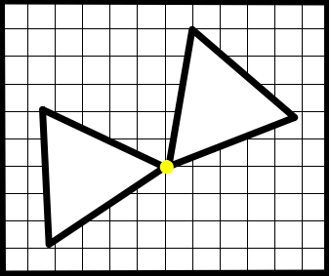

  - Do the two congruent figures below show a translation, rotation, or reflection?
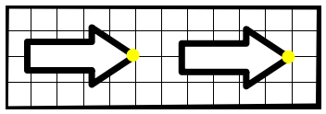

  - Do the two congruent figures below show a translation, rotation, or reflection?
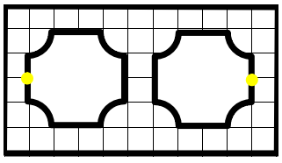

- Does the image below demonstrate a translation? Explain your thinking using pictures, numbers, and words.

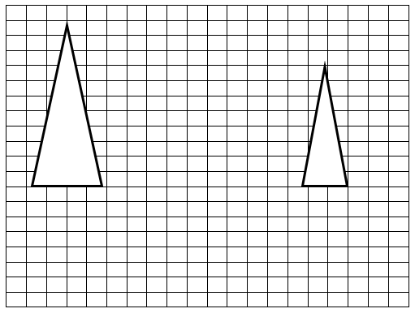

SOL 5.14a - Just in Time Quick Check Teacher Notes
Common Errors/Misconceptions and their Possible Indications

- Determine the transformation.

  - Do the two congruent figures below show a translation, rotation, or reflection?

Some students may have difficulty identifying transformations because of an unfamiliarity with the specific vocabulary terms for transformations because of a lack of exposure. Teachers may find it helpful to point out that the “t” in rotation helps to remind them it is a turn. Teachers may wish to use these language patterns in conjunction with a math journal, word wall, and anchor charts. Also, teachers may wish to have students do kinesthetic activities that mimics the rotation action such as having students pivot on one foot while saying the term rotate. Students will also benefit from taking polygons and manipulating them to show different points on which a polygon can rotate.

Tracing shapes and rotating them can be helpful in visualizing this transformation. Teacher may wish to have students explore the concept of windmills, tires, pinwheels, and other real world objects that demonstrate rotation. The VDOE Algebra Readiness Remediation Plan titled Transformations may be helpful to use with students who need additional support.

b) Do the two congruent figures below show a translation, rotation, or reflection?

Some students may have difficulty identifying transformations because of an unfamiliarity with the specific vocabulary terms for transformations because of a lack of exposure. Teachers may find it helpful to point out that blend “sl” in the term translation matches the blend “sl” in the term slide. Teachers may wish to use these language patterns in conjunction with a math journal, word wall, and anchor charts. Students may also benefit from placing polygons on grid paper and manipulating them to show how when slid in any direction each point from the image remains equidistant from the points on the preimage.

It may be beneficial to have students practice with reproducing them by tracing a polygon in one location, sliding it, and then tracing it again to show a translation making sure that the distance from the preimage points are equidistant to the new images points. Teachers may also wish to have students record preimage points of physical objects, slide them across a flat surface, and record the new image points by measuring the distance between each point. The VDOE Algebra Readiness Remediation Plan titled Translations may be helpful to use with students who need additional support.

c) Do the two congruent figures below show a translation, rotation, or reflection?

Some students may have difficulty identifying transformations because of an unfamiliarity with the specific vocabulary terms for transformations because of a lack of exposure. Teachers may find it helpful to point out that blend “fl” in the term reflection matches the blend “fl” in the term flip. Teachers may wish to use these language patterns in conjunction with a math journal, word wall, and anchor charts. In addition, teachers may wish to have students do kinesthetic activities that mimic the action of a reflection by having students use a mirror and object to demonstrate positionality. Students will also benefit from using polygons and manipulating them using mirrors on grid paper.

Additionally, using tracing paper or cutouts of the figure can be very helpful for students to physically move the figure across the reflection “dotted” line to support a visual approach. The VDOE Algebra Readiness Remediation Plan titled Reflections may be helpful to use with students who need additional support.

- Does the image below demonstrate a translation? Explain your thinking using pictures, numbers, and words.

Students may have difficulty with this question if they do not realize that translated figures maintain congruency. This may indicate that a student views the transformation as a translation because the similar figure has slid across the grid. Teachers may wish to emphasize that figures that are translated, rotated, or reflected maintain congruency with the original image.

