Just In Time Quick Check

Standard of Learning (SOL) 5.13b
Strand: Measurement and Geometry

Standard of Learning (SOL) 5.13b

The student will investigate the sum of the interior angles in a triangle and determine an unknown angle measure.

Grade Level Skills:
- Use models to prove that the sum of the interior angles of a triangle is 180 degrees, and use that relationship to determine an unknown angle measure in a triangle.
Just in Time Quick Check
Just in Time Quick Check Teacher Notes

Supporting Resources:
- VDOE Mathematics Instructional Plans (MIPS)
  - 5.13b - Exploring the Sum of a Triangle’s Angles (Word) / PDF Version
- VDOE Algebra Readiness Remediation Plans
  - Triangles (Word) / PDF
- VDOE Word Wall Cards: Grade 5 (Word) | (PDF)
  - Acute Angle
  - Right Angle
  - Obtuse Angle
  - Straight Angle
  - Acute Triangle
  - Obtuse Triangle
  - Right Triangle
- VDOE Rich Mathematical Tasks: Designing Windows Task
  - 5.13 Designing Windows Task Template (Word) / PDF Version
- Desmos Activity
  - Determine an Unknown Angle Measure in a Triangle
Supporting and Prerequisite SOL: 5.12, 5.13a

SOL 5.13b - Just in Time Quick Check

- What is the sum of measures of the angles in triangle ABC, in degrees? Explain your thinking using pictures, numbers, and words.

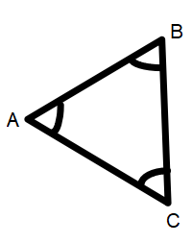

- Determine the missing angle measure.

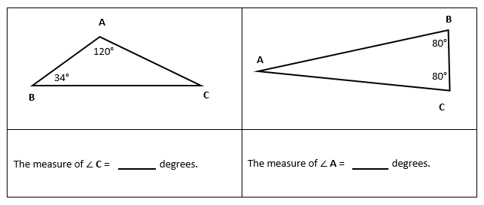

- Explain what your strategy is for determining the measure of ∠B in the triangle below.

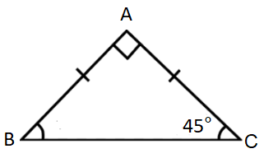
Measure of ∠B=______ ⁰

SOL 5.13b - Just in Time Quick Check Teacher Notes
Common Errors/Misconceptions and their Possible Indications

- What is the sum of the measures of the angles in triangle ABC, in degrees? Explain your thinking using pictures, numbers, and words.

If students have not had experience with investigating the sums of interior angles in a triangle, they may guess the sum by estimating the angle measures and then adding them. Provide opportunities for exploration by having students create obtuse, acute, and right triangles and then cut off their angles and reconfigure them along a line. Teachers also may wish to create anchor charts with students that summarize their findings.

- Determine the missing angle measure.

Some students may have difficulty because they lack a strategy for finding the missing angle. Teachers may wish to have students create a part, part, part, whole table to help them solve for the missing angle measure. Teachers may wish to facilitate discussions which encourage sharing of different strategies for solving missing angle measure problems. Some students may think that angle C is 60 because they only subtract 120 from 180. Other students may think that angle A is 80 because the other two angles are 80, or that angle A is 20 because 80+20=100.
- Explain what your strategy is for determining the measure of ∠B in the triangle below.

Measure of ∠B=______ ⁰

Some students may have difficulty recalling the symbolic notation for right angles in addition to not understanding the sum of a triangle’s angle measurement. Teachers may wish to review symbolic notation using Word Wall cards and anchor charts. Teachers may wish to facilitate discussions where students share their strategies for determining a missing angle measure and have students write in math journals about their strategies for finding a missing angle measurement. Teachers should be aware that some students will get this answer correct only because they use the same number that they already see in the figure. It is important that they be able to explain why they are correct.

