Just In Time Quick Check

Standard of Learning (SOL) 5.13a
Strand: Measurement and Geometry

Standard of Learning (SOL) 5.13a
The student will classify triangles as right, acute, or obtuse and equilateral, scalene, or isosceles.

Grade Level Skills:
- Classify triangles as right, acute, or obtuse.
- Classify triangles as equilateral, scalene, or isosceles.
- Compare and contrast the properties of triangles.
- Identify congruent sides and right angles using geometric markings to denote properties of triangles.
Just in Time Quick Check
Just in Time Quick Check Teacher Notes

Supporting Resources:
- VDOE Mathematics Instructional Plans (MIPS)
  - 5.13a - Triangle Sort (Word) / PDF Version
- VDOE Algebra Readiness Remediation Plans
  - Triangles (Word) / PDF
- VDOE Word Wall Cards: Grade 5 (Word) | (PDF)
  - Acute Triangle
  - Obtuse Triangle
  - Right Triangle
  - Equilateral Triangle
  - Scalene Triangle
  - Isosceles Triangle
- VDOE Rich Mathematical Tasks: Designing Windows
  - 5.13 Designing Windows Task Template (Word) / PDF Version
- Desmos Activity
- Polygraph: Triangles
- Types of Triangles Activity
Supporting and Prerequisite SOL: 5.12, 5.13b, 3.12b

SOL 5.13a - Just in Time Quick Check
- Classify the triangles shown below. Use the word bank to help you.

Right Triangle Acute Triangle Obtuse Triangle

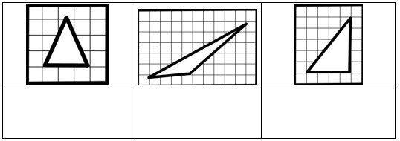

- Classify the triangles shown below. Use the word bank to help you.

Scalene Triangle Isosceles Triangle Equilateral Triangle

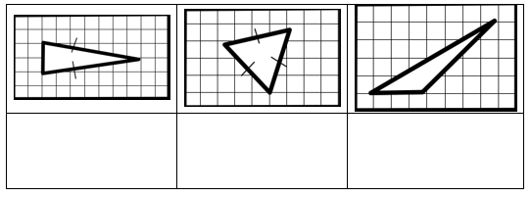
- Classify the triangles shown below in 2 ways. Use the word bank to help you.

Acute Triangle Obtuse Triangle Right Triangle
Scalene Triangle Isosceles Triangle Equilateral Triangle

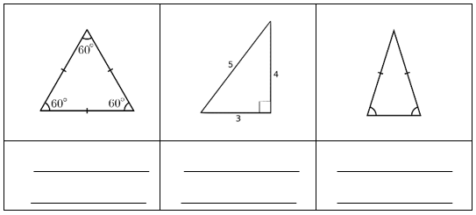

- Identify and explain what the symbolic notation in each triangle means. Use the word bank to help you.

angles sides degrees congruent hash marks right

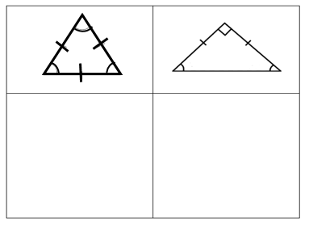

- Compare and contrast the properties of the given triangles in the chart below.
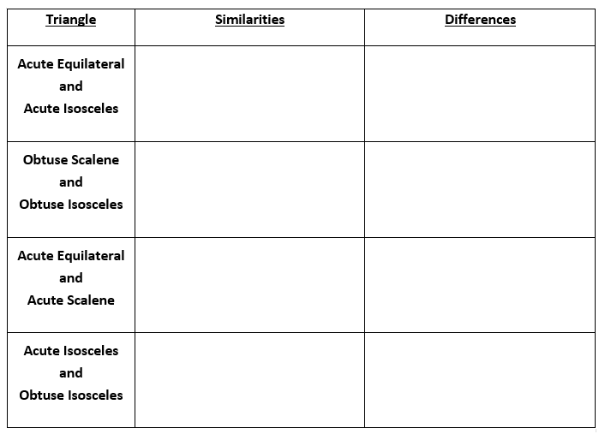

SOL 5.13a - Just in Time Quick Check Teacher Notes
Common Errors/Misconceptions and their Possible Indications
- Classify the triangles shown below. Use the word bank to help you.

Right Triangle Acute Triangle Obtuse Triangle

Some students may identify the obtuse triangle or right triangle as an acute triangle because they both have two acute angles. They may not realize that all triangles have at least two acute angles and the triangle is classified according to the 3rd angle. Teachers may wish to have students classify triangles based on their angles by exploring different possible angle measurements of triangles using manipulatives such as AngLegs and Geoboards. This may help students discover properties of right, acute, and obtuse triangles. Teachers may reference Word Wall cards and anchor charts throughout students’ work with triangles.
- Classify the triangles shown below. Use the word bank to help you.

Scalene Triangle Isosceles Triangle Equilateral Triangle

` Some students may be challenged by the terms isosceles and scalene as they are new terms. Teachers may wish to have students classify triangles based on their sides by exploring different possible length measurements of triangles using manipulatives such as AngLegs and Geoboards. This may help students discover properties of equilateral, isosceles, and scalene triangles. Teachers may reference Word Wall cards and anchor charts throughout students’ work with triangles as well as math journals to support vocabulary instruction.
- Classify the triangles shown below in 2 ways. Use the word bank to help you.

Acute Triangle Obtuse Triangle Right Triangle
Scalene Triangle Isosceles Triangle Equilateral Triangle

Some students may have difficulty classifying triangles by both their angles and their side measures. Some students may think that it is possible to combine all angle classifications with all side classifications. Teachers may wish to have students explore which classifications are possible by having students explore combinations through the use of manipulatives. This may lead to the discovery that some side classifications are incompatible with some angle classification. Teachers may also wish to ask questions that require students to justify their thinking.
- Identify and explain what the symbolic notation in each triangle means. Use the word bank to help you.

angles sides degrees congruent hash marks right

Some students may have difficulty with symbolic notation due to limited practice with the symbolic notation. Teachers may wish to model the notation for side congruency and angle measurements and create anchor charts with students using the notation to classify triangles. Teachers may wish to have students include the notation with the definitions in their vocabulary journals.

- Compare and contrast the properties of the given triangles in the chart below.

Comparing and contrasting characteristics of different triangles requires a deeper understanding of the properties necessary for a triangle to be classified a specified way. Teachers may wish to have students explore different types of triangles and compare and contrast their properties using a properties table, or a Venn diagram. Having students attempt to draw each of these triangles may help them identify the similarities and differences, as well.

