Just In Time Quick Check

Standard of Learning (SOL) 5.12
Strand: Measurement and Geometry

Standard of Learning (SOL) 5.12
The student will classify and measure right, acute, obtuse, and straight angles.

Grade Level Skills:
- Classify angles as right, acute, obtuse, or straight
- Identify the appropriate tools (e.g., protractor and straightedge or angle ruler as well as available software) used to measure and draw angles.
- Measure right, acute, obtuse, and straight angles, using appropriate tools, and identify their measures in degrees.
- Solve addition and subtraction problems to determine unknown angle measures on a diagram in practical problems.
Just in Time Quick Check
Just in Time Quick Check Teacher Notes

Supporting Resources:
- VDOE Mathematics Instructional Plans (MIPS)
  - 5.12 - Exploring Angles (Word) / PDF
- VDOE Algebra Readiness Remediation Plans
  - Estimate Angle Measures (Word) / PDF
  - Measuring Angles (Word) / PDF
- VDOE Word Wall Cards: Grade 5 (Word) | (PDF)
  - Acute Angle
  - Obtuse Angle
  - Right Angle
  - Straight Angle
- Desmos Activity
  - Angle Measure Activity
Supporting and Prerequisite SOL: 4.10, 3.11

SOL 5.12 - Just in Time Quick Check

- Use the word bank below to identify the appropriate tool(s) used to measure and draw angles.

protractor straight edge angle ruler

- Draw an angle of 180 degrees- __________________________

    - Measure a 90 degree angle- ___________________________

- Use a protractor to measure the angles below and the word bank to identify the type of angle.

straight angle right angle acute angle obtuse angle

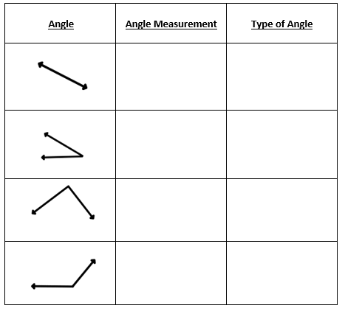

- Below are two straight angles. Use the given angles to help you determine the missing angle measure.

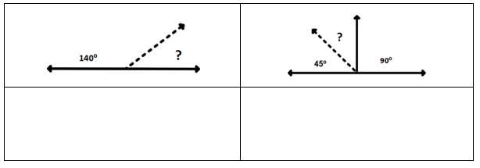

SOL 5.12 - Just in Time Quick Check Teacher Notes
Common Errors/Misconceptions and their Possible Indications
- Use the word bank below to identify the appropriate tool(s) used to measure and draw angles.

protractor straight edge angle ruler

    - Draw an angle measuring 180 degrees- __________________________

    - Measure a 90-degree angle- ___________________________

Some students may have difficulty identifying tools use for measuring angles because they have limited experience with the tools that can be used. Some students may not understand that a straightedge can be used to create a 180- degree angle. Teachers may wish to provide opportunities to explore physical and virtual protractors, straight edges, and angle rulers. Teachers may facilitate discussions where students compare and contrast the tools and the angles that can be created and measured.
- Use a protractor to measure the angles below and the word bank to identify the type of angle.

straight angle right angle acute angle obtuse angle

Some students may have difficulty recognizing an angle when it has been rotated therefore may have difficulty identifying angles because of their orientation. Also, some students may have difficulty remembering the names of angles based on their angle measurement. Teachers may have students explore and identify straight, acute, obtuse, and right angles in their environment and add these to a vocabulary journal with illustrations, terms, and definitions. Teachers may facilitate discussions where students practice using the angle vocabulary in context.
Some students may have difficulty setting up and reading a protractor correctly especially when the position of the angle is rotated. Some students may place the protractor in a horizontal position, regardless of the orientation of the angle being measured. Teachers may wish to provide explicit instruction with virtual and physical protractors. Teachers may facilitate discussions of reasonable estimates before measuring and also provide students with opportunities to measure angles in a variety of orientations. Teachers may refer to Word Wall cards and anchor charts during student practice with protractors.
- Below are two straight angles. Use the given angles to help you determine the missing angle measure.

Some students may have difficulty because they may not recall that the measure of a straight angle is 180 degrees making the task of finding the missing angle measure challenging. Also, some students who recall this information may have difficulty finding the missing measure to make the 180-degree measure. They may try to add known parts together. Teachers may wish to have students use part to whole organizers to help students see the part they are trying to determine and how it relates to the whole measure of the straight angle. Teachers may facilitate discussions where students can communicate their strategies for determining missing angles using the properties of angles.

