Just In Time Quick Check

Standard of Learning (SOL) 5.9b
Strand: Measurement and Geometry

Standard of Learning (SOL) 5.9b

The student will solve practical problems involving length, mass, and liquid volume using metric units.

Grade Level Skills:
- Estimate and measure to solve practical problems that involve metric units:
– length (millimeters, centimeters, meters, and kilometers)
– mass (grams and kilograms)
– liquid volume (milliliters, and liters).
Just in Time Quick Check
Just in Time Quick Check Teacher Notes

Supporting Resources:
- VDOE Mathematics Instructional Plans (MIPS)
  - 5.9ab - Measurement Mania (Word) / PDF Version
- VDOE Co-Teaching Mathematics Instruction Plans (MIPS)
  - 5.9 - Measurement (Word) / PDF Version
- VDOE Word Wall Cards: Grade 5 (Word) | (PDF)
  - Kilometer
  - Meter
  - Centimeter
  - Kilograms
  - Grams
  - Milliliters
  - Liters
- VDOE Instructional Videos for Teachers
  - Converting Units (grades 3-8)
Supporting and Prerequisite SOL: 5.4, 5.5a, 5.5b, 5.9a, 4.4d, 4.8a, 4.8b, 3.7a, 3.7b

SOL 5.9b - Just in Time Quick Check

- Describe a container that would hold about 5 liters.

- Juan received an iPad and an iPhone when he started his new job. He was interested in knowing the difference in the length of the iPad and the iPhone. Use a centimeter ruler to determine the difference in the lengths of Juan’s iPad and iPhone.

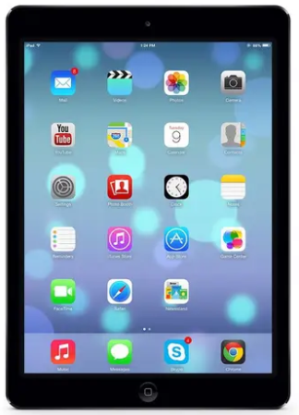

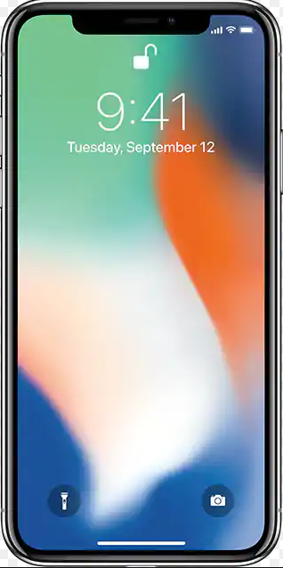

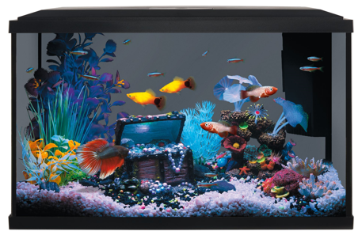
- Amy filled her aquarium with water, rocks, plants, and fish. What unit of measure should Amy use to determine the mass of this aquarium? Explain your answer.

- Measure the length of the basket to the nearest centimeter.
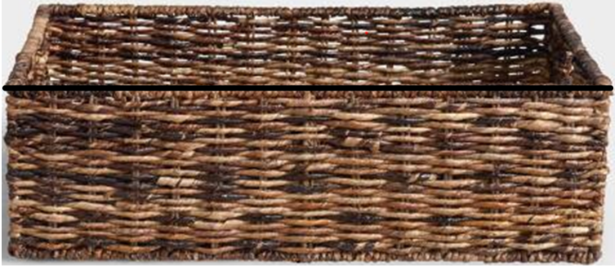

Ms. Jones will place five baskets end to end, without overlapping, on her shelf. What must be the minimum length of the shelf to hold five baskets?

SOL 5.9b - Just in Time Quick Check Teacher Notes
Common Errors/Misconceptions and their Possible Indications

- Describe a container that would hold about 5 liters.

Some students may have difficulty with this problem if they do not understand the relative size of metric measurements. Teachers may wish to have students physically pour liquids into different sized containers to gain a conceptual understanding of the size of a liter. Have students think about the size of a container that would hold 1 liter, 2 liters, etc., and also relate to containers they may be familiar with such as 2 liter bottles of soda. Teachers may consider relating the size of the metric measurement to a U.S. customary unit that students may be more familiar with, such as pint and gallon.

- Juan received an iPad and an iPhone when he started his new job. He was interested in knowing the difference in the length of the iPad and the iPhone. Juan used a centimeter ruler to measure the iPhone and iPad. What was the difference, in centimeters, in the lengths of Juan’s iPad and iPhone?

Some students may have difficulty measuring the length of the iPad and iPhone with the centimeter ruler, especially if the measurement is not in whole centimeters, and they need to think about the decimal equivalent. Teachers may wish to review how to measure using a ruler, and how to measure in centimeters. Additionally, some students may have difficulty knowing they will need to subtract to find the difference in the two lengths. Teachers may wish to use concrete manipulatives with students to explore similar problems so they gain an understanding of what it means to find the difference in the lengths of objects.

- Amy has an aquarium filled with water, rocks, plants, and fish. She needs to move the aquarium to a different location. What unit of metric measure should Amy use to determine the mass of this aquarium? Explain your answer.

Some students may respond with liters, thinking of a liquid volume unit of measure. These students know the aquarium is filled with water, and assume that liquid volume should be the unit of measure Amy would use. They did not understand that she wished to measure the mass. Students would benefit from a discussion on when it is appropriate to use the measures of liquid volume and mass.

- Measure the length of the basket to the nearest centimeter.

Ms. Jones will place five baskets end to end, without overlapping, on her shelf. What must be the minimum length of the shelf to hold five baskets?

Some students may have difficulty measuring the length of the basket. Teachers may wish to review how to measure to the nearest centimeter using a metric ruler with students. Additionally, some students may have difficulty combining the measurements to find the equivalent length of five baskets. Teachers may wish to expose students to these types of problems to build a stronger foundation. Teachers may also consider the use of centimeter cubes or other manipulatives to provide the opportunity for students to conceptualize the length of more than one object.

