Just In Time Quick Check
Standard of Learning (SOL) 5.8a
Strand: Measurement and Geometry

Standard of Learning (SOL) 5.8a
The student will solve practical problems that involve perimeter, area, and volume in standard units of measure.

Grade Level Skills:
- Solve practical problems that involve perimeter, area, and volume in standard units of measure.
- Determine the perimeter of a polygon, with or without diagrams, when
– the lengths of all sides of a polygon that is not a rectangle or a square are given;
– the length and width of a rectangle are given; or
– the length of a side of a square is given.
- Estimate and determine the area of a square and rectangle using whole number measurements given in metric or U.S. Customary units, and record the solution with the appropriate unit of measure (e.g., 24 square inches).
- Develop a procedure for determining the area of a right triangle using only whole number measurements given in metric or U.S. Customary units, and record the solution with the appropriate unit of measure (e.g., 12 square inches).
- Estimate and determine the area of a right triangle, with diagrams, when the base and the height are given.
- Develop a procedure for determining volume using manipulatives (e.g., cubes).
- Estimate and determine the volume of a rectangular prism with diagrams, when the length, width, and height are given, using whole number measurements. Record the solution with the appropriate unit of measure (e.g., 12 cubic inches).
Just in Time Quick Check
Just in Time Quick Check Teacher Notes

Supporting Resources:
- VDOE Mathematics Instructional Plans (MIPS)
  - 5.8a - Volume of a Rectangular Prism (Word) / PDF Version
  - 5.8ab - The Sandbox: Perimeter, Area, and Volume (Word) / PDF Version
- VDOE Algebra Readiness Remediation Plans
  - Banking Business (Word) / PDF
  - Estimating Area (Word) / PDF
  - Finding Area and Perimeter / PDF
- VDOE Word Wall Cards: Grade 5 (Word) | (PDF)
  - Area
  - Perimeter
  - Volume
- Desmos Activity
  - Exploring Triangle Area with Geoboards
Supporting and Prerequisite SOL: 4.7, 4.12, 3.8a, 3.8b

SOL 5.8a - Just in Time Quick Check

- Determine the perimeter of this polygon.
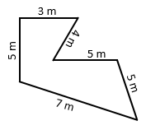

Perimeter _______________

- Determine the perimeter and area of:

  - A rectangle with a length of 15 cm and a width of 7 cm.

Perimeter _______________

Area _______________

  - A square with a side that measures 6 inches.

Perimeter _______________

Area _______________

- Determine the area of the triangle.
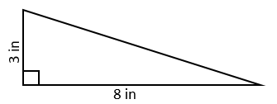

Area: _______________

- Determine the volume of the rectangular prism.
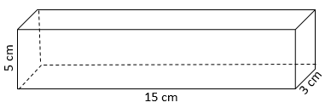

Volume: _______________

- Ms. Hamilton has a large piece of paper for her bulletin board that is 4 feet in width and 8 feet in length. What are the perimeter and area of the piece of paper?

Perimeter _______________

Area _______________

- Grayson filled his fish tank with water. Its length is 10 inches, its width is 3 inches, and its height is 6 inches.

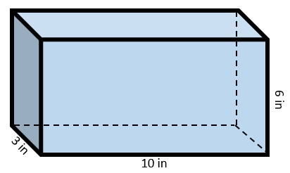

How much water can his fish tank hold? __________________

SOL 5.8a - Just in Time Quick Check Teacher Notes
Common Errors/Misconceptions and their Possible Indications

- Determine the perimeter of this polygon.

Perimeter _______________

A common error often seen in finding perimeter is that students omit one of the side measurements, especially if two or more sides have the same measurement. Encourage students to highlight the numbers and sides as they add them to ensure they are including all side measurements. For students who struggle with the meaning of perimeter, teachers may wish to highlight or use manipulatives to create a visual representation of perimeter on an anchor chart or in a math journal.

- Determine the perimeter and area of:

  - A rectangle with a length of 15 cm and a width of 7 cm.

Perimeter _______________

Area _______________

  - A square with a side that measures 6 inches.

Perimeter _______________

Area _______________

A common mistake in finding perimeter of rectangles is only using the two sides given to calculate the perimeter. Teachers may wish to encourage students to draw their rectangles and squares and label all of the sides before calculating the perimeter. Some students may also confuse the meanings of perimeter and area. Teachers may wish to provide manipulatives to help students make the connection that perimeter is a length measurement and area is a space coverage measurement. To highlight the characteristics of squares and rectangles, teachers may wish to create anchor charts with students that illustrate that opposite sides of a rectangle and all sides of a square are congruent.

- Determine the area of the triangle.

Area: _______________

Some students may multiply the base and the height, but do not divide it by two for the area of the triangle. Teachers may wish to use grid paper and manipulatives to help students decompose rectangles to discover the relationship between the area of a rectangle and a triangle.

- Determine the volume of the rectangular prism.

Volume: _______________

Students may have difficulty with volume because of a lack of experience, or they may confuse it with area and perimeter. Teachers may wish to provide experiences that allow students to fill and count containers with cube manipulatives by layer to discover how perimeter, area, and volume are related.
- Ms. Hamilton has a large piece of paper for her bulletin board that is 4 feet in width and 8 feet in length. What are the perimeter and area of the piece of paper?

Perimeter _______________

Area _______________

Some students may have more difficulty finding perimeter and area in a practical problem without a visual representation. Teachers may wish to expose students to various types of perimeter and area problems, emphasizing the benefit of drawing a figure and labeling it to help them solve. Additionally, students often confuse how to label the answer with appropriate units. Teacher may wish to engage the students in hands-on activities to help them distinguish that perimeter is measured in linear units, while area is measured in square units.

- Grayson filled his fish tank with water. Its length is 10 inches, its width is 3 inches, and its height is 6 inches.

How much water can his fish tank hold? __________________

Some students may be unfamiliar with finding the volume in cubic inches in a practical problem because of text comprehension and lack of experience. It may also be difficult for them to contextualize volume in cubic units. In addition to hands-on experiences with measuring volume with cubic units, teachers may also wish to use a sort with perimeter, area, and volume situations that requires students to comprehend and differentiate among the practical situations.

