Just In Time Quick Check

Standard of Learning (SOL) 4.14c
Strand: Probability and Statistics

Standard of Learning (SOL) 4.14c
The student will compare two different representations of the same data (e.g., a set of data displayed on a chart and a bar graph, a chart and a line graph, or a pictograph and a bar graph).

Grade Level Skills:
- Compare two different representations of the same data (e.g., a set of data displayed on a chart and a bar graph; a chart and a line graph; a pictograph and a bar graph).
Just in Time Quick Check
Just in Time Quick Check Teacher Notes

Supporting Resources:
- VDOE Mathematics Instructional Plans (MIPS)
  - Analyzing Temperature Data (Word) / PDF
  - Statistics: Sandwich Data (Word) / PDF
- VDOE Word Wall Cards: Grade 4 (Word) / PDF
  - Bar Graph
  - Line Graph
Supporting and Prerequisite SOL: 4.14a, 4.14b, 3.15a, 3.15b, 2.15a, 2.15b

SOL 4.14c - Just in Time Quick Check
- The data shown in the table represents the number of new fans who became members of a fan club over a ten-day period on a new social networking website.

a. Create a line graph using the data from the table.

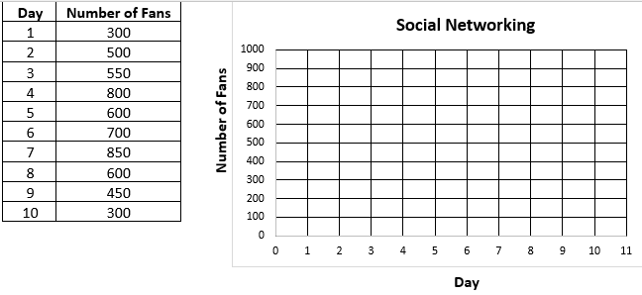

b. Which representation would it be easier to see the daily increases and decreases of the number of members over time?
Explain.

2. Each table matches the same data shown in one of the four bar graphs. Write the letter of the bar graph that matches the same data in the table.
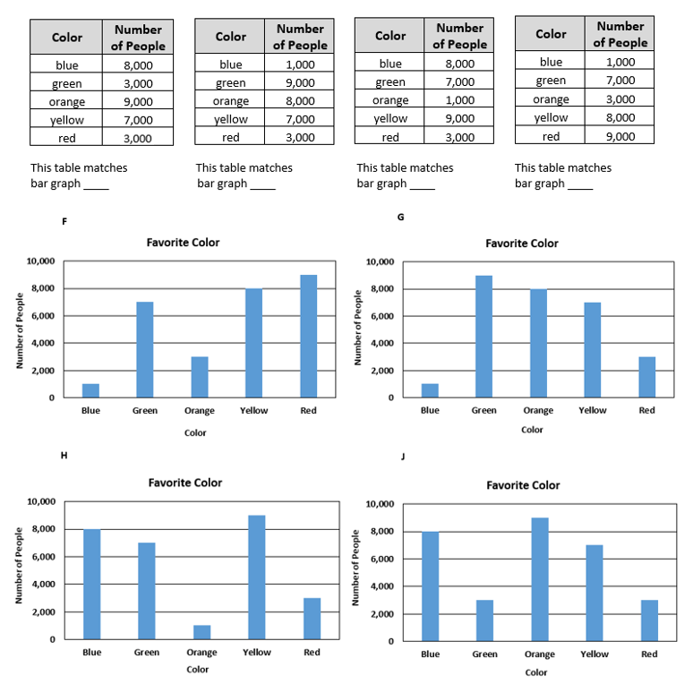

3. Two students, Marissa and Tommy, each created a bar graph to show the same data as this pictograph.
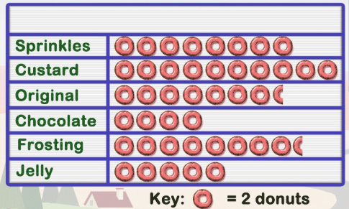
Donut Sales

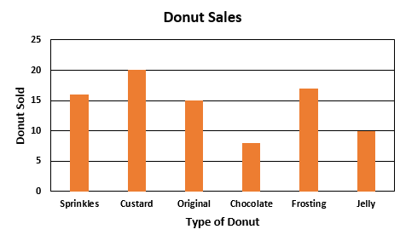
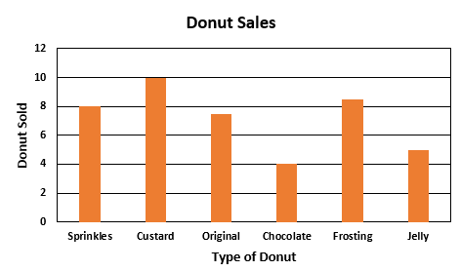
Marissa’s Graph Tommy’s Graph
a. Which student correctly made a bar graph using the same data from the pictograph?

b. Explain what the other student did incorrectly when making their bar graph.

4. Use the bar graph to answer part a and b.
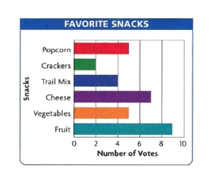
a. Complete the table that represents the same data in the bar graph shown.
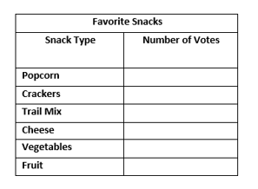

b. Which representation is it easier to determine which snack was chosen most often? Explain.

SOL 4.14c - Just in Time Quick Check Teacher Notes
Common Errors/Misconceptions and their Possible Indications

1. The data shown in the table represents the number of new fans who became members of a fan club over a ten- day period on a new social networking website.
a. Create a line graph using the data from the table.

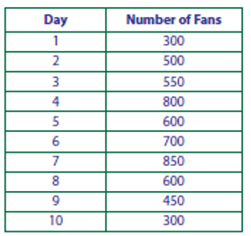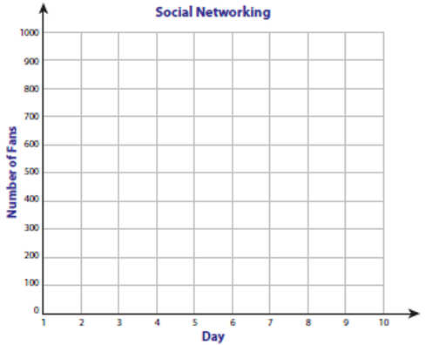

b. Which representation would it be easier to see the daily increases and decreases of the number of members over time?
Explain.

Some students may not understand how to plot values represented in the table that are not an exact match to the increments used in the line graph. This may indicate that a student has difficulty realizing that 550, 850, and 450 from the table are located halfway between the predetermined increments on this line graph. If students do not see the exact number on the vertical axis, they may not be sure where to place the mark on the line. Teachers may wish to have students think about the axes as they would a number line. Ask questions like-- “What increments are used on this number line? What numbers would occur between the labeled numbers? What numbers are in the table that do not appear on the number line? Where would we place those numbers?” Another common mistake some students may make is to skip a number on the horizontal axis. They need to make sure that the day number from the table matches the day number on the horizontal axis in the line graph.

2. Each table matches the same data shown in one of the four bar graphs. Write the letter of the bar graph that matches the same data in the table.
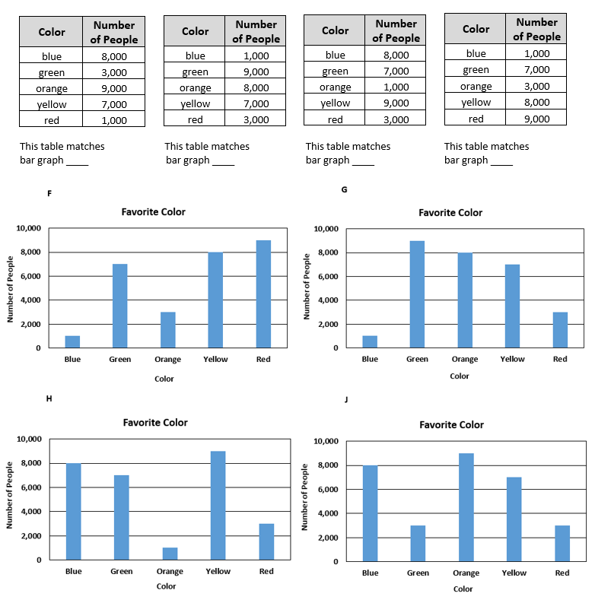
A common error some students may make would be to look at one piece of data in the table and not follow through to make sure all the bars in the graph match all the data in the table. Two tables have 8,000 people for Blue; some students may select graph H and assume that all other values match. It is important for students to know that the bar graph must match all data represented in the table. It might be helpful to have students examine all the data values in the table to make an appropriate match to the same data represented in a bar graph.
Some students may not be able to determine the value when the bar height is between two intervals. For example, in bar graph F, the green bar is between six thousand and eight thousand people. Some students may not understand if the bar height is in the middle between six thousand and eight thousand, it represents seven thousand. It may be beneficial for students to think of the vertical axis as a number line. A discussion of the interval used and the numbers missing would benefit students.

3. Two students, Marissa and Tommy, each created a bar graph to show the same data as this pictograph.
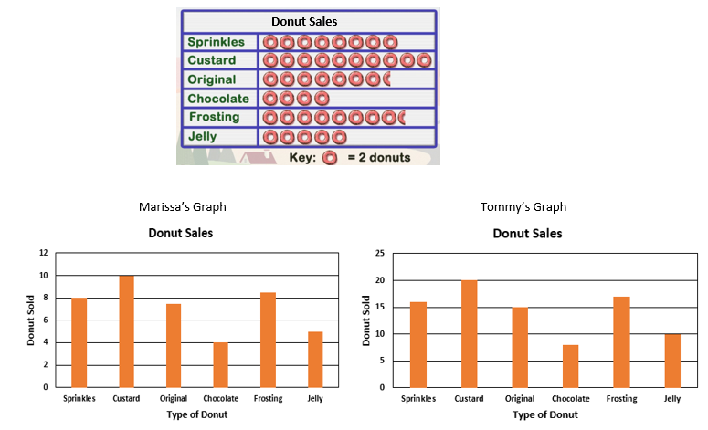

a. Which student correctly made a bar graph using the same data from the pictograph?
b. Explain what the other student did incorrectly when making their bar graph.

A common misconception some students may have is to look at the two graphs and observe that since the relative bar heights are the same the graphs are identical. This may indicate that the student does not understand how to interpret the key provided with the pictograph. It also may indicate that a student is not aware that the increments on the vertical axes are different for the two graphs. Marissa’s graph did not take into account the key provided with the pictograph and she counted each donut in the pictograph as one donut instead of two.
It may be helpful for teachers to ask students to explain how they compare data in two different representations. Some students may struggle with communicating their mathematical thinking and will benefit from hearing peers’ responses when comparing data. This method will allow teachers to determine student errors and provide feedback as needed.

4. Use the bar graph to answer part a and b.
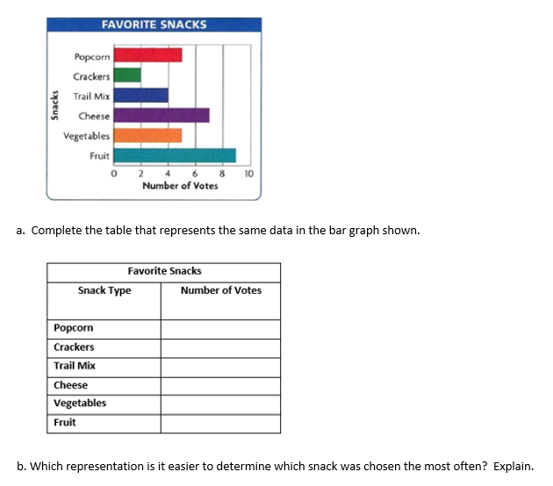

Some students may not have experience with horizontal bar graphs. Teachers may wish to show students a horizontal and vertical bar graph representing the same data set.
The ranges on the horizontal axis are in increments of two; some students may have difficulty determining the answer for popcorn, cheese and vegetables. Students who do not understand the increments may express the answer as a decimal rather than a whole number.
Student responses will vary as to which representation is easier to determine which snack was chosen most often. Asking students to explain their answer will provide insight as to what they are thinking.

