Just In Time Quick Check

Standard of Learning (SOL) 4.14a
Strand: Probability and Statistics

Standard of Learning (SOL) 4.14a
The student will collect, organize, and represent data in bar graphs and line graphs.

Grade Level Skills:
- Collect data, using, for example, observations, measurement, surveys, scientific experiments, polls, or questionnaires.
- Organize data into a chart or table.
- Represent data in bar graphs, labeling one axis with equal whole number increments of one or more (numerical data) (e.g., 2, 5, 10, or 100) and the other axis with categories related to the title of the graph (categorical data) (e.g., swimming, fishing, boating, and water skiing as the categories of “Favorite Summer Sports”).
- Represent data in line graphs, labeling the vertical axis with equal whole number increments of one or more and the horizontal axis with continuous data commonly related to time (e.g., hours, days, months, years). Line graphs will have no more than 10 identified points along a continuum for continuous data.
- Title the graph or identify an appropriate title. Label the axes or identify the appropriate labels.
Just in Time Quick Check
Just in Time Quick Check Teacher Notes

Supporting Resources:
- VDOE Mathematics Instructional Plans (MIPS)
  - 4.14abc - Analyzing Temperature Data (Word) / (PDF)
  - 4.14abc - Statistics: Sandwich Data (Word) / (PDF)
- VDOE Co-Teaching Mathematics Instruction Plans (MIPS)
  - 4.14a - Collecting Data for Bar Graphs and Line Graphs (Word) / (PDF)
- VDOE Word Wall Cards: Grade 4 (Word) | (PDF)
  - Bar Graph
  - Line Graph
- VDOE Algebra Readiness Remediation Plans
  - 4.14ab (Word) / PDF
Supporting and Prerequisite SOL: 3.15a, 2.15a

SOL 4.14a - Just in Time Quick Check

Use the following information for questions 1 and 2.

Mrs. Moore’s class sold cookies at the school bake sale to raise money for a field trip. Jeffery sold 50 cookies, Marcus sold 10 cookies, Matt sold 90 cookies, Jessica sold 10 cookies, Parker sold 80 cookies, and Ebony sold 25 cookies.

- Use this data to complete the data table below.

Cookies Sold
Student | Number of cookies Sold

- Use the blank bar graph below and the completed “Cookies Sold” data table to create a bar graph that correctly displays all of the data shown in the table.
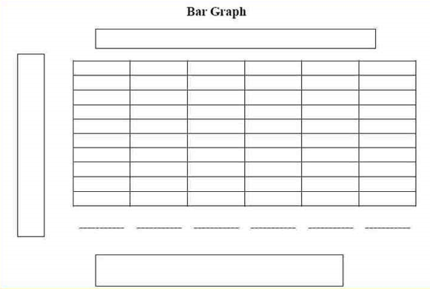

- Tim wanted to make a graph that shows the height of a plant each day after planting a seed. After Tim planted the seed, he recorded the height, in inches, of the plant each day for 6 days. His data is shown in the table. What type of graph can best be used to represent Tim’s data?

Day | Height (inches)
1 | 0
2 | 0
3 | 2
4 | 3
5 | 5
6 | 6

4. Tim planted a seed and recorded the height, in inches, of the plant each day for 6 days. His data is shown in the table. Create a line graph that correctly displays the data shown in the table to represent the height of the plant for each of the 6 days after Tim planted the seed.

Day | Height (inches)
1 | 0
2 | 0
3 | 2
4 | 3
5 | 5
6 | 6

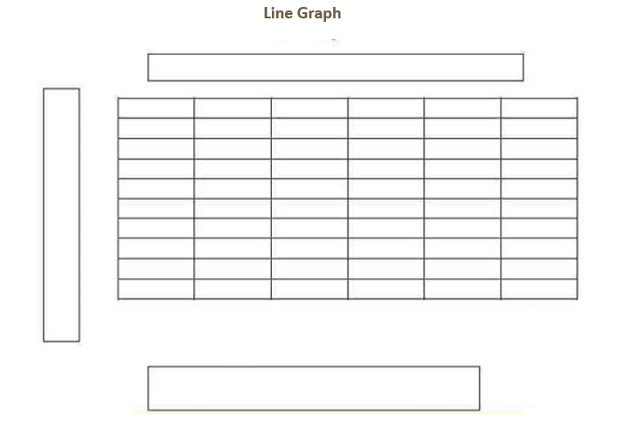

SOL 4.14a - Just in Time Quick Check Teacher Notes
Common Errors/Misconceptions and their Possible Indications
Use the following information for questions 1 and 2.

Mrs. Moore’s class sold cookies at the school bake sale to raise money for a field trip. Jeffery sold 50 cookies, Marcus sold 10 cookies, Matt sold 90 cookies, Jessica sold 10 cookies, Parker sold 80 cookies, and Ebony sold 25 cookies.

- Use this data to complete the data table below.

Cookies Sold
Student | Number of cookies Sold
Some students may struggle with organizing the given data into the table. Encourage students to examine and organize the data using a strategy such as crossing out data as they record it in the table. Some students may benefit color coding each person and using that same color to complete the table. Students should review the table and make sure the table is correct before attempting to graph the data.

- Use the blank bar graph below and the completed “Cookies Sold” data table to create a bar graph that correctly displays all of the data shown in the table.

There are several misconceptions a student may have when appropriately graphing the given data. One misconception that students may have is determining which graph type-if not given (Bar Graph or Line Graph) to use to represent given data. This may indicate that the student does not know when to use each type of graph based on the data that they are trying to represent. Exposure to different examples of bar graphs that represent different types of categorical data will increase a student’s knowledge of when a bar graph is appropriate.

Some students may struggle with labeling each axis based on the given data. This likely indicates that the student is not familiar with how the data is organized and represented. The teacher should review how to label each part of the graph (the horizontal and vertical axis, the categories, and the title) so the graph can be easily interpreted.
Some students may have trouble determining the appropriate increment to use based on the data given or collected. It might be helpful for a teacher to review data that is recorded in increments of whole numbers, usually 1, 2, 5, 10, or 100. The student would benefit from determining the appropriate increment based on the scale of multiple sets of data. Similarly, the student may begin the scale with the first quantity of data (10 based on the data represented in this graph), rather than zero.

Since the most appropriate increment for this graph is multiples of 10, a student may have trouble graphing the amount of cookies sold by Ebony (25). This may indicate that the student has trouble representing numbers that are not an exact value of the increment used. Have a student use a number line to locate where the number 25 would be graphed.

- Tim wanted to make a graph that shows the height of a plant each day after planting a seed. After Tim planted the seed, he recorded the height (in inches) of the plant each day for 6 days. His data is shown in the table. What type of graph can best be used to represent Tim’s data?
Day | Height (inches)
1 | 0
2 | 0
3 | 2
4 | 3
5 | 5
6 | 6

Students often have trouble determining which graph type (Bar Graph or Line Graph) to use to represent given data. This may indicate that the student does not know when to use each type of graph based on the data that they are trying to represent. Expose students to different examples of line graphs that show how one variable changes over time. This will increase a student’s knowledge of when a line graph is appropriate.

- Tim planted a seed and recorded the height, in inches, of the plant each day for 6 days. His data is shown in the table. Create a line graph that correctly displays the data shown in the table to represent the height of the plant for each of the 6 days after Tim planted the seed.

Day | Height (inches)
1 | 0
2 | 0
3 | 2
4 | 3
5 | 5
6 | 6

A common misconception some students may have when representing data, specifically in line graphs, is they may begin graphing the data directly on the vertical axis rather than beginning above the first horizontal label. This may indicate that students are having difficulty determining how to display the data that changes continuously over time. Encourage students to line up their plotted data directly above the horizontal axis in which they are graphing and that it correlates vertically with the increments used. Help students make the connection between points on a number line and points on a coordinate plane. Then connect the points to form a line graph. Encourage students to focus on the difference between looking at data represented by separate points on a coordinate plane and the same data points connected with a line. Emphasize how the line can help them notice trends and lead to inferences about the data. Dividing the process into steps can help students be more successful creating a line graph.

Students may also struggle with labeling each axis based on the data given. This likely indicates that the student is not familiar with how the data is organized and represented in a line graph. The teacher should review how to label each part of the graph so that the graph is easily interpreted. Students commonly confuse the labels for the horizontal and vertical axis. This indicates a misunderstanding that the vertical axis should be labeled with the range of values in the collected data set at the given time interval on the horizontal axis, and the horizontal axis with continuous data, commonly related to time. The student would benefit from exposure to examples of line graphs appropriately representing a variety of data. The teacher should focus on the labels of the graph and how they are crucial to correctly interpreting the line graph.

