Just In Time Quick Check

Standard of Learning (SOL) 4.13b

Strand: Probability and Statistics

Standard of Learning (SOL) 4.13b
The student will represent probability as a number between 0 and 1, inclusive.

Grade Level Skills:
- Write the probability of a given simple event as a fraction, where there are no more than 24 possible outcomes.
- Determine the likelihood of an event occurring and relate it to its whole number or fractional representation (e.g., impossible or zero; equally likely; certain or one).
Just in Time Quick Check
Just in Time Quick Check Teacher Notes

Supporting Resources:
- VDOE Mathematics Instructional Plans (MIPS)
  - 4.13ab-Probabilty- How Certain Are You? (Word) / (PDF Version)
  - 4.13ab- Probability: Spinning Color (Word)/ (PDF)
  - 4.13abc -Probability: Sweet as Candy (Word)/ (PDF)
- VDOE Word Wall Cards: Grade 4 (Word) / (PDF)
  - Probability Number Line
  - Certain
  - Likely
  - Unlikely
  - Equally Likely
  - Impossible
- Desmos Activity
  - Chance Experiments
Supporting and Prerequisite SOL: 4.13a, 3.14, 2.14

SOL 4.13b - Just in Time Quick Check
- Label the number line with the probability terms certain, likely, equally likely, unlikely, and impossible.

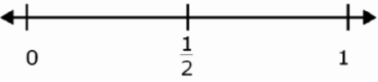

- Locate the probability of each event described on the number line. Write the letter of the event where you think it belongs on the number line.

- A coin with one side heads and one side tails will land on heads.
- You will have one birthday each year.
- You roll a fair number cube with faces labeled 1 through 6 and get a number less than 2.
- On your way home from school you will see a live dinosaur.
- You pull a yellow tile from a bag containing 1 blue tile and 9 yellow tiles.

- Mia has a spinner with eight equal sections as shown.

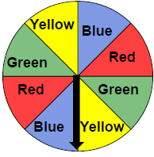

Mia will spin the arrow on the spinner one time. What is the probability the arrow will land on a blue or green section? Write the probability as a fraction on the number line.
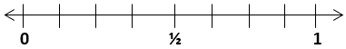

- Hayden has a fair coin with one side heads and one side tails. Which letter on this number line best represents the probability that this coin flipped one time will land with tails facing up? How would you describe this using a probability term?

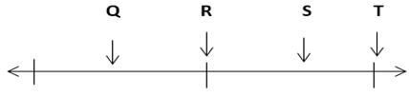
1
0
1/2

- Austin will roll a fair number cube that has faces labeled 1 through 6. Place a point on the number line to represent the probability that Austin will roll a number greater than 3. Write the probability term that describes the chance of rolling a number greater than 3.

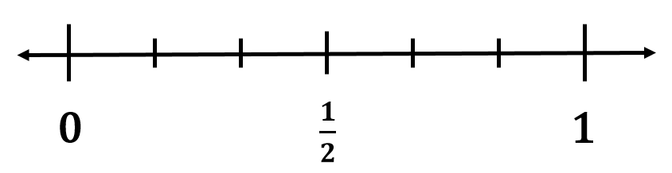

SOL 4.13b - Just in Time Quick Check Teacher Notes
Common Errors/Misconceptions and their Possible Indications
- Label the number line with the probability terms certain, likely, equally likely, unlikely, and impossible.
A student may struggle with correctly representing probability on a number line if they lack understanding of the vocabulary terms associated with probability. This may indicate that a student does not understand why each term is located at the appropriate place on the number line. Manipulatives such as color tiles, number cubes, and spinners can be used to promote concrete understanding, as well as situational examples. For example, a student may not understand that an event is “certain” until they are given a concrete representation or model of a situation in which that is the outcome. They may also have trouble understanding that “certain” means the fraction is represented as the whole number 1 on the number line. The same issue may arise for an outcome that is “impossible” – students may have difficulty understanding that “impossible” is represented as zero on the number line. Provide plenty of opportunities for students to conduct probability experiments and become familiar with the terms associated with probability for this grade level.

- Locate the probability of each event described on the number line. Write the letter of the event where you think it belongs on the number line.

- A coin with one side heads and one side tails will land on heads.
- You will have one birthday each year.
- You roll a fair number cube with faces labeled 1 through 6 and get a number less than 2.
- On your way home from school you will see a live dinosaur.
- You pull a yellow tile from a bag containing 1 blue tile and 9 yellow tiles.

A common misconception some students may have is knowing how to determine the number of favorable outcomes and total number of possible outcomes of each simple event described. This may indicate that some students struggle with writing a fraction to describe the likelihood of an event. Provide students with different examples so that they can describe the likelihood of multiple events.
A student may not be able to measure the probability of each event. Factors such as not understanding the statement or difficulty with reading comprehension may contribute to difficulty with questions like these. Encourage the student to read each statement carefully and highlight important words. Provide students with a variety of manipulatives (number cubes, coins, color tile, etc.) and opportunities to conduct their own probability experiments. Model how to record results as fractions.
- Mia has a spinner with eight equal sections as shown.
Mia will spin the arrow on the spinner one time. What is the probability the arrow will land on a blue or green section? Write the probability as a fraction on the number line.
A common error some students may make is to not use the total of blue and green sections to represent the number of favorable outcomes (numerator) to get a fraction of $\frac{4}{8}$. This may indicate that a student does not understand that blue or green represents all of the sections labeled blue and green. A student would benefit from the use of manipulatives to show that more than one outcome can be included in the number of favorable outcomes.
A student may not understand that $\frac{4}{8}$ is equivalent to $\frac{1}{2}$. Provide students with manipulatives and fraction tiles to understand equivalency if needed. Guide students to understand that the whole number (1) on the number line would represent a combination of red, green, blue, and yellow as outcomes. Help them recognize that the total number of possible outcomes represents the denominator. Emphasize the difference between using the word “or” and the word “and” in a question stem. The word “or” in the question means they have the option of blue or green, whereas the word “and” would mean the outcome would have to include both blue and green.
A student may have difficulty pulling out both the green and blue fractional parts to determine the total of each because they are separated on the spinner. Provide opportunities for students to use spinners and act out the problem. Students can use manipulatives, number the sections on the spinner, and even cut out a spinner to visualize the parts.
- Hayden has a fair coin with one side heads and one side tails. Which letter on this number line best represents the probability that this coin flipped one time will land with tails facing up? How would you describe this using a probability term?
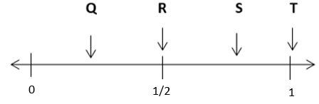

Students may have difficulty with probability on a number line due to a lack of fractional understanding and number sense. Ensure that students understand what each letter on the number line represents as a fraction and have them record the fraction for each letter on the number line. It may be necessary to revisit how these fractions relate to the benchmarks of 0, $\frac{1}{2}$, and 1. Discuss the relationship between these fractional benchmarks and probability – for example, ask students “If there are zero chances that something will happen, how would you describe that in terms of probability?” and “What if something is certain to happen, how would you represent that as a fraction?” Students may need additional support to understand that an event that is “certain” is represented as (1) on a number line.
A student may not understand that there are only two possible outcomes for flipping a coin: the coin can land heads up, or the coin can land tails up. They may not understand that the two are equally likely and can be represented by the fraction $\frac{1}{2}$. Provide the students with a coin as a manipulative and the opportunity to conduct their own investigations. Model for students how to record results as fractions.

5. Austin will roll a fair number cube that has faces labeled 1 through 6. Place a point on the number line to represent the probability that Austin will roll a number greater than 3. Write the probability term that describes the chance of rolling a number greater than 3.

Students may not have an understanding that the denominator represents the number of differently labeled faces on the number cube. Provide students with manipulatives and opportunities to conduct their own investigations to assist with the understanding that the number of rolls is represented by the numerator.
Students may not have an understanding that the numbers greater than 3 are 4, 5, and 6 therefore, may not be able to represent the probability as the fraction $\frac{3}{6}$ . They may also lack the understanding of equivalent fractions and may have trouble understanding where $\frac{3}{6}$ lies on the number line in relation to $\frac{1}{2}$. Provide the students with fraction manipulatives and opportunities to represent equivalent fractions and then place them on a number line. (Note that students in grade 4 are not expected to simplify fractions in probability situations.)

