Just In Time Quick Check

Standard of Learning (SOL) 4.8d

Strand: Measurement and Geometry

Standard of Learning (SOL) 4.8d
The student will solve practical problems that involve length, weight/mass, and liquid volume in U.S. Customary units.

Grade Level Skills:
- Solve practical problems that involve length, weight/mass, and liquid volume in U.S. Customary units.
Just in Time Quick Check
Just in Time Quick Check Teacher Notes

Supporting Resources:
- VDOE Mathematics Instructional Plans (MIPS)
  - Liquid Volume: It's My Party (Word / PDF)
- VDOE Word Wall Cards: Grade 4 Word / PDF
  - Ounces
  - Pounds
  - Inches
  - Feet
  - Yards
  - Miles
  - Cups
  - Pints
  - Quarts
  - Gallons
- VDOE Instructional Videos for Teachers
  - Converting Units (grades 3-8)
  - Liquid Measure (grades 4-8)
Supporting and Prerequisite SOL: 4.8a, 4.8b, 4.8c, 3.7a, 3.7b, 2.8a, 2.8b

SOL 4.8d - Just in Time Quick Check

1 yard = 3 feet

A school cafeteria is 18 yards wide. This cafeteria is exactly __________ feet wide.

4 cups = 1 quart

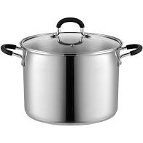
This pot holds 8 quarts of soup. This pot can hold exactly __________ cups of soup.

1 gallon = 8 pints

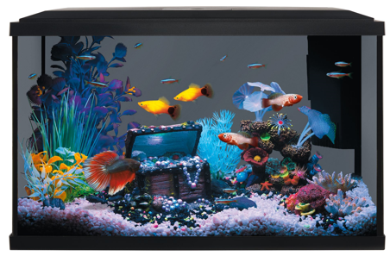

Amy filled her aquarium with 96 pints of water. How many gallons of water did she use?

- Measure the length of the basket to the nearest inch.

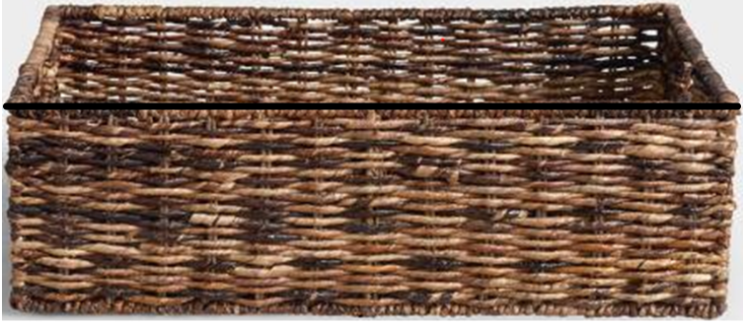

Ms. Jones will place five baskets end to end, without overlapping, on her shelf. What is the minimum length of this shelf in order to hold five baskets end to end?

SOL 4.8d - Just in Time Quick Check Teacher Notes
Common Errors/Misconceptions and their Possible Indications

1 yard = 3 feet

A school cafeteria is 18 yards wide. This cafeteria is exactly __________ feet wide.

A common misconception some students may have is to state the equivalency is equal to 6 feet. This may indicate that a student thinks the conversion from yards to feet is established by dividing by 3 instead of multiplying by 3. Teachers may wish to have students practice with friendly equivalencies to familiarize students with these relationships. Teachers may consider using concrete manipulatives to support students with the visualization of this concept.

4 cups = 1 quart

This pot holds 8 quarts of soup. This pot can hold exactly __________ cups of soup.

A common misconception some students may have is to reverse the equivalent relationship between cups and quarts. This may indicate that a student thinks that 8 quarts is equivalent to 2 cups. Teachers may wish to have students practice with equivalency tables and have students physically pour liquids to check for accuracy. Teachers may also wish to support students in finding patterns and rules in equivalency tables.

1 gallon = 8 pints

Amy filled her aquarium with 96 pints of water. How many gallons of water did she use?

A common misconception some students may have is difficulty converting from a smaller unit of measurement to larger unit of measurement. This may indicate that a student uses the inverse relationship when converting from a smaller unit of measurement to a larger unit of measurement. Teachers may wish to have students explore the relationship between pints and gallons by pouring smaller containers of liquid into larger containers to demonstrate the equivalent conversion of the larger unit.

- Measure the length of the basket to the nearest inch.
Ms. Jones will place five baskets end to end, without overlapping, on her shelf. What is the minimum length of this shelf in order to hold five baskets end to end?

A common error some students may have is using a measuring device accurately to determine the length of the basket shown. This may indicate that a student has difficulty measuring to the nearest inch using an inch ruler. Additionally, some students may have difficulty combining the measurements to find the equivalent length of five baskets. Teachers may wish to expose students to these types of problems to build a stronger foundation. Also, teachers may consider the use of Unifix cubes or other manipulatives to provide the opportunity for students to conceptualize the length of more than one object.

