Just In Time Quick Check

Standard of Learning (SOL) 4.8b

Strand: Measurement and Geometry

Standard of Learning (SOL) 4.8b
The student will estimate and measure weight/mass and describe the result in U.S. Customary and metric units.

Grade Level Skills:
- Determine an appropriate unit of measure (ounce, pound, gram, and kilogram) to use when measuring the weight/mass of everyday objects in both U.S. Customary and metric units.
- Estimate and measure the weight/mass of objects in both U.S. Customary and metric units (ounce, pound, gram, or kilogram) to the nearest appropriate measure, using a variety of measuring instruments.
- Record the weight/mass of an object with the unit of measure (e.g., 24 grams).
Just in Time Quick Check
Just in Time Quick Check Teacher Notes

Supporting Resources:
- VDOE Mathematics Instructional Plans (MIPS)
  - Fruit Basket Measurement (Word / PDF)
  - Measuring Weight/Mass (Word / PDF)
- VDOE Algebra Readiness Remediation Plans
  - Measurement Bingo (Word / PDF)
- VDOE Word Wall Cards: Grade 4 Word / PDF
  - Balance Scale
  - Scale
  - Ounce
  - Pound
  - Gram
  - Kilogram
Supporting and Prerequisite SOL: 2.8b

SOL 4.8b - Just in Time Quick Check

- Which unit of measure is most appropriate to determine the weight of one feather: ounces or pounds?

____________________

- Which unit of measure is most appropriate to determine the mass of a chair: grams or kilograms?

____________________

- Look at the balance scale below. The square has a mass of six grams.
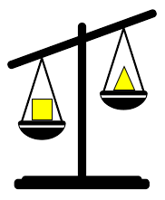
Estimate the mass of the triangle. Explain your thinking.

__________________________________________________________________________________

__________________________________________________________________________________

__________________________________________________________________________________

__________________________________________________________________________________

__________________________________________________________________________________

- The scale below holds fruit.

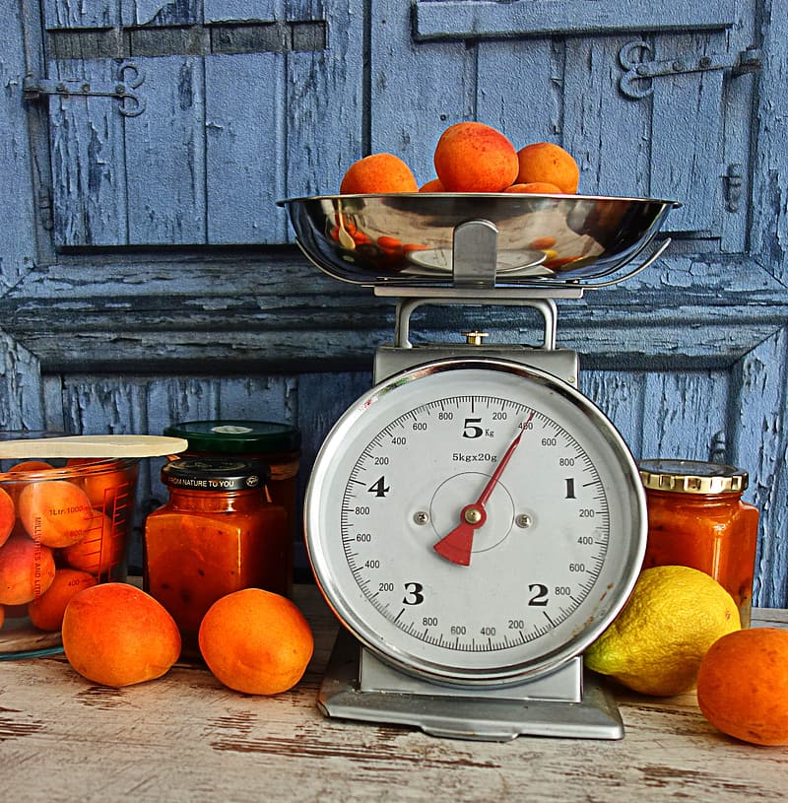

What is the mass, in grams, of the fruit that is shown in the scale? __________

- What is the mass, in grams, of the phone shown below? __________

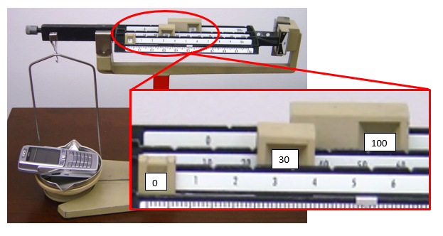

- Estimate and measure the weight/mass of the objects. Record your estimate and the actual weight/mass in the tables below.

Object | U.S. Customary Ounces/Pounds | U.S. Customary Ounces/Pounds
 | Estimate | Actual
Calculator
Book
Laptop Computer

Object | Metric System Grams/Kilograms | Metric System Grams/Kilograms
 | Estimate | Actual
Calculator
Book
Laptop Computer

SOL 4.8b - Just in Time Quick Check Teacher Notes
Common Errors/Misconceptions and their Possible Indications

- Which unit of measure is most appropriate to determine the weight of one feather: ounces or pounds?

____________________

Some students may have difficulty with choosing ounces or pounds because they are unfamiliar with the units of measure. This may indicate that a student has had limited exposure or opportunities to explore these measures. Teachers may wish to have students explore with hands on experiences, examples of objects that weigh about an ounce and about a pound to help create benchmarks. Teachers may also wish to compare items that are more than one of each unit, like 6 pounds versus 6 ounces. With more experiences to weigh objects in ounces and pounds students will make more informed estimates and choose appropriate unit of measures.

- Which unit of measure is most appropriate to determine the mass of a chair: grams or kilograms?

____________________

Some students may have difficulty choosing grams or kilograms because they are unfamiliar with the units of measure. This may indicate that a student has had limited exposure or opportunities to explore these measures involving metric units. This may be especially true for the metric system since metric measurements are not often used outside of school. Teachers may wish to have students explore with hands on experiences, examples of objects whose mass is about a gram or kilogram. Teachers may also wish to compare objects that would best be measured in grams versus kilograms to clear up students’ misconceptions.

- Look at the balance scale below. The square has a mass of six grams.
Estimate the mass of the triangle. Explain your thinking.

A common misconception some students have with balance scales is interpreting which object has the heavier mass. This may indicate that the student thinks the higher side has the larger mass. Students would benefit from hands on experiences of using a balance scale and comparing the objects they put on each side. Some students may have difficulty estimating the mass of the triangle if they are unfamiliar with how to use a balance scale. In addition, some students who are able to visually see that the square is heavier, may have difficulty applying that information in order to make an estimate for the mass of the triangle. Teachers may wish to have students practice making estimates and then use balance scales to find the mass of objects. Comparing their estimate to the actual measurement will assist them in refining their estimation skills.

- The scale below holds fruit.

What is the mass, in grams, of the fruit that is shown in the scale? __________

Some students may have difficulty reading this scale because it is in grams and kilograms instead of pounds and ounces. This might indicate that a student may confuse the smaller gram markings with the larger kilogram markings leading to an incorrect mass measurement. Teachers may wish to expose students to many different types of scales for ounces, pounds, grams, and kilograms so that they are able to explore how they are marked, enabling them to accurately determine the weight/mass of an object(s) place in a scale.

- What is the mass, in grams, of the phone shown below? __________
Some students may have difficulty adjusting the weights on this scale to determine an accurate mass. This may indicate a lack of exposure to using a measuring instrument similar to this. Students that successfully balance this scale may have difficulty with combining the gram mass amounts. Teachers may wish to give students opportunities to practice using this type of scale or a variety of measuring instruments with objects of different masses.

- Estimate and measure the weight/mass of the objects. Record your estimate and the actual weight/mass in the tables below.

Object | U.S. Customary Ounces/Pounds | U.S. Customary Ounces/Pounds
 | Estimate | Actual
Calculator
Book
Laptop Computer

Object | Metric System Grams/Kilograms | Metric System Grams/Kilograms
 | Estimate | Actual
Calculator
Book
Laptop Computer

Some students may have difficulty choosing a reasonable estimate due to lack of exposure. Students need many opportunities to estimate and find the mass/weight of objects in order to help refine their estimation skills. In addition, students should have practice with various types of measuring instruments to find the weight/mass of objects in order to explore strategies that might be needed to read them accurately.

