Just In Time Quick Check

Standard of Learning (SOL) 4.7
Strand: Measurement and Geometry

Standard of Learning (SOL) 4.7
The student will solve practical problems that involve determining perimeter and area in U.S. Customary and metric units.

Grade Level Skills:
- Determine the perimeter of a polygon with no more than eight sides, when the lengths of the sides are given, with diagrams.
- Determine the perimeter and area of a rectangle when given the measure of two adjacent sides, with and without diagrams.
- Determine the perimeter and area of a square when the measure of one side is given, with and without diagrams.
- Solve practical problems that involve determining perimeter and area in U.S. Customary and metric units.
Just in Time Quick Check
Just in Time Quick Check Teacher Notes

Supporting Resources:
- VDOE Mathematics Instructional Plans (MIPS)
  - 4.7 - Will the Tablecloth Fit? (Word) / PDF Version
- VDOE Algebra Readiness Remediation Plans
  - Finding Area and Perimeter / PDF
- VDOE Word Wall Cards: Grade 4 (Word) | (PDF)
  - Perimeter
  - Area
- VDOE Instructional Videos for Teachers
  - Units of Measure (grades 4-8)
- Desmos Activity
  - Area and Perimeter of Rectangles and Squares
Supporting and Prerequisite SOL: 4.4a, 4.4b, 4.4d, 4.8a, 3.7a, 3.8a, 3.8b, 2.8a

SOL 4.7 - Just in Time Quick Check

- Determine the perimeter of the following polygons:

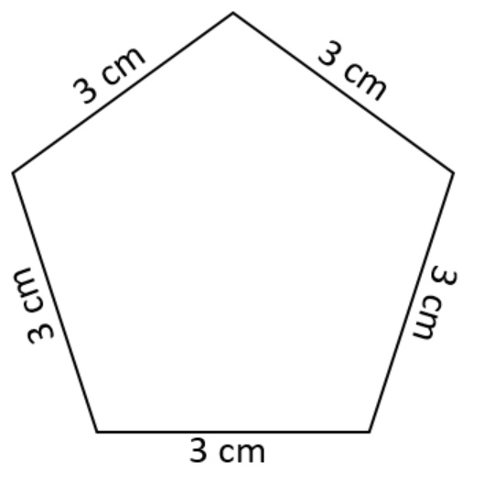 Perimeter __________________________
b.
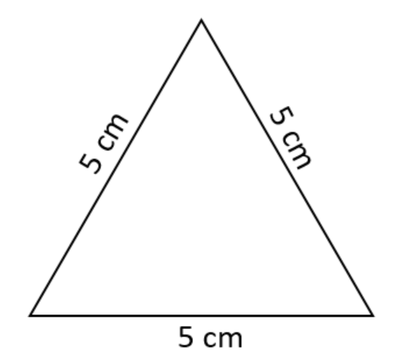 Perimeter ___________________________
c.
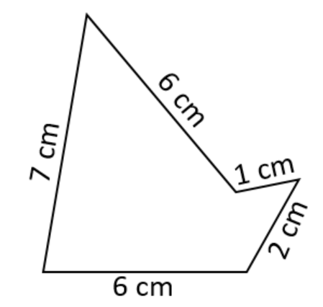Perimeter ___________________________

- Determine the perimeter and area of the rectangle.

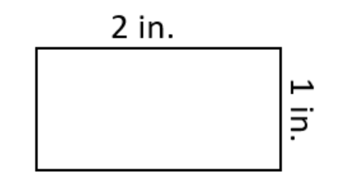

Perimeter ________________________ Area_____________________________
- Determine the perimeter and area of a square with a side that measures 6 ft.
Perimeter ________________________ Area_____________________________

- Sandra buys a rectangular rug for her bedroom. The rug has a width of 15 ft. and length of 24 ft. What is the area of the rug?

- Mario wants to put a fence around part of his yard. He wants the area inside the fence to be 48 square feet. What could be the dimension(s) of the fenced area? Draw the figure and label the dimensions.

SOL 4.7 - Just in Time Quick Check Teacher Notes
Common Errors/Misconceptions and their Possible Indications

- Determine the perimeter of the following polygons:

Perimeter __________________________
b.
Perimeter ___________________________
c.
Perimeter ___________________________

Some students may have difficulty due to the lack of understanding the word “perimeter.” These students will benefit from more experience with practical problems that involve finding the perimeter of a figure. Teachers may wish to use manipulatives to provide a visual representation of perimeter and area, as vocabulary may be an obstacle for some students when working within the geometry strand. Incorporating the vocabulary associated with measurement into classroom discussions, as well as utilizing anchor charts and/or the VDOE word wall cards, may assist students with conceptualizing the vocabulary.
Some students may struggle with the computation of the perimeter. They may make computation errors when adding 3 + 3 + 3 + 3 + 3 or multiplying 3 cm by 5 sides (or 5 + 5 + 5 or multiplying 5 cm by 3 sides). Students will benefit from hearing peers’ strategies for determining perimeter and exposure to their systems for keeping track and combining the measures of multiple sides. Some students may calculate the perimeter correctly but leave off the unit of measure. It is important for students to label the measurements with the correct unit. Provide students with hands-on opportunities to measure objects to build the connection that perimeter and area are types of measurements.

- Determine the perimeter and area of the rectangle.

Perimeter __________________________
Area ______________________________
Some students who obtain 3 inches as their answer when solving for perimeter may not understand the characteristics of a rectangle. Students may not recall that opposite sides of a rectangle are congruent. Teachers may wish to have students label each side of their rectangle with the appropriate measurements.
Students who obtain 2 inches as their answer may not have conceptualized the difference between perimeter and area. The underlying concept that perimeter is a length measurement and area is a space measurement can sometimes create confusion. Teachers may wish to have students count the number of squares within a figure (as they did in grade 3) to reinforce the connection between square units and area. More experiences with practical problems involving area and perimeter may be beneficial.
- Determine the perimeter and area of a square with a side that measures 6 ft.
Perimeter __________________________
Area ______________________________
Some students may not understand the characteristics of a square, or they may struggle when a labeled diagram is not provided. Students may not recall that all sides of a square are congruent. Teachers may wish to have students draw and label each side of the square with the appropriate measurements to reinforce this characteristic. When solving for the area of a square, some students may multiply 6 ft by 4 instead of 6 ft by 6 ft. Teachers may wish to have students use grid paper and count the number of squares needed to cover the space inside the square to support conceptual understanding of area and the attributes of the unit of measure.
- Sandra buys a rectangular rug for her bedroom. The rug has a width of 15 ft. and length of 24 ft. What is the area of the rug?
Students who confuse perimeter and area may find the perimeter of the rug, rather than the area. Teachers may wish to encourage students draw and label the dimensions of the rectangular rug before attempting to solve the problem to assist the students in visualizing what is being asked. Additionally, engaging students in discussions about real life applications of perimeter and area will assist students in understanding the difference between area and perimeter.
- Mario wants to put a fence around part of his yard. He wants the area inside the fence to be 48 square feet. What could be the dimension(s) of the fenced area? Draw the figure and label the dimensions.
This question requires students to work backwards from knowing the area to finding the dimensions of a specified area. Students may not recognize that they need to use factor pairs of a number (i.e., factor pairs of 48 in the given problem) in order to find the dimensions of the area. Some students may also struggle with finding an answer when there is more than one correct solution. Teachers may wish to encourage students to create the figure on grid paper to assist them with finding a solution.
Alternatively, teachers may also encourage students to investigate situations in which students must find the length and width for a given perimeter. These investigations, coupled with class discussions of students’ strategies, findings, and observations during these explorations, may be beneficial.

