Just In Time Quick Check

Standard of Learning (SOL) 4.6a
Strand: Computation and Estimation

Standard of Learning (SOL) 4.6a
The student will add and subtract decimals.

Grade Level Skills:
- Estimate sums and differences of decimals
- Add and subtract decimals through thousandths, using concrete materials, pictorial representations, and paper and pencil.
Just in Time Quick Check
Just in Time Quick Check Teacher Notes

Supporting Resources:
- VDOE Mathematics Instructional Plans (MIPS)
  - 4.6ab - Decimal Sums and Differences (Word) and PDF Version
- VDOE Word Wall Cards: Grade 4 (Word and PDF)
  - Decimal Place Value Position
  - Addition
  - Subtraction
- Desmos Activity
  - The Decimal Challenge
Supporting and Prerequisite SOL: 4.3a, 4.4b, 3.3a, 2.6a, 2.6b

SOL 4.6a - Just in Time Quick Check

- What is the difference between 12 and 2.803?

- Solve the problem shown.

5.045 + 18.9

- This model is shaded to represent one whole.

Model 1 and Model 2 are shaded to represent a decimal.
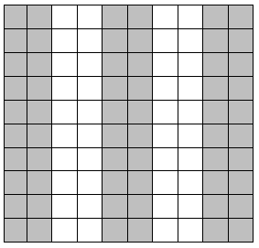
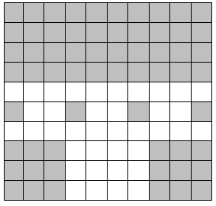

Model 1 Model 2

What is the sum of Model 1 and Model 2?

- A teacher asked three students to estimate the sum of this problem.

13.98 + 7.3

  - Student A stated that the estimated sum was 15.
  - Student B stated that the estimated sum was 21.
  - Student C stated that the estimated sum was 84.

Explain which student has the best estimate and why.

- This model represents one whole.
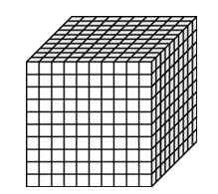

What is the difference between Model 1 and Model 2?

Model 1 Model 2

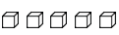
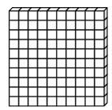
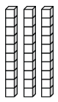

SOL 4.6a - Just in Time Quick Check Teacher Notes
Common Errors/Misconceptions and their Possible Indications

- What is the difference between 12 and 2.803?

A common misconception when subtracting a decimal from a whole number is not understanding the location of the decimal point in a whole number. Some students will place the decimal point before the whole number creating the number 0.12 while other students will place the decimal point in any location, thereby still changing the value of the number. Models will be beneficial to help students apply the concept of decimal number sense when adding or subtracting numbers.

When subtracting with different numbers of digits, some students will line up the decimal point or add zeros to help with place value. This strategy can be useful for some students, but it is important for students to understand the basis of the algorithm and make sense of adding and subtracting digits of like place values.

Another common misconception is understanding how to subtract with regrouping. When solving this problem, some students will subtract 12.000 – 2.803 getting a difference of 10.803. These students would benefit from the use of models such as base ten blocks. When modeling with base ten blocks it is always important for students to identify the whole. Using manipulatives, along with place value mats, will be necessary when modeling this problem. Students should also explore using pictorial representations such as decimal grids and number lines when solving computation problems.

When adding or subtracting, students should also estimate prior to solving the problem to check for the reasonableness of their answers. When estimating this particular problem, students should identify that the decimal 2.803 is close to 3, therefore the difference should be around 9.

- Solve the problem shown.

5.045 + 18.9

A common misconception for some students when solving the problem with a traditional algorithm is to line the numbers up with a right alignment disregarding the decimal point. An example of this misconception is shown.

5.045
+ 18.9

These students are adding different place values together, obtaining a sum of 5.234, and their answer is not reasonable. These students would benefit from modeling using base 10 blocks. Modeling will provide students with a visual of the related place values of each number, and the importance of combining like place values, tenths, hundredths, etc. Using a place value chart is another strategy to assist students in understanding the value of each digit and the significance of the decimal location.

Prior to finding the sum, it is important for students to apply estimation strategies. When estimating this particular problem, 5.045 is close to 5 and 18.9 is close to 19, therefore the sum is around 24. When estimating the sum, students can use their estimation to check for the reasonableness of their answers. It is important for students to explore a variety of different representations to develop a conceptual understanding of decimal computation prior to solving problems procedurally.
- This model is shaded to represent one whole.

Model 1 and Model 2 are shaded to represent a decimal.

Model 1 Model 2

What is the sum of Model 1 and Model 2?

A common misconception when adding or subtracting decimals with pictorial representations is being able to identify the whole. Some students are unable to understand that the base ten model of the 10 x 10 grid (also known as a flat) represents one whole; therefore, one rod is a tenth and the unit represents a hundredth. In this particular problem, Model 1 represents a decimal that is less than a whole, and Model 2 represents a decimal that is more than a whole.

When identifying the sum of these two models, students must first be able to identify the value of each model. Some students may transfer the whole number value of the flat and read it as one hundred, thinking that Model 2 is 160 instead of 1.6.

Provide students with multiple practice opportunities arranging flats, rods, and units to create decimal numbers in a place value chart based on a teacher-defined whole. It is important for students to also explore a variety of problems with pictorial representations where the whole changes. Presenting various representations, and changing the whole, will allow students to develop a deeper understanding of the concept of decimals.

- A teacher asked three students to estimate the sum of this problem.

13.98 + 7.3

  - Student A stated that the estimated sum was 15.
  - Student B stated that the estimated sum was 17.
  - Student C stated that the estimated sum was 21.

Explain which student has the best estimate and why.

There are several different strategies that students can apply when estimating sums or differences. It is important for students to apply a strategy that would provide a reasonable estimate when solving problems. If a student selected answer choice a, then this student tried to solve the problem by lining up the numbers with a right alignment disregarding the decimal point. An example of this misconception is shown below.

13.98
+ 7.3
14.71

The student most likely rounded 14.71 to 15. In addition to needing additional support using models to identify the value of each digit, this student may need more experiences in terms of why it is important to estimate before finding the exact answer. Rounding the exact answer is not the same as estimating before solving to determine reasonableness.

If a student selected Student B as having the best estimate, then this student rounded 13.98 to 10 and 7.3 to 7, adding 10 + 7 to get an estimated sum of 17. It is important for students to be encouraged to determine the best estimate by applying number sense strategies when estimating. In this case, it would be more appropriate to round to the nearest whole number. Using rods and units to build each number will help students understand why it is would be more appropriate to round to the nearest whole number.

- This model represents one whole.

What is the difference between Model 1 and Model 2?

Model 1 Model 2

A common misconception when adding or subtracting decimals with pictorial representations is being able to identify the whole. In this particular problem, the whole is represented by a cube. When identifying the other base ten models that represent each place value students need to focus on decimal number sense and the relationship among each place value. It is important for students to understand that a tenth is always a tenth of the whole, the hundredth is a hundredth of the whole, and so on. Below is a place value chart and the corresponding base ten blocks when the cube is modeled as a whole.

Base Ten Block Model Representations
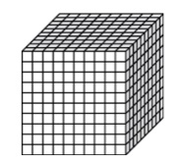
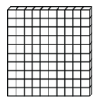

whole tenth hundredth thousandth

It is important to look at students’ work to identify their decimal for each model. For Model 1, some students will assume that the rods represent the tenths place value creating 1.35 instead of the decimal 1.035. The same is true for Model 2- some students will assume that the unit represents the hundredths place creating the number 0.28 instead of the decimal 0.208. If a student is unable to identify the place value representation of each model, then the students will be unable to find the difference between the models. Providing students the opportunity to model decimals given different representations of the whole will help them develop a greater understanding of decimal place values.

