Just In Time Quick Check

Standard of Learning (SOL) 4.13a
Strand: Probability and Statistics

Standard of Learning (SOL) 4.13a
The student will determine the likelihood of an outcome of a simple event.

Grade Level Skills:
- Model and determine all possible outcomes of a given simple event where there are no more than 24 possible outcomes, using a variety of manipulatives (e.g., coins, number cubes, and spinners).
- Determine the outcome of an event that is least likely to occur or most likely to occur where there are no more than 24 possible outcomes.
- Determine the likelihood of an event occurring and relate it to its whole number or fractional representation (e.g., impossible or zero; equally likely; certain or one).
Just in Time Quick Check
Just in Time Quick Check Teacher Notes

Supporting Resources:
- VDOE Mathematics Instructional Plans (MIPS)
  - 4.13ab-Probabilty- How Certain Are You? (Word) / (PDF Version)
  - 4.13ab- Probability: Spinning Color (Word)/ (PDF)
  - 4.13abc -Probability: Sweet as Candy (Word)/ (PDF)
- VDOE Word Wall Cards: Grade 4 (Word) / (PDF)
  - Probability Number Line
  - Certain
  - Likely
  - Unlikely
  - Equally Likely
  - Impossible
- Desmos Activity
  - Chance Experiments
Supporting and Prerequisite SOL: 3.14, 2.14

SOL 4.13a - Just in Time Quick Check

- Jack has 3 green marbles, 4 yellow marbles, and 1 blue marble in a bag. All marbles are the same shape and size. Answer the questions about Jack’s marbles. Model your thinking using a tool or pictures.
  - If Jack chooses a marble from the bag, what are all the possible marble colors he could choose?
  - If Jack chooses a marble from the bag, which color is most likely to be chosen?
  - If Jack chooses a marble from the bag, which color is least likely to be chosen?

- Use the spinner to answer the following questions.
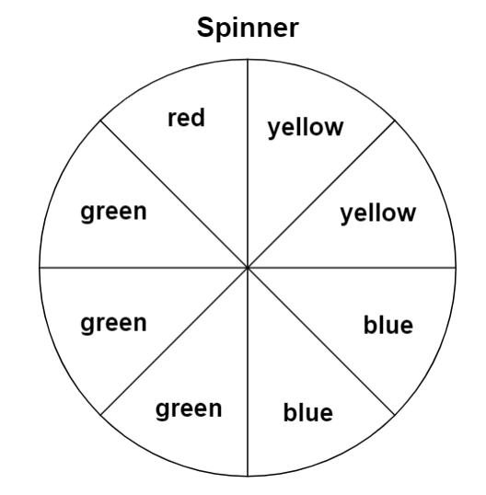

  - When spinning the spinner, which color is it most likely to land on? Explain.
  - When spinning the spinner, which color is it least likely to land on? Explain.
  - Is the spinner equally likely to land on any color? Explain.

- Parker bought a box of 10 cookies. If Parker selects a cookie from the box and it is impossible to select a chocolate chip cookie, how many of the cookies are chocolate chip?

4) What number should be used in the remaining sections to be certain that the same number is spun on every spin?
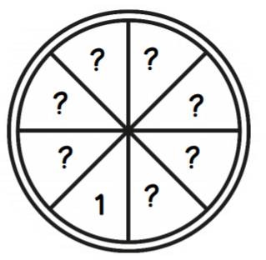

SOL 4.13a - Just in Time Quick Check Teacher Notes
Common Errors/Misconceptions and their Possible Indications
- Jack has 3 green marbles, 4 yellow marbles, and 1 blue marble in a bag. All marbles are the same shape and size. Answer the questions about Jack’s marbles. Model your thinking using a tool or pictures.
  - If Jack chooses a marble from the bag, what are all the possible marble colors he could choose?
  - If Jack chooses a marble from the bag, which color is most likely to be chosen?
  - If Jack chooses a marble from the bag, which color is least likely to be chosen?

A common misconception that some students may have is confusing or not correctly understanding the meaning of the probability terms (certain, likely, unlikely, impossible). Appropriate vocabulary and manipulatives may be used when teaching these terms. A student may benefit from practice demonstrating each term using manipulatives. Allowing students to have a concrete tool to show each probability sample allows them to see the relationships between the fractional part and the whole.
Some students may not understand that all the possible marble colors (outcomes) is referring to every selection that can be made. These students would benefit from examples using manipulatives in which they identify all outcomes that can possibly be chosen.

- Use the spinner to answer the following questions.
  - When spinning this spinner, which color is it most likely to land on? Explain.
  - When spinning this spinner, which color is it least likely to land on? Explain.
  - Is the spinner equally likely to land on any color? Explain.

A common student misconception some students may have is representing fractional parts when using spinners. Some students may not understand that green is “most likely” to be spun because they may not be able to visualize that the green sections represents 3 out of 8 fractional parts. Similarly, some students may not see that red is the “least likely” because there is only 1 red section out of 8. For both instances, manipulatives and spinners can be used to demonstrate the concept of “most” and “least” in terms of favorable outcomes as well as other situations. Some students would benefit from hands-on experiments testing the outcome of each color.
Some students may not associate yellow and blue as being “equally likely” because the fractional parts are separated into eighths, instead of halves. A student would benefit from practice using visuals and manipulatives when describing “equally likely” as an outcome of a simple event.

- Parker bought a box of 10 cookies. If a cookie is picked from the box and it is impossible to pick a chocolate chip cookie, how many of the cookies are chocolate chip?

Some students may not know the meaning of the term “impossible” as a probability outcome. Teachers may wish to refer to the Grade 4 Curriculum Framework for examples of problems where the probability of the event is impossible. Manipulatives, scenarios, and other visuals can be used for reinforcement. Teachers may wish to provide the student with concrete situations using manipulatives in which the outcome is impossible.
Some students may also see “how many” as a key word and add. Some student may then try to solve 10 + 0 = 10. Encourage these students to break down the problem and to use strategies for problem solving. Numberless word problems can help students visualize the content and make sense of the problem solving process

- What number should be used in the remaining sections to be certain that the same number is spun on every spin?
A common error some students may make is to number the remaining spaces with the numbers 2 through 8. This may indicate that a student may not understand that every section should be labeled with a 1 in order for that outcome to be certain. Some students may not understand the term “certain” and how to be sure that 1 is the only possible outcome. Provide students with visuals and concrete situations using manipulatives in which the outcome is certain.

