Just In Time Quick Check

Standard of Learning (SOL) 4.12
Strand: Measurement and Geometry

Standard of Learning (SOL) 4.12
The student will classify quadrilaterals as parallelograms, rectangles, squares, rhombi, and/or trapezoids.

Grade Level Skills:
- Develop definitions for parallelograms, rectangles, squares, rhombi, and trapezoids.
- Identify properties of quadrilaterals including parallel, perpendicular, and congruent sides.
- Classify quadrilaterals as parallelograms, rectangles, squares, rhombi, and/or trapezoids.
- Compare and contrast the properties of quadrilaterals.
- Identify parallel sides, congruent sides, and right angles using geometric markings to denote properties of quadrilaterals.
Just in Time Quick Check
Just in Time Quick Check Teacher Notes

Supporting Resources:
- VDOE Mathematics Instructional Plans (MIPS)
  - 4.12 - Classifying Quadrilaterals (Word) / PDF Version
- VDOE Co-Teaching Mathematics Instruction Plans (MIPS)
  - 4.12 - Quadrilateral Properties (Word) / PDF Version
- VDOE Algebra Readiness Remediation Plans
  - Quadrilaterals (Word) / PDF
- VDOE Word Wall Cards: Grade 4 (Word) | (PDF)
  - Quadrilaterals
  - Geometric Markings
  - Parallelogram
  - Rectangle: Right Angle
  - Square: Right Angle
  - Rhombus
  - Trapezoid
- VDOE Rich Mathematical Tasks:
- 4.12 Exploring Quadrilaterals Task Template (Word) / PDF Version
- Desmos Activity
  - Polygraph: Basic Quadrilaterals
Supporting and Prerequisite SOL: 4.10b, 3.13

SOL 4.12 - Just in Time Quick Check
- Circle the figures that are quadrilaterals.
Explain why the figures you circled are quadrilaterals.

- A polygon has the characteristics shown in the figure below.
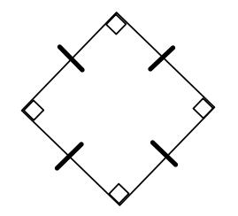
  - What is the best classification of this figure?

  - Name two other classifications that could be used to describe this figure.

- Look at the figures below.
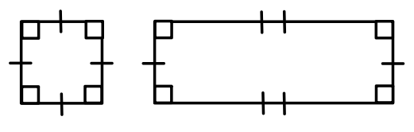
- Explain how they are similar to each other.

- Explain how they are different from one another.

- Use the word bank below to fill in each blank in the diagram below.

Parallelogram Rhombus Trapezoid Rectangle Square
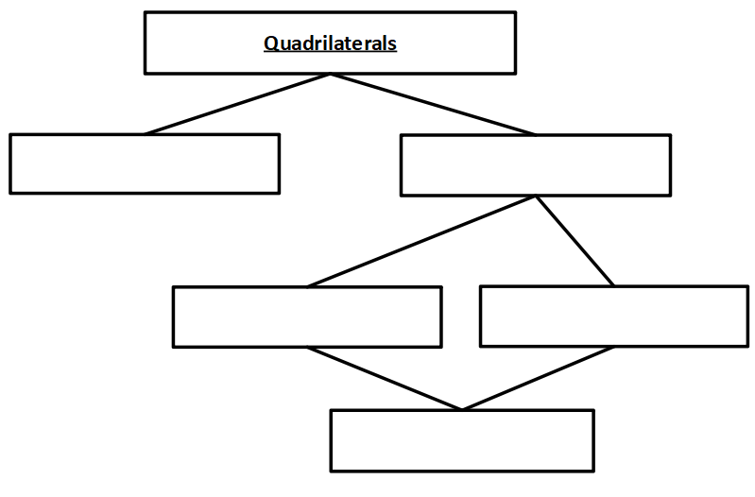

- A quadrilateral has these characteristics.
- Exactly one pair of opposite sides is parallel.
- It has exactly two right angles.
- Exactly two sides are congruent.
This figure can best be described as a ___________________________.
Explain your thinking using pictures, symbols, and words.

- Use geometric markings to indicate parallel sides, congruent sides, and right angles for each polygon shown below. If you do not know the markings, label the following.
- right angles
- parallel sides
- congruent sides
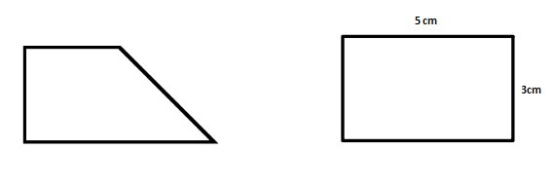

SOL 4.12 - Just in Time Quick Check Teacher Notes
Common Errors/Misconceptions and their Possible Indications

- Circle the figures that are quadrilaterals.
Explain why the figures you circled are quadrilaterals.
Students may have difficulty, specifically with the term quadrilateral, as well as other geometric vocabulary terms. This may indicate that a student does not make the connection between the geometric term quadrilateral and the prefix “quad”. Teachers may wish to use word sorts with geometric terms to help students make connections to these terms and language patterns, such as prefixes. Teachers may also wish to use the Word Wall cards as anchor charts for students to reference.

- A polygon has the characteristics shown in the figure below.
  - What is the best classification of this figure?

b) Name two other classifications that could be used to describe this figure.
Students may have difficulty identifying the best classification for this figure because of its orientation. This may indicate that a student’s understanding of the shape might be referred to as a diamond and that students have only had exposure to polygons with horizontal and vertical sides. Teachers may wish to have students sort quadrilaterals by their properties when quadrilaterals are displayed in different orientations. Students may also have difficulty naming this figure within a hierarchy, and may not realize that a square can also be classified as a parallelogram, a rectangle, and a rhombus. Teachers may wish to provide quadrilateral sorts that allow students to explore the relationship between squares and other quadrilaterals (i.e. parallelogram, rectangle, and rhombus).

- Look at the figures below.
  - Explain how they are similar to each other.

  - Explain how they are different from one another.
Some students may be limited in their explanation of the similarities between the two figures. This will be evident if a student states that each figure has four right angles and fails to mention that opposite sides are congruent and both figures are quadrilaterals and rectangles. Teachers may wish to review properties that define these figures and have students organize shapes in Venn diagrams to explore their similarities and differences.

- Use the word bank below to fill in each blank in the diagram below.
Parallelogram Rhombus Trapezoid Rectangle Square
Some students may have difficulty classifying quadrilaterals. This may indicate that a student lacks exposure and experience with identifying the properties of quadrilaterals. Teachers may wish to have students organize pictorial representations of quadrilaterals and terms by their properties in a hierarchical organizer.

- A quadrilateral has these characteristics.
- Exactly one pair of opposite sides is parallel.
- It has exactly two right angles.
- Exactly two sides are congruent.
This figure can best be described as a ____________________________.
Explain your thinking using pictures, symbols, and words.
Some students may have difficulty identifying a figure based on characteristics only using verbal descriptions. This may indicate that a student lacks experience classifying a quadrilateral without an image. Teachers may wish to provide visual representations as in questions 2 and 3 before using verbal descriptions without pictorial representations. When using verbal descriptions without a pictorial representation, consider having students visualize, draw, and name the figure.

- Use geometric markings to indicate parallel sides, congruent sides, and right angles for each polygon shown below. If you do not know the markings, label the following.
- right angles
- parallel sides
- congruent sides
Some students may have difficulty with using geometric markings to denote properties of quadrilaterals. This may indicate that a student is not familiar with geometric notation and does not know how to use hatch marks for identifying parallel sides and congruent sides of a figure. Teachers may wish to create anchor charts with these notations for students to refer to and have students practice making marks on quadrilaterals.

