Just In Time Quick Check

Standard of Learning (SOL) 4.10b
Strand: Measurement and Geometry

Standard of Learning (SOL) 4.10b

The student will identify and describe intersecting, parallel, and perpendicular lines.

Grade Level Skills:
- Identify parallel, perpendicular, and intersecting line segments in plane and solid figures.
- Identify practical situations that illustrate parallel, intersecting, and perpendicular lines.
- Use symbolic notation to describe parallel lines and perpendicular lines.
Just in Time Quick Check
Just in Time Quick Check Teacher Notes

Supporting Resources:
- VDOE Mathematics Instructional Plans (MIPS)
  - 4.10ab - Geometry in Real-world Situations (Word) / PDF Version
- VDOE Word Wall Cards: Grade 4 (Word) | (PDF)
  - Intersecting Lines
  - Parallel Lines
  - Perpendicular Lines
  - Symbolic Notation
Supporting and Prerequisite SOL: 4.10a, 3.11

SOL 4.10b - Just in Time Quick Check
- Look at the rhombus below. Which side is parallel to $\overline{AD}$?

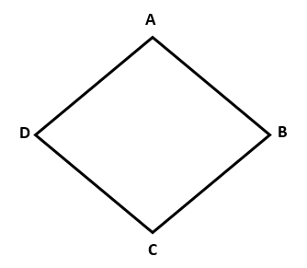

- Look at the rectangle below. Identify a side of this rectangle that is perpendicular to $\overline{BC} .$

- Look at the pentagon below. Name a side that intersects $\overline{DE}$.

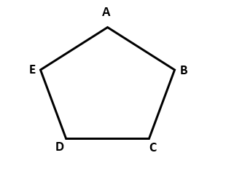

- Look at the cube. Four vertices of the cube are labeled. Use the labeled vertices to answer the questions.

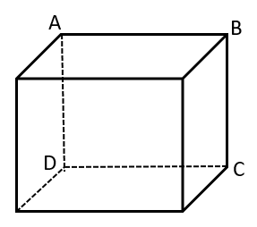

  - Which edge is parallel to edge AB?

  - Name an edge that is perpendicular to edge AB.

  - Name an edge that intersects edge AB.

- Use the map below to fill in the blank in each sentence that follows. There may be more than one correct answer.
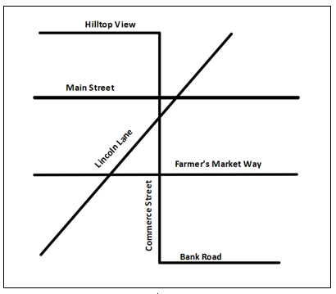

  - Main Street appears parallel to ___________________________________________________. Explain your answer.

  - Lincoln Lane intersects_____________________________________________________. Explain your answer.

  - Commerce Street appears perpendicular to _________________________________________. Explain your answer.

SOL 4.10b - Just in Time Quick Check Teacher Notes
Common Errors/Misconceptions and their Possible Indications
- Look at the rhombus below. Which side is parallel to $\overline{AD}$?

Some students may have difficulty identifying parallel lines because the parallel lines are not oriented horizontally or vertically. Teachers may wish to have students trace or color the parallel lines in plane figures and rotate them to different orientations. This will help students understand parallel lines may appear in figures in a different orientation.
- Look at the rectangle below. Identify a side of this rectangle that is perpendicular to $\overline{BC}$.

Some students may have the misconception that $\overline{AD}$is perpendicular to $\overline{BC.}$ This would indicate students are confusing “perpendicular” with “parallel.” Teachers may wish to use manipulatives such as Anglegs, etc. to create plane figures. Encourage students to discuss which line segments are parallel/perpendicular. Using the Word Wall cards as an anchor chart will help students discern the difference between parallel and perpendicular.
Other students may have difficulty with this problem because perpendicular lines (or line segments) are defined as intersecting lines/line segments that must create 90-degree angles. Students may struggle with recognizing that lines/line segments may be intersecting lines as well as perpendicular if these lines/line segments form a 90-degree angle. Teachers may wish to have students identify perpendicular lines and line segments using real life objects to provide contextual examples. Providing opportunities for students to share and explain their examples will benefit all students. Encourage students to create perpendicular line segments with pictures or drawings in a vocabulary journal.
- Look at the pentagon below. Name a side that intersects $\overline{DE}$.

Some students may not be able to identify an intersecting side. This may indicate they have the misconception that intersecting lines always extend beyond the point of intersection. Students would benefit from exposure to a variety of representations of intersecting lines and line segments, including those that comprise plane and solid figures. Teachers may wish to have students extend the sides of the plane/solid figures with a straightedge to show the line segments intersect.

- Look at the cube. Four vertices of the cube are labeled. Use the labeled vertices to answer the questions.
  - Which edge is parallel to edge AB?

  - Name an edge that is perpendicular to edge AB.

  - Name an edge intersects edge AB.
Some students may have difficulty with this problem because they have not had experience recognizing parallel, perpendicular, and intersecting line segments in solid figures. Students may not understand that the edges of a solid figure can be parallel, perpendicular, or intersecting. They also may not understand that the vertices are points of intersection for intersecting line segments. Teachers may wish to use manipulatives of solid figures to have students 1) identify the plane figures that compose the solid figure, 2) identify the vertices, and 3) describe the types of line segments in the figures as intersecting/parallel/perpendicular. In addition, using a net for a solid figure may help some students visualize how the edges of the solid create parallel/perpendicular/intersecting line segments.

- Use the map below to fill in the blank in each sentence that follows. There may be more than one correct answer.
- Main Street appears parallel to ___________________________________________________. Explain your answer.

- Lincoln Lane intersects_____________________________________________________. Explain your answer.

- Commerce Street appears perpendicular to _________________________________________. Explain your answer.

Some students may be unable to apply their understanding of parallel, perpendicular, and intersecting lines to a map. Teachers may wish to use manipulatives to create a physical model of the map. Have students identify the intersecting/parallel/perpendicular lines from the model and participate in a class discussion on why they decided certain lines were intersecting/parallel/perpendicular. Once students are able to identify lines from a model, provide them with the map. Teachers may wish to have students mark/color/highlight the lines to provide a connection from the conceptual to the abstract. Students would benefit from exposure to a variety of representations of parallel, perpendicular, and intersecting lines.

