Just In Time Quick Check

Standard of Learning (SOL) 4.5a
Strand: Computation and Estimation

Standard of Learning (SOL) 4.5a
The student will determine common multiples and factors, including least common multiple and greatest common factor.

Grade Level Skills:
- Determine common multiples and common factors of numbers.
- Determine the least common multiple and greatest common factor of no more than three numbers.

Just in Time Quick Check

Just in Time Quick Check Teacher Notes

Supporting Resources:
- VDOE Mathematics Instructional Plans (MIPS)
  - 4.5a – Factor Frenzy: Common Factors and Greatest Common Factor (Word)/PDF Version
  - 4.5a – Multiple Madness: Common Multiples and Least Common Multiples (Word)/PDF Version
  - 4.5a – Number Ray Investigation: Factors and Multiplies (Word)/PDF Version
- VDOE Word Wall Cards: Grade 4 (Word and PDF Version)
  - Multiple
  - Least Common Multiple
  - Factor
  - Greatest Common Factor
Supporting and Prerequisite SOL: 4.4a, 3.4c, 2.2a

SOL 4.5a - Just in Time Quick Check
- Identify the least common multiple of 3, 5, and 30.

- A teacher asked three students to identify the least common multiple of 8 and 6. Each student had a different response.
  - Student A stated that the least common multiple was 48.
  - Student B said that the least common multiple was 24.
  - Student C claimed that the least common multiple was 2.

Which of these students correctly identified the least common multiple of 8 and 6? Explain your answer.

- Identify each number that is a common multiple of 3 and 9.
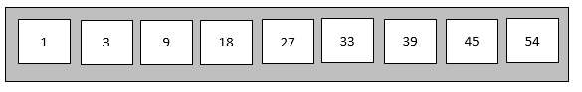

- Use the numbers shown below the diagram to complete this problem. Write the numbers in the correct section to show the factors of 36, the factors of 30, and the common factors of 36 and 30. Some of the numbers in the table may not be used.
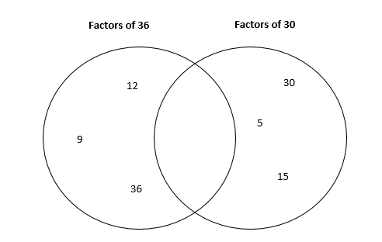

Numbers for Diagram

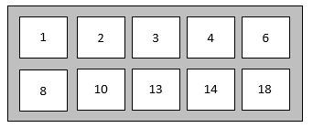

- Complete the table shown below. Identify the greatest common factor and the least common multiple for each set of numbers.

Set of Numbers | Greatest Common Factor | Least Common Multiple
12 and 30
3, 6, and 7

SOL 4.5a - Just in Time Quick Check Teacher Notes
Common Errors/Misconceptions and their Possible Indications

- Identify the least common multiple of 3, 5, and 30.
A common misconception for some students when finding the common multiple of two or more whole numbers is they may not understand that the given number is also a multiple of that whole number. For example, when looking at this problem, it is important for students to recognize that 30 is a multiple of 30. If students did not identify 30 as a multiple of 30, then these students may have stated that 60 was the first common multiple of 3, 5, and 30. Using a hundreds chart or having students create a chart to organize multiples of a whole number is a strategy that can be used when identifying common multiples and/or the least common multiple.
It is important for students to understand the concept of multiples in order to apply this skill to the concept of adding and subtracting fractions with unlike denominators.
- A teacher asked three students to identify the least common multiple of 8 and 6. Each student had a different response.
  - Student A stated that the least common multiple was 48
  - Student B said that the least common multiple was 24
  - Student C claimed that the least common multiple was 2.

Which of these students correctly identified the least common multiple of 8 and 6? Explain your answer.
A common misconception for some students when identifying the least common multiple of two whole numbers is to multiply the two numbers. If a student identified a common multiple but was unable to identify the least common multiple, then this student may need additional time identifying multiples of a whole number. There are several different strategies that students can explore when determining the least common multiple of numbers, including skip counting, equal jumps on a number line, or using a hundreds chart. Students can also create a table or a diagram to recognize common multiples and/or identify the least common multiple.
Students who select “Student C” may not understand the meaning of the term “multiple” and may have it confused with the term “factor.” Using a hundreds chart or skip counting is a strategy that can be used to help build a greater understanding of the term “multiple.”
- Identify each number that is a common multiple of 3 and 9.
A common misconception when identifying common multiples of a given set of numbers, particularly when one of the numbers is a multiple of the other, is to select the smaller number as a multiple. For example, some students may select 3 as a common multiple of 3 and 9 because they have confused multiples and factors. Since 3 is a factor of 9, then all multiples of 9 are also multiples of 3. Using a hundreds chart to model this relationship may benefit some students. Another strategy is to use a multiplication chart to provide a visual for students in determining common multiples. Exploring other sets of numbers will help students develop a deeper understanding of multiples that will enable them to apply these skills when determining equivalent fractions or common denominators.
- Use the numbers shown below to complete the diagram. Write the numbers in the correct section identifying the factors of 36, factors of 30, and the common factors of 36 and 30. Some of the numbers in the table may not be used.

Numbers for Diagram

A common error for some students when identifying common factors results from not identifying all factors of each given whole number. When identifying factors of a whole number, students should be able to identify a whole number that divides evenly into that number with no remainder. Several different strategies may be used to help students identify factors of a whole number. Using manipulatives such as a multiplication chart or hundreds chart or pictorial representations to create arrays may help students to identify factors of a whole number. Students may arrange or create arrays with equal rows until all factors have been identified. When students list factors, the organization is important in identifying all factors of a whole number. One method of organization is to list pairs of factors starting with 1 and the number and continue using strategies to discover if the numbers that lie between them are also factors of that number.
Another common misconception for some students is not recognizing that 1 is always a common factor for every number. It is important for students to relate factors to the concept of fractions, understanding that a fraction is in simplest form when the numerator and denominator have no common factor other than the number 1.

- Complete the table shown below. Identify the greatest common factor and the least common multiple for each set of numbers.

Set of Numbers | Greatest Common Factor | Least Common Multiple
12 and 30
3, 6, and 7

A common misconception for some students is to confuse the terms “multiples” and “factors.” Using Word Wall cards and other strategies will help students understand the difference in these terms. Connecting these terms to the concepts of multiplication and division would also benefit students in identifying factors and multiples.
Another common misconception is some students do not understand that 1 can be the greatest common factor. In the set of numbers 3, 6, and 7, the greatest common factor is 1. Exploring and identifying factors of different sets of numbers is important in developing a greater understanding of factors.
Using a calculator to check for common multiples and factors is a strategy that may benefit some students. This strategy could be used to reinforce divisibility rules and students’ understanding of those rules.

