Just In Time Quick Check
Standard of Learning (SOL) 4.3d
Strand: Number and Number Sense

Standard of Learning (SOL) 4.3d
The student will, given a model, write the decimal and fraction equivalents.

Grade Level Skills:
- Represent fractions for halves, fourths, fifths, and tenths as decimals through hundredths, using concrete objects.
- Relate fractions to decimals, using concrete objects (e.g., 10-by-10 grids, meter sticks, number lines, decimal squares, decimal circles, money).
- Write the decimal and fraction equivalent for a given model (e.g., $\frac{1}{4}$ = 0.25 or 0.25 = $\frac{1}{4}$ ; 1.25 = $\frac{5}{4}$ or $1\frac{1}{4}$ .
Just in Time Quick Check
Just in Time Quick Check Teacher Notes

Supporting Resources:
- VDOE Mathematics Instructional Plans (MIPS)
  - 4.3d - Fraction-Decimal Relationships with Grids (Word) / PDF Version
- VDOE Co-Teaching Mathematics Instruction Plans (MIPS)
  - 4.3d - Fraction Decimal Grid (Word) / PDF Version
- VDOE Algebra Readiness Remediation Plans
  - Fractions, Decimals, and Percents with Hundred Grids (Word) / PDF
  - Hundreds Grids (Word) / PDF
  - Picture Perfect (Word) / PDF
- VDOE Word Wall Cards: Grade 4 (Word) | (PDF)
  - Decimal
  - Equivalent
Supporting and Prerequisite SOL: 4.2b, 4.2c, 4.3a, 3.2b, 3.2c, 2.4a, 2.4b, 2.4c

SOL 4.3d - Just in Time Quick Check

- Shade and label the two models to represent an equivalent fraction and decimal. Explain how you know that the fraction and decimal are equivalent.

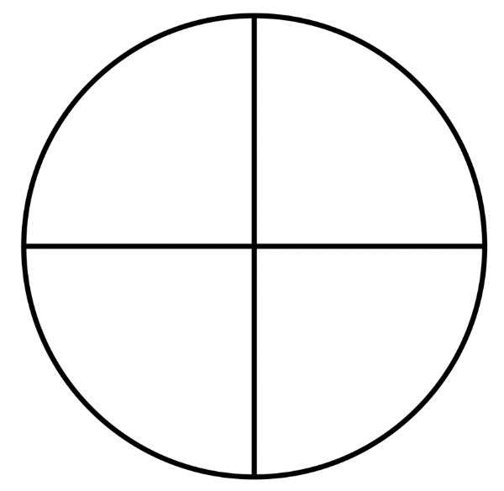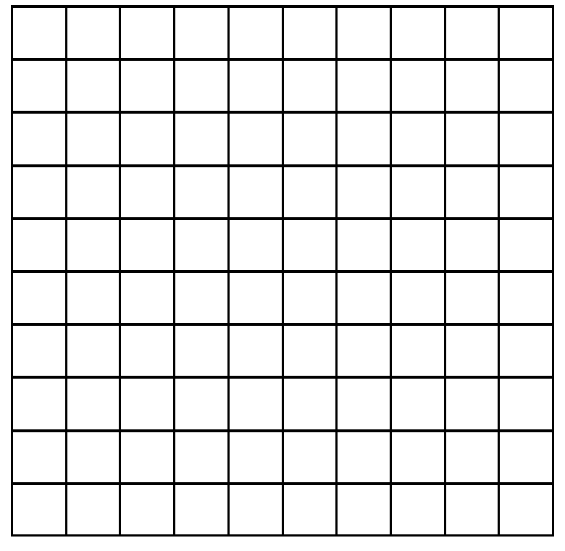

______________ ______________
fraction decimal

- What fraction of Model A is shaded?
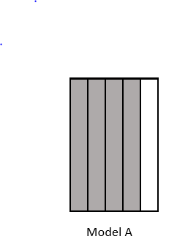

- Shade the decimal grid to represent an equivalent decimal.
- Name the decimal.
- Explain how you know they are equivalent.

- What fraction and equivalent decimal best represent the location of point M on the number line? Explain your thinking.

______________ ______________
fraction decimal

SOL 4.3d - Just in Time Quick Check Teacher Notes
Common Errors/Misconceptions and their Possible Indications
- Shade and label the two models to represent an equivalent fraction and decimal. Explain how you know that the fraction and decimal are equivalent.

______________ ______________
fraction decimal

A common misconception for some students is thinking of decimals as completely separate from fractions, rather than recognizing that decimals are another way to record fractions. Students with this misconception may struggle to relate fraction and decimal models, especially with different sized and/or shaped wholes.
Students may benefit from thinking about the hundred grid as the whole for the fraction and then dividing the grid into four equal sections. For example, they may draw a vertical line between the 5th and 6th column and a horizontal line between the 5th and 6th row. Students could then count to determine that a fourth contains 25 squares. This activity could be repeated to find another fraction-decimal relationship. These relationships could be reinforced by showing how the decimal can be written as a fraction with a denominator of 100 and then looking at the equivalent fraction relationships.
An additional strategy is to provide students with practice opportunites to match fraction and decimal models with different sized and shaped wholes that represent the same amounts. Students may benefit from sorting, matching and even comparing pre-shaded fraction and decimal hand-held or virtual picture cards to master this skill.

- What fraction of Model A is shaded?

- Shade the decimal grid to represent an equivalent decimal.
- Name the decimal.
- Explain how you know they are equivalent.

A common error for some students is relying on the method of counting the shaded parts of the whole, without understanding the relationship between the shaded parts and the whole. Students making this error may have the misconception that four shaded sections in one model are equivalent to four shaded sections in another model. These students may not understand that the shaded amount is meaningless unless you know its relationship to the whole. As a result, some students may reply to this question by shading four columns (forty hundredths) rather than eight columns (eighty hundredths).
These students may benefit from using concrete materials like fraction strips to build fractions involving fifths. They can then find the equivalent fraction in tenths. Once a student knows the equivalent fraction with a denominator of ten, they can use base ten blocks to find the equivalent fraction with a denominator of 100. It may be helpful to then connect the base ten blocks to a hundred grid.
Another strategy is to provide students with practice opportunities to fold or cut pictorial representations of fifths into the equivalent fraction in tenths. This helps students see that for every fifth, two tenths are represented, and for every two tenths, one fifth is represented. This can be done with square grids and circular fraction models.
- What fraction and equivalent decimal best represent the location of point M on the number line? Explain your thinking.
______________ _____________
fraction decimal

A common error for some students is naming a fraction or decimal without recognizing that the fractional parts are represented between 2 and 3 on the number line model. These students may not recognize that there are four equal spaces between 2 and 3 (representing fourths). As a result, students may name the point as 1 (because 1 comes before 2) or they may randomly choose a fraction that might come right before a whole (ex: two-thirds, four-fifths, five-sixths). Another possible error is naming the point $1\frac{1}{2}$ because there are two lines showing before the 2.
Students making this error may benefit from using number lines representing a variety of fractions and counting with fraction pieces to demonstrate that the fractions represented on a number line remain constant over the whole number line. For example, the student can be given a number line that is broken into fourths. They begin at 0 and move to the first mark on the number line. As they move to that mark, they place a one-fourth fraction piece on their work space and say one-fourth. They then move to the next mark, place another one-fourth piece, and say two-fourths. This continues through $\frac{3}{4}$, $\frac{4}{4}$ (whole), $1\frac{1}{4}$ , $1\frac{2}{4}$, etc.
After using the fraction pieces to reinforce the iterative nature of fraction number lines, provide students with practice opportunities to use incomplete number lines and parts of number lines to determe the value of different postions on the number line before and after the section where the whole is defined.

