Just In Time Quick Check
Standard of Learning (SOL) 4.3a
Strand: Number and Number Sense

Standard of Learning (SOL) 4.3a
The student will read, write, represent, and identify decimals expressed through thousandths.

Grade Level Skills:
- Read and write decimals expressed through thousandths, using base-ten manipulatives, drawings, and numerical symbols.
- Represent and identify decimals expressed through thousandths, using base-ten manipulatives, pictorial representations, and numerical symbols (e.g., relate the appropriate drawing to 0.05).
- Investigate the ten-to-one place value relationship for decimals through thousandths, using base-ten manipulatives (e.g., place value mats/charts, decimal squares, and base-ten blocks).
- Identify and communicate, both orally and in written form, the position and value of a decimal through thousandths (e.g., given 0.385, the 8 is in the hundredths place and has a value of 0.08).
Just in Time Quick Check
Just in Time Quick Check Teacher Notes

Supporting Resources:
- VDOE Mathematics Instructional Plans (MIPS)
  - 4.3a - Reading and Writing Decimals (Word) / PDF Version
- VDOE Word Wall Cards: Grade 4 (Word) | (PDF)
  - Decimal Place Value Position
Supporting and Prerequisite SOL: 4.1a, 3.1a, 3.1b, 3.1c, 3.2a, 3.2b, 3.2c

SOL 4.3a - Just in Time Quick Check

- This model represents one whole.

What decimal number does this model represent?
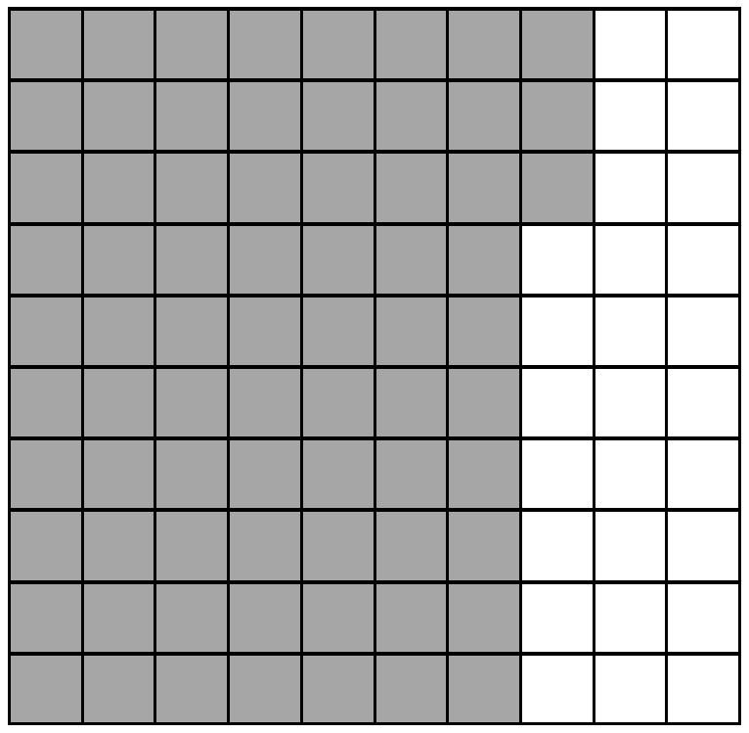

- This model represents one whole.

What decimal number does this model represent?
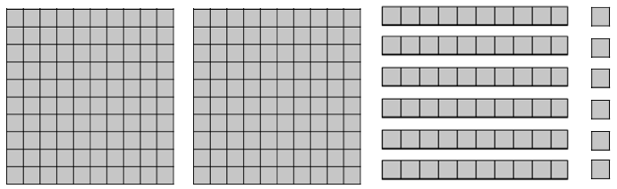

- Complete the chart to show the place value of each digit in the number 7.524.

Digit | Place | Value
5 | tenths
4
7 | ones
2 |  | 0.02

- Write this decimal number in standard form.

“nine hundred eighty-one thousandths”

SOL 4.3a - Just in Time Quick Check Teacher Notes
Common Errors/Misconceptions and their Possible Indications
- This model represents one whole.

What decimal number does this model represent?

A common error for some students is to use whole number base-ten place value thinking rather than recognizing that this model represents a decimal number. Instead of recognizing the whole as one unit, some students may transfer the whole number value of the “flat” and read it as one hundred.
In this question, students may write this number as 373 instead of writing it correctly as decimal number 3.73
Provide students with multiple practice opportunities arranging flats, rods, and units to create decimal numbers in a place value chart based on a teacher-defined whole. It would also be helpful for students to place digit cards in the chart to label their block representation with the standard form of the decimal number.

- This model represents one whole.

What decimal number does this model represent?

A common misconception for some students is thinking that the flat always represents a whole when modeling decimals. Students with this misconception would read this number as 2.66 rather than 26.6.
These students may benefit from experiences modeling with concrete materials that push them to determine the value with varying models serving as the whole. For example, students may use 1 flat, 4 rods, and 2 units to model a number. Students would then think about the value of the number if a flat was the whole (1.42), if a rod was the whole (14.2), or if a unit was the whole (142). They may also be pushed to think about the value if a cube was the whole (0.142).
Students may also benefit from starting with a number first and then creating the number with concrete materials, after being told which piece represents a whole. For example, students could be asked to model 24.5 if a rod is the whole.
- Complete the chart to show the place value of each digit in the number 7.524.

Digit | Place | Value
5 | tenths
4
7 | ones
2 |  | 0.02

A common error is assuming that the numbers listed in the chart are in the same order as the digits in the number. As a result, some students may misrepresent decimals when assigning place and value to digits.
Provide students practice opportunities assigning digits, values, and places of decimal numbers in charts or other formats when digits are listed in random order.
Another strategy to benefit students displaying errors in determining the place and value of decimal numbers is to use a place value chart and concrete manipulatives. Give students opportunities to use the chart as they read numbers in written form aloud to themselves and then build the number. Using flats, rods, and units to model the number will help build conceptual understanding of the place and value of each number. Connecting the conceptual to written (place value chart) and symbolic (decimal form) will strengthen students’ understanding.
- Write this decimal number in standard form.

“nine hundred eighty-one thousandths”
Some students may apply their knowledge and experience with whole numbers to reading and writing decimal numbers. In this question, a student response may be 981 with no representation of the decimal point or decimal place values when the correct response reads 0.981.
It may be helpful to provide some students with a decimal place value chart that shows the decimal places in the order that they appear in numbers. It may also be beneficial to include a clearly marked space in the chart for the decimal point, paired with a reference to the word “and” to facilitate the process of reading and writing decimal numbers from standard form.

