Just In Time Quick Check
Standard of Learning (SOL) 4.2b
Strand: Number and Number Sense

Standard of Learning (SOL) 4.2b
The student will represent equivalent fractions.

Grade Level Skills:
- Represent equivalent fractions through twelfths, using region/area models, set models, and measurement/length models.
Just in Time Quick Check
Just in Time Quick Check Teacher Notes

Supporting Resources:
- VDOE Mathematics Instructional Plans (MIPS)
  - 4.2ab - Fraction Strips: Comparing and Ordering Fractions (Word) / PDF Version
- VDOE Word Wall Cards: Grade 4 (Word) | (PDF)
  - Equivalent
  - Less Than
  - Greater Than
  - Equal To
  - Numerator/Denominator
  - Proper Fraction
  - Improper Fraction
  - Mixed Number
- VDOE Instructional Videos for Teachers
  - Models for Teaching Fractions
- Desmos Activities
  - Equivalent Fractions
  - Fraction Card Sort
Supporting and Prerequisite SOL: 4.2c, 4.3d, 3.2a, 3.2b, 3.2c, 2.4a, 2.4b, 2.4c

SOL 4.2b - Just in Time Quick Check

Model 1
Model 2

Model 1 represents a whole. Model 2 is shaded to represent a fraction. Each section of Model 2 is the same size.
- What fraction does Model 2 represent?

- Name a fraction that is equivalent to the fraction represented in Model 2.

- Use this model to represent the equivalent fraction.

- A set of circles is shown. What fraction of the set of circles is shaded?

- Name an equivalent fraction to the fraction represented by the shaded circles.

- Draw a new set model to represent the equivalent fraction.

- A fraction is represented at point M on this number line.

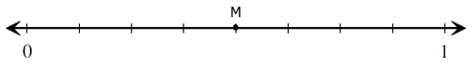

Circle all models that show fractions that are equivalent to the fraction represented by point M.

 |  | 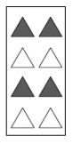
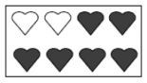 | 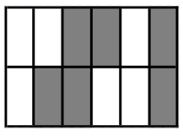 | 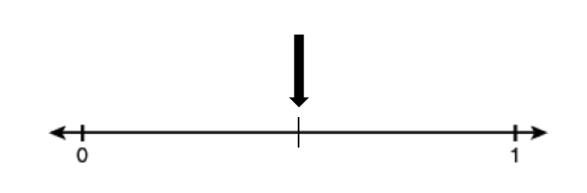

- This model is shaded to represent the fraction $\frac{6}{8}$ .
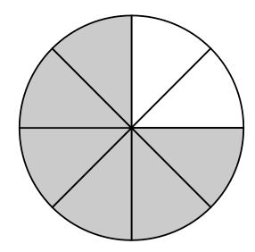
Create models to represent fractions that are equivalent to $\frac{6}{8}$ . Write the fraction for each model that you create.

SOL 4.2b - Just in Time Quick Check Teacher Notes
Common Errors/Misconceptions and their Possible Indications

Model 1
Model 2

Model 1 represents a whole. Model 2 is shaded to represent a fraction. Each section of Model 2 is the same size.
- What fraction does Model 2 represent?

- Name a fraction that is equivalent to the fraction represented in Model 2.

- Use this model to represent the equivalent fraction.

A common misconception for some students is thinking that breaking fractional pieces into smaller pieces changes the value of the shaded portion. For example, students may think that drawing a horizontal line through the image of one-third to create two-sixths changes it to a larger fraction because the numbers are larger.
Teachers may wish to begin with concrete materials to explore equivalent fractions. Students can build fractions using fraction strips or fraction bars, and then work to find fractions that are equivalent to the original fraction. For example, students may use thirds pieces to model one-third and then try several other fractional pieces until they discover that two-sixths and four-twelfths are equivalent.
After building equivalent fractions with concrete models, teachers may wish to move to pictorial models. Provide students with opportunities to draw additional lines in fraction models to double, triple, quadruple, etc. the number of equal parts in a whole. Additionally, have students practice removing lines from fraction models to decrease the number of equal parts by half, by a third, by a fourth, etc. Then have students rename the fractional amount to include the new numerator and denominator of the equivalent fraction they created.

- A set of circles is shown. What fraction of the set of circles is shaded?
- Name an equivalent fraction to the fraction represented by the shaded circles.

- Draw a new set model that represents the equivalent fraction.

A common misconception for some students is thinking that the whole must contain the same number of parts when creating equivalent fractions with sets. In this example, students may think that the equivalent fraction must contain exactly 4 circles or 4 pieces. They may draw another model using 3 shaded figures and 1 unshaded figure.
Teachers may wish to begin with concrete models such as two-sided counters. A student can model a fraction such as $\frac{3}{4}$ using 3 red counters and 1 yellow counter. Teachers can encourage students to add 3 more red counters and 1 more yellow counter to create the equivalent fraction $\frac{6}{8}$ (see example below). If students struggle to understand how these fractions can be equivalent, it may help to arrange them in two rows and then cover one row, allowing students to see that each row shows $\frac{3}{4}$ so the entire group of counters also must show $\frac{3}{4}$. Students can continue adding rows to find more equivalent fractions.

Another way to help students see that the fractions are equivalent is to break the 8 counters into four equivalent groups. Students can then see that three out of the four groups are shaded.
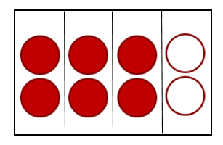

Teachers may then wish to move on to using pictorial models to represent equivalent fractions with set models. Students can draw models using a variety of equivalent fractions.

- A fraction is represented at point M on this number line.
Circle all models that show fractions that are equivalent to the fraction represented by point M.

A common error for some students is to misread increments on a number line by counting the lines rather than focusing on the spaces between the lines. This frequently results from students not understanding that the number line is a way of using length to model fractions, so they should be thinking about the distance rather than the number of increments.
Provide students with practice opportunities counting and labeling number lines by the fractional amounts dictated by the number of spaces and lines after the 0. Guide students to see that the spaces are the factional parts and each line names the value of the space before it.
It may also be helpful to have students draw an area model above the number line that matches the increments in the number line. Making a connection to a model that is often easier to interpret may help to make the increments on the number line clearer to students. In the example below, a number line models $\frac{1}{2}$ and matches the area model shown directly above it.
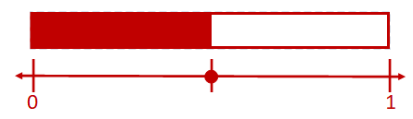

Provide students with opportunities to identify fractions with different denominators on the same number line by removing or adding increment lines. The number line in question 3 shows eighths. Highlighting every other line reveals sixteenths, showing that point M can be identified as four-eighths and as eight-sixteenths.
Example:
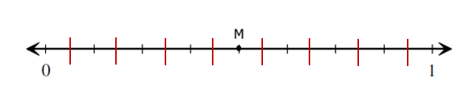
- This model is shaded to represent the fraction $\frac{6}{8}$ .
Create models to represent fractions that are equivalent to $\frac{6}{8}$ . Write the fraction for each model that you create.
Some students may not see the connection between the area, set, and measurement models as tools for recognizing and representing equivalent fractional amounts.
Provide students with practice opportunities to identify and represent equivalent fractions across area, set, and measurement/number line models. Give students opportunities to apply and connect the strategies they used when they worked with each model in isolation.
Example: Removing lines or adding additional lines to area models and number line models are similar ways to see and represent fractions with different denominators in the same visual.

