Just in Time Quick Check

Standard of Learning (SOL) 3.9b
Strand: Measurement and Geometry

Standard of Learning (SOL) 3.9b
The student will solve practical problems related to elapsed time in one-hour increments within a 12-hour period.

Grade Level Skills:
- Solve practical problems related to elapsed time in one-hour increments within a 12-hour period (within a.m. or p.m.):
- when given the beginning time and the ending time, determine the time that has elapsed;
- when given the beginning time and amount of elapsed time in one-hour increments, determine the ending time; or
- when given the ending time and the elapsed time in one-hour increments, determine the beginning time.
Just in Time Quick Check
Just in Time Quick Check Teacher Notes

Supporting Resources:
- VDOE Mathematics Instructional Plans (MIPS)
  - 3.9b - Hoppin’ on the Elapsed Time Line (Word) / PDF Version
  - 3.9b - Where Did the Time Go? (Word) / PDF Version
- VDOE Word Wall Cards: Grade 3 (Word) | (PDF)
  - Clock: Minutes, One-half Hour, One Hour
  - Elapsed Time
Supporting and Prerequisite SOL: 3.9a, 2.2a, 2.9, 1.9a

SOL – 3.9b - Just in Time Quick Check

- A movie started at the time shown on the clock.
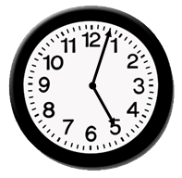
It ended at this time.
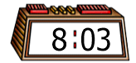
How long did the movie last?

- The clock below shows the time Kristen’s soccer practice started.
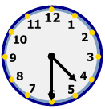
It ended two hours later.
What was the time when Kristen’s soccer practice ended?

- Dara baked cookies with his mother for one hour.
This clock shows the time he finished.
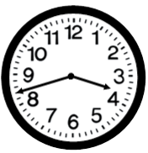
What was the time when Dara started baking cookies with his mother?

SOL 3.9b - Just in Time Quick Check Teacher Notes
Common Errors/Misconceptions and Their Possible Indications
- A movie started at the time shown on the clock.
It ended at this time.
How long did the movie last?
Some students may write 5:03 or 8:03 because they do not understand they need to find the elapsed time. These students may need more opportunities to determine elapsed time in practical situations. Students may find geared analog clocks and/or timelines helpful in determining elapsed time by counting on from the beginning time or counting back from the ending time. Other students may not read the analog clock correctly which will impact their understanding of the elapsed time.
- The clock below shows the time Kristen’s soccer practice started.
It ended two hours later.
What was the time when Kristen’s soccer practice ended?
Some students may answer 2:30 because they found the start time instead of the end time. These students will benefit from opportunities to solve elapsed time problems in collaboration with their peers. Listening to their peers’ strategies and reasoning will help students begin to make sense of strategies for solving practical problems associated with using the skills of telling time and determining elapsed time. These students may also benefit from using a timeline or graphic organizer such as the one included below.

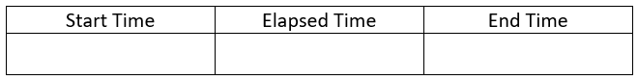

- Dara baked cookies with his mother for one hour.
This clock shows the time he finished.
What was the time when Dara started baking cookies with his mother?
A common error that students make with this type of problem is to actually find a new finish time. For this problem, some students may write 4:43 because they think the clock is showing the start time and add one hour. These students need additional opportunities determining the start time when the ending time and elapsed time have been given. Students may benefit from being provided or creating a timeline or graphic organizer similar to the one shown below to keep track of all of the components of a practical problem involving elapsed time.

