Just in Time Quick Check
Standard of Learning (SOL) 3.9a
Strand: Measurement and Geometry

Standard of Learning (SOL) 3.9a
The student will tell time to the nearest minute, using analog and digital clocks.

Grade Level Skills:
- Tell time to the nearest minute, using analog and digital clocks.
- Match a written time (e.g., 4:38, 7:09, 12:51) to the time shown on analog and digital clocks to the nearest minute.
Just in Time Quick Check
Just in Time Quick Check Teacher Notes

Supporting Resources:
- VDOE Mathematics Instructional Plans (MIPS)
- 3.9a - It’s About Time (Word) / PDF Version
- VDOE Co-Teaching Mathematics Instruction Plans (MIPS)
- 3.9a - Telling Time to the Minute (Word) / PDF Version
- VDOE Word Wall Cards: Grade 3 (Word) | (PDF)
  - Minutes
  - One-half Hour
  - One Hour
Supporting and Prerequisite SOL: 2.2a, 2.9, 1.9a

SOL 3.9a - Just in Time Quick Check
- Circle the clock that has the matching digital and analog time.
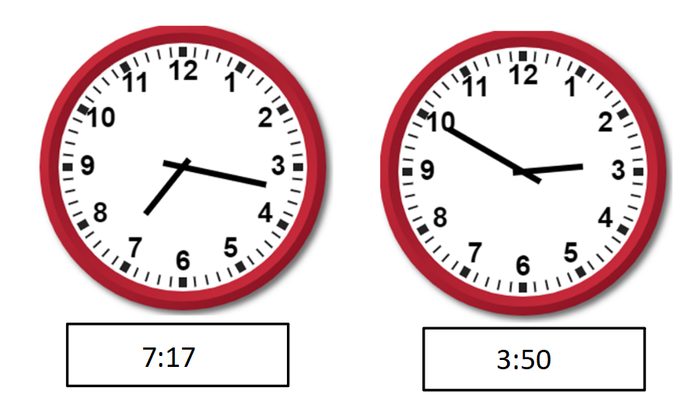
- Circle the clock that best shows 12:42.
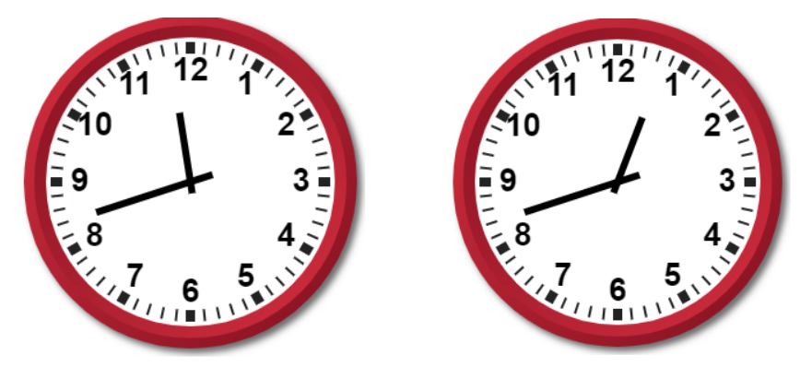
Explain how you decided which clock best shows 12:42.
___________________________________________________________________________________________________________________________________________________________________________________________________________________________________________________________________________________________________________________________

- Write the digital time for each analog clock.
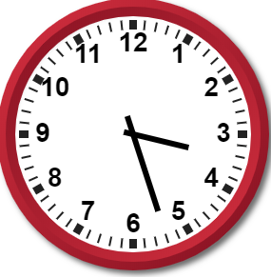 ________________________________

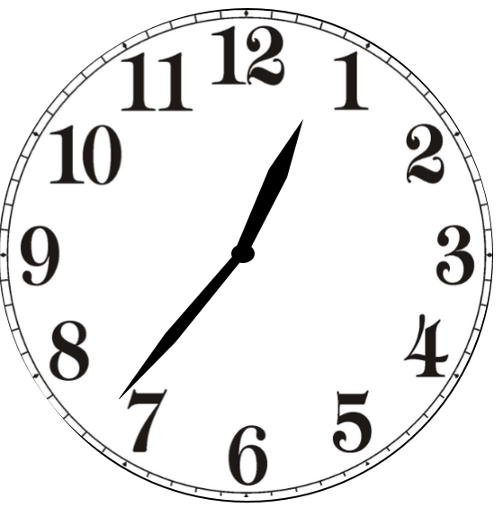 ________________________________

SOL 3.9a - Just in Time Quick Check Teacher Notes
Common Errors/Misconceptions and their Possible Indications
- Circle the clock that has the matching digital and analog time.
Students may choose the clock that says 3:50 because the hour hand is closer to the number 3 than to the number 2. These students may think that the hour hand must be directly on the number, not recognizing that 50 minutes past 3 means that the hour has almost passed and it is close to 4:00. The hour hand should be closer to the four for this clock to display 3:50. Students need experiences to develop a better understanding of how the hour hand and minute hand work together. “Gear type” clocks during practice serve as models of how as the minute hand moves around the clock one full turn, the hour hand moves from one number to the next. It will be beneficial for students to hear the reasoning of their peers as they tell the time shown on clocks throughout the day.
- Circle the clock that best shows 12:42.
Explain how you decided which clock best shows 12:42.
Students may choose the clock that says 11:42. These students are not paying attention to where the hour hand is located. During additional opportunities to practice telling time, have students look at clocks such as these and share what is the same and what is different. Having students compare the two clocks will allow them to see that the position of the hour hand changes the time and that these two clocks do not display the same time. Students would benefit from hearing the reasoning of their peers as to which clock best shows 12:42.
- Write the digital time for each analog clock.
________________________________
When reading the time on this clock, some students may confuse the number on the clock face with the number of minutes passed (i.e. saying 3:5). The students may copy the numbers they see on the clock or use the numbers closest to the hands to determine a time. These students have not yet developed an understanding of how to read the time on a clock or an understanding that there are 60 minutes in one hour. It may be necessary to go back to using just the hour hand and work with students to brainstorm what happens at different hours during the day (i.e., at 8:00 wake up, 9:00 start school, 12:00 have lunch, etc.). Once students are more comfortable using and reading the hour hand, add opportunities to work with the minute hand. Ask students what the tick marks mean, how many minutes pass between each number, and then work with them on counting by fives to read the different amounts past the hour.
________________________________
Some students will read this time as 7:04 because they have confused the hour hand and the minute hand. These students will need additional opportunities to read just the hour and be reminded that the hour hand is the shorter of the two hands. Create and display an anchor chart with graphics and the words “hour” and “minute” for the students to reference as they build this understanding.

