Just In Time Quick Check

Standard of Learning (SOL) 3.16
Strand: Patterns, Functions, and Algebra

Standard of Learning (SOL) 3.16
The student will identify, describe, create, and extend patterns found in objects, pictures, numbers, and tables.

Grade Level Skills:
- Identify and describe repeating and growing patterns using words, objects, pictures, numbers, and tables.
- Identify a missing term in a pattern (e.g., 4, 6, , 10, 12, 14).
- Create repeating and growing patterns using objects, pictures, numbers, and tables.
- Extend or identify missing parts in repeating and growing patterns using objects, pictures, numbers, and tables.
- Solve problems that involve the application of input and output rules limited to addition and subtraction of whole numbers.
- When given the rule, determine the missing values in a list or table. (Rules will be limited to addition and subtraction of whole numbers.)
Just in Time Quick Check
Just in Time Quick Check Teacher Notes

Supporting Resources:
- VDOE Mathematics Instructional Plans (MIPS)
- Exploring Multiples (Word) / PDF Version
- Patterns on a Hundreds Chart (Word) / PDF Version
- Patterns in a Staircase (Word) / PDF Version
- What’s My Rule? (Word) / PDF Version
- VDOE Co-Teaching Mathematics Instruction Plans (MIPS)
  - Multiples (Word) / PDF Version
- VDOE Algebra Readiness Formative Assessments
  - 3.16 (Word) / PDF
- VDOE Word Wall Cards: Grade 3 (Word) / PDF
  - Pattern: Growing and Input/output Table
  - Calculator
Supporting and Prerequisite SOL: 3.3a, 3.3b, 2.16, 1.13, 1.14

SOL 3.16 - Just in Time Quick Check

- Create a growing pattern using all three of the shapes shown below.
- You may use a shape more than one time.

- Aiko made a repeating pattern with number cards. Her little sister spilled ice cream on part of the pattern as shown below.

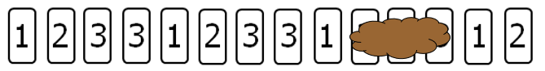
_____________________________ __ __ __
What number is on each of the three cards covered with ice cream? Write the correct number for each covered card on the space below the card.

- Determine the unknown values in the table below.
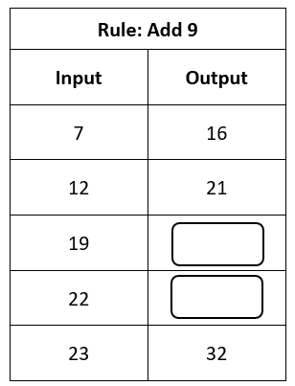

Carson made this number pattern.

1, 5, 9, 13, 17, 21 …

If the pattern continues, what will the ninth number be? _____________

SOL 3.16 - Just in Time Quick Check Teacher Notes
Common Errors/Misconceptions and their Possible Indications

- Create a growing pattern using all three of the shapes shown below.
- You may use a shape more than one time.

Some students may confuse repeating and growing patterns and create a repeating pattern. They may benefit from instruction that has them compare and contrast repeating and growing patterns. Some students may create a growing pattern that is incorrect because it doesn’t represent a pattern. They may benefit from more opportunities to build and analyze growing patterns.
- Aiko made a repeating pattern with number cards. Her little sister spilled ice cream on part of the pattern as shown below.

____________________________ __ __ __
What number is on each of the three cards covered with ice cream? Write the correct number for each covered card on the space below the card.
Students who answer 1,2,3 may not understand what the core is and are starting the pattern again. These students would benefit from more instruction on finding the core in a pattern. Students who answer 2,3,4 may think this is a growing pattern. These students would benefit from more experiences creating both repeating and growing patterns as well as finding the missing terms in patterns.
- Determine the unknown values in the table.
Students who believe the unknown values are 26 and 31 have used the relationship between 16 and 21 in the output column and not the rule or the relationship between the input and output. These students may benefit from more opportunities to create and extend input/output tables. Some students may understand the pattern but have trouble with the calculations. They may benefit from using a calculator to check their computation, as well as additional opportunities to practice strategies for addition and subtraction.

Carson made this number pattern.

1, 5, 9, 13, 17, 21 …

If the pattern continues, what will the ninth number be? _____________
Some students may write 22, the number that follows 21. Some students may write 25 because they understood the pattern but wrote the next number rather than the ninth number. These students would benefit from more experiences analyzing patterns to see how they are changing and then extending the pattern beyond the next number.

