Just In Time Quick Check

Standard of Learning (SOL) 3.15b
Strand: Probability and Statistics

Standard of Learning (SOL) 3.15b
The student will read and interpret data represented in pictographs and bar graphs.

Grade Level Skills:
- Analyze data represented in pictographs and bar graphs, orally and in writing.
- Read the information presented on a bar or pictograph (e.g., the title, the categories, the description of the two axes).
- Interpret information from pictographs and bar graphs, with up to 30 data points and up to eight categories, describe interpretation orally and by writing at least one sentence.
- Describe the categories of data and the data as a whole (e.g., data were collected on preferred ways to cook or prepare eggs — scrambled, fried, hard boiled, and egg salad).
- Identify parts of the data that have special characteristics, including categories with the greatest, the least, or the same (e.g., most students prefer scrambled eggs).
- Select a correct interpretation of a graph from a set of interpretations, where one is correct and the remaining are incorrect.

Just in Time Quick Check

Just in Time Quick Check Teacher Notes

Supporting Resources:
- VDOE Mathematics Instructional Plans (MIPS)
- 3.15ab - Data Mania (Word) / PDF Version
- 3.15ab - Statistics Throughout the Year (Word) / PDF Version
- VDOE Word Wall Cards: Grade 3 (Word / PDF)
  - Bar Graphs
  - Pictographs
Supporting and Prerequisite SOL: 3.15a, 2.15b, 1.12b

SOL 3.15b - Just in Time Quick Check
- Jessica surveyed her students to find out who eats certain snacks. Jessica made a pictograph of her results. Use this pictograph to answer the questions below.
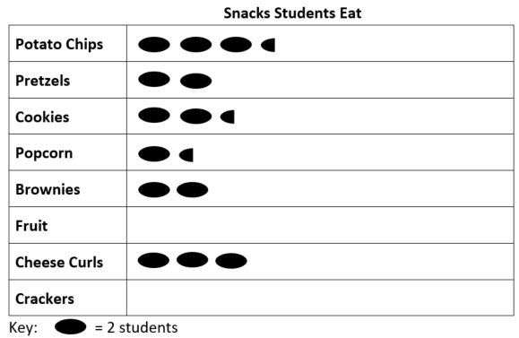

Based on the pictograph, circle each true statement.
- The number of students who eat cookies is exactly 2 more than the number of students who eat popcorn.
- The number of potato chips students eat is exactly $3\frac{1}{2}$ .
- The fewest number of students eat popcorn.
- A total of 13 students were surveyed for this graph.

Write one sentence comparing the data for brownies and popcorn.
________________________________________________________________________________________________________________________________________________________________________________________________________________________

- Tom observed the number of days that had rainfall for four months. The pictograph represents the data Tom collected. Use the data to answer the questions.
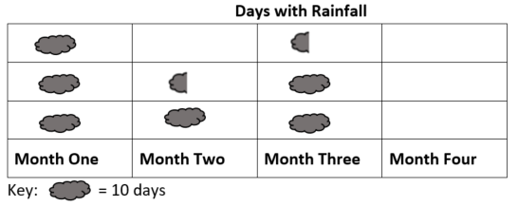

Which month had the least amount of rainfall? _______________________
How many days did Tom observe rainfall in Month Three? Explain how you know. ________________________________________________________________________________________________________________________________________________________________________________________________________________________

- A store manager counted the number of boxes of cookies on a shelf in her store. This graph shows that information.
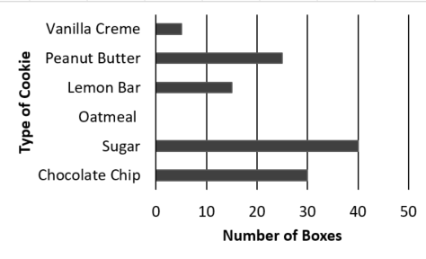

Create a title for this graph. _________________________________________________
Write two sentences that describe the information represented in the graph. Use one or more of these words in each sentence: greatest, least, same.
- _______________________________________________________________________________________________________________________________________________________________________________________________________________
- _______________________________________________________________________________________________________________________________________________________________________________________________________________

SOL 3.15b - Just in Time Quick Check Teacher Notes
Common Errors/Misconceptions and their Possible Indications

- Jessica surveyed her students to find out who eats certain snacks. Jessica made a pictograph of her results. Use this pictograph to answer the questions below.

Based on the pictograph, circle each true statement.
- The number of students who eat cookies is exactly 2 more than the number of students who eat popcorn.
- The number of potato chip students eat is exactly $3\frac{1}{2}$ .
- The fewest number of students eat popcorn.
- A total of 13 students were surveyed for this graph.

Students who fail to choose option “a” may not be using the key in their interpretation. Experiences constructing pictographs that have different keys help students develop an understanding of its importance. Students who choose “b” are interpreting each symbol as 1 snack rather than 2 students. As with statement “a,” these students would benefit from experiences pictographs where the symbol represents 2, 5, and/or 10. Students who chose “c” may be disregarding the categories having 0 symbols, or they may need experience describing and comparing data using mathematical vocabulary (e.g., least, fewer, more, greater, greatest, etc.). Students who select “d” as a true statement may not know how to count the half-ovals. These students would benefit from additional experience with pictographs that use symbols to represent half of the quantity described by the key.
For each of these misconceptions, having students explain their thinking about graphs provides teachers with meaningful and actionable information for the next instructional steps.
Write one sentence comparing the data for brownies and popcorn.
________________________________________________________________________________________________________________________________________________________________________________________________________________________
Students who are unable to write a sentence that correctly compares brownies and popcorn may benefit from an opportunity to talk with a peer or with the teacher about their comparison before writing about it. Additionally, providing scaffolding (e.g., sentence starters, anchor charts, etc.) may help students develop the ability to describe data represented in graphs.

- Tom observed the number of days that had rainfall for four months. The pictograph represents the data Tom collected. Use the data to answer the questions.
Which month had the least amount of rainfall? _______________________
Students who struggle with the idea of zero as being the least and may choose Month Two. Exposing students to graphs that include zero as a result will help students overcome this misconception.
How many days did Tom observe rainfall in Month Three? Explain how you know. ________________________________________________________________________________________________________________________________________________________________________________________________________________________
Students may have difficulty interpreting the $\frac{1}{2}$ cloud as representing 5 days, or they may believe that the $2\frac{1}{2}$ clouds represents $2\frac{1}{2}$ days. For both of these misconceptions, students would benefit from experiences creating and interpreting pictographs for which the symbols represent multiples of $2, 5,$ or $10$ and that require them to include $\frac{1}{2}$ symbols.
- A store manager counted the number of boxes of cookies on a shelf in her store. This graph shows that information.

Create a title for this graph. _________________________________________________
Students may title the graph with information that is too specific (e.g., Types of Cookies or Vanilla Creme) rather than information that describes the main idea represented. These students may benefit from more discussion of what the title tells us and opportunities to consider titles that are too narrow, too broad, and “just right.”
Write two sentences that describe the information represented in the graph. Use one or more of these words in each sentence: greatest, least, same.
- _______________________________________________________________________________________________________________________________________________________________________________________________________________
- _______________________________________________________________________________________________________________________________________________________________________________________________________________
Students who are unable to compare the data categories represented in the graph using the vocabulary provided may benefit from an opportunity to talk with a peer or with the teacher about their description before writing about it. Teachers are encouraged to provide scaffolding (e.g., sentence starters, anchor charts, etc.) to help students develop the ability to compare and contrast data represented in graphs.

