Just In Time Quick Check
Standard of Learning (SOL) 3.15a
Strand: Probability and Statistics

Standard of Learning (SOL) 3.15a
The student will collect, organize, and represent data in pictographs or bar graphs.

Grade Level Skills:
- Formulate questions to investigate.
- Design data investigations to answer formulated questions, limiting the number of categories for data collection to four.
- Collect and organize data, using various forms of data collections (e.g., surveys, polls, questionnaires, scientific experiments, observations).
- Represent data in a pictograph (limited to 16 or fewer data points for no more than four categories).
- Represent data in a bar graph (limited to 16 or fewer data points for no more than four categories).
- Label each axis on a bar graph and give the bar graph a title. Limit increments on the numerical axis to whole numbers representing multiples of 1, 2, 5, or 10.
Just in Time Quick Check
Just in Time Quick Check Teacher Notes

Supporting Resources:
- VDOE Mathematics Instructional Plans (MIPS)
- 3.15ab - Data Mania (Word) / PDF Version
- 3.15ab - Statistics Throughout the Year (Word) / PDF Version
- VDOE Word Wall Cards: Grade 3 (Word / PDF)
  - Bar Graphs
  - Pictographs
Supporting and Prerequisite SOL: 2.15a, 1.12a

SOL 3.15a - Just in Time Quick Check

- Jaquan surveys students in his class to see what color of bike they each have. This table shows the results of the survey.

Bike Colors
Color of Bike | Number of Students
Blue | 6
Green | 5
Red | 3
Gray | 2

Create a bar graph using Jaquan’s data.
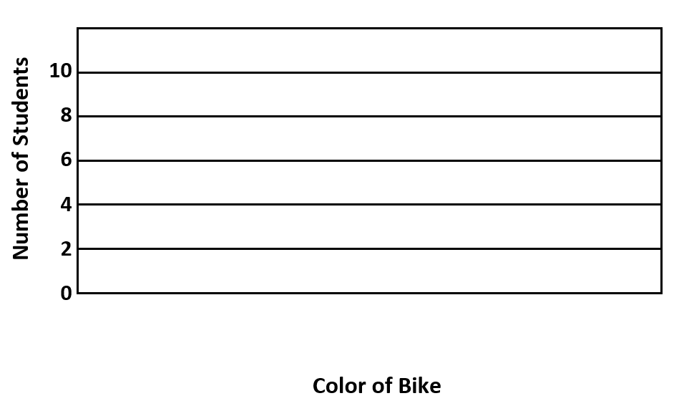

- Tonya recorded the amount of rainfall in Richmond for four weeks. This table shows the data she collected.

Rainfall in Richmond
Week | Number of Inches
1 | 5
2 | 2
3 | 3
4 | 6

Create a pictograph using the data Tonya collected.

Rainfall in Virginia
Week 1

Week 2

Week 3

Week 4

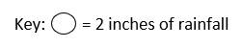

SOL 3.15a - Just in Time Quick Check Teacher Notes
Common Errors/Misconceptions and their Possible Indications

- Jaquan surveys students in his class to see what color of bike they each have. This table shows the results of the survey.

Bike Colors
Color of Bike | Number of Students
Blue | 6
Green | 5
Red | 3
Gray | 2

Create a bar graph using Jaquan’s data.
Students often have the misconception that all intervals on a bar graph are equal to 1 and may shade their bars all the way to the top for 6, to the 10 line for 5, to the 6 line for 3, and to the 4 line for 2. These students will benefit from collecting data and creating bar graphs with a variety of scale intervals and from skip counting by the interval used in the scale.
Students who do not shade the bar representing 5 halfway between 4 and 6 and the bar representing 3 halfway between 2 and 4 need more experiences representing quantities that fall between the intervals used in the scale on a bar graph. Opportunities to compare and contrast two different bar graphs that represent the same data but have different scales (e.g., a bar graph with a scale interval of 1 and a bar graph with a scale interval of 2), including class discussions about the similarities and differences in the representations, will be beneficial.
Students who do not give the graph a title or label the bars for the categorical axis will benefit from more experiences transferring data that have been collected into a graph. Access to blank bar graph templates that include empty boxes for the missing parts of a graph may be helpful as students develop this skill.
- Tonya recorded the amount of rainfall in Richmond for four weeks. This table shows the data she collected.

Rainfall in Richmond
Week | Number of Inches
1 | 5
2 | 2
3 | 3
4 | 6

Create a pictograph using the data Tonya collected.

Rainfall in Richmond
Week 1

Week 2

Week 3

Week 4

Students may represent 1 inch of rainfall with one circle and may not understand that $\frac{1}{2}$ of 1 circle should be used to represent 1 inch of rainfall in this pictograph. These students may not yet recognize that each symbol in a pictograph can represent a quantity greater than 1, and they may benefit from instruction in skip counting, even/odd numbers, and halving. More experiences analyzing and discussing data represented in pictographs that use half-symbols to represent quantities will be helpful. Some students may also have difficulty because the weeks are represented by numbers and the rainfall is represented by numbers. They may use the number of the week rather than the inches of rainfall to determine how many circles to put in each row.

