Just In Time Quick Check

Standard of Learning (SOL) 3.12b
Strand: Measurement and Geometry

Standard of Learning (SOL) 3.12b
The student will identify and name polygons with 10 or fewer sides.

Grade Level Skills:
- Identify and name polygons with 10 or fewer sides in various orientations:
  - triangle is a three-sided polygon;
  - quadrilateral is a four-sided polygon;
  - pentagon is a five-sided polygon;
  - hexagon is a six-sided polygon;
  - heptagon is a seven-sided polygon;
  - octagon is an eight-sided polygon;
  - nonagon is a nine-sided polygon;
  - decagon is a ten-sided polygon.
Just in Time Quick Check
Just in Time Quick Check Teacher Notes

Supporting Resources:
- VDOE Mathematics Instructional Plans (MIPS)
  - 3.12ab – Polygons Galore (word) / PDF Version
- VDOE Word Wall Cards: Grade 3 (Word) / PDF
  - Plane Figures
  - Polygons: Triangles
  - Polygons: Quadrilaterals
  - Polygons: Pentagon, Hexagon, Heptagon, Octagon
  - Polygons: Nonagon and Decagon
  - Rectangle: Right Angle
  - Square: Right Angle
  - Triangle: Side and Vertex
Supporting and Prerequisite SOL: 3.11, 3.12a, 2.13, 1.11a, 1.11b

SOL 3.12b - Just in Time Quick Check

- Determine the number of sides in each polygon in the table. Use the word bank to name each polygon.
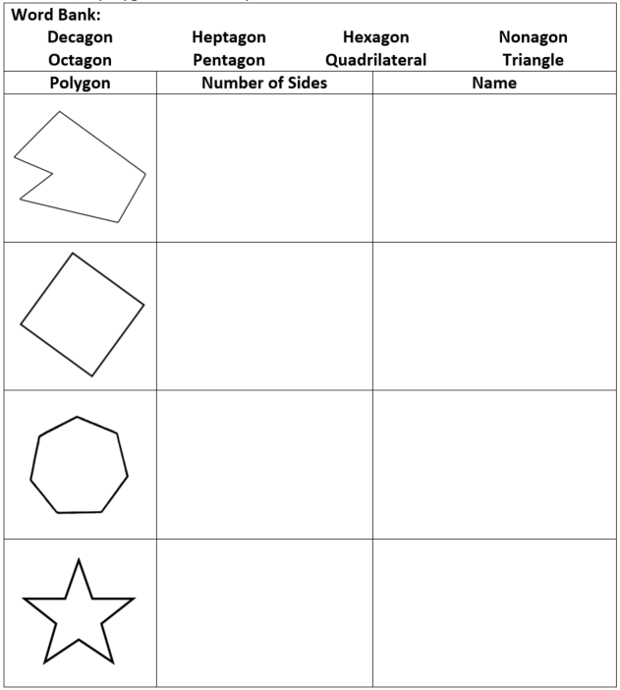

- You will need scissors, glue or tape, and a separate sheet of paper for this activity.
  - Write your name on the sheet of paper.
  - Cut out the polygons in the table below so that you have cards to sort.
  - Sort the cards into groups according to the number of sides in each polygon. Glue or tape each group of shapes to the sheet of paper.
  - Write the name for each group according to the number of sides.
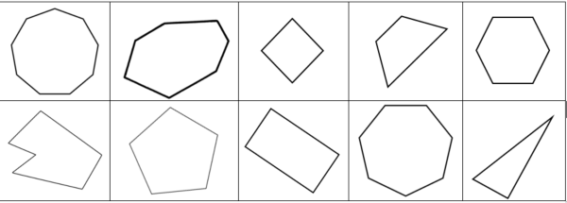

SOL 3.12b - Just in Time Quick Check Teacher Notes
Common Errors/Misconceptions and their Possible Indications

- Determine the number of sides in each polygon in the table. Use the word bank to name each polygon.
Students may be unsure of how to count the sides, especially if the shape is concave. Students may also confuse prefixes when naming polygons. These students will benefit from more opportunities to determine the number of sides of regular and irregular polygons. It is important that these experiences include concave polygons. Using varied materials (power polygons, pattern blocks, geoboards, etc.) is helpful. Students may benefit from drawing polygons on dot paper and labeling the number of sides on their figures.
Students will benefit from hearing and using the vocabulary used to name polygons during regular classroom instruction. Incorporating and encouraging the use of this vocabulary during class discussions is a meaningful way to provide practice with the prefixes used to name polygons. Teachers are encouraged to include real-life figures that represent the prefixes and meanings when possible (e.g., a piece of honeycomb is shaped like a hexagon; a playing card has four sides like a quadrilateral; home base for softball or baseball has five sides and is a pentagon, etc.). Making connections between the prefixes used in naming polygons and their environment helps students build understanding. It is important, however, to use real-life figures that do not have rounded corners as these violate the definition of polygon. It may be helpful for students to identify and name polygons in their home.
- You will need scissors, glue or tape, and a separate sheet of paper for this activity.
  - Write your name on the sheet of paper.
  - Cut out the polygons in the table below so that you have cards to sort.
  - Sort the cards into groups according to the number of sides in each polygon. Glue or tape each group of shapes to the sheet of paper.
  - Write the name for each group according to the number of sides.
Students may name the shapes based on the way they look instead of counting the number sides. Some students may need to mark each side as it is counted to prevent counting a side twice. Opportunities to fold paper shapes, change the number of sides, and rename the shapes accordingly can help students to see that though the shapes may look similar, the number of sides is different.

