Just In Time Quick Check

Standard of Learning (SOL) 3.12a
Strand: Measurement and Geometry

Standard of Learning (SOL) 3.12a
The student will define polygon.

Grade Level Skills:
- Define polygon.
- Classify figures as polygons or not polygons.
Just in Time Quick Check
Just in Time Quick Check Teacher Notes

Supporting Resources:
- VDOE Mathematics Instructional Plans (MIPS)
  - 3.12ab – Polygons Galore (word) / PDF Version
- VDOE Word Wall Cards: Grade 3 (Word) / PDF
  - Plane Figures
  - Polygons: Triangles
  - Polygons: Quadrilaterals
  - Polygons: Pentagon, Hexagon, Heptagon, Octagon
  - Polygons: Nonagon and Decagon
Supporting and Prerequisite SOL: 3.11, 3.12b, 2.13, 1.11a, 1.11b

SOL 3.12a - Just in Time Quick Check
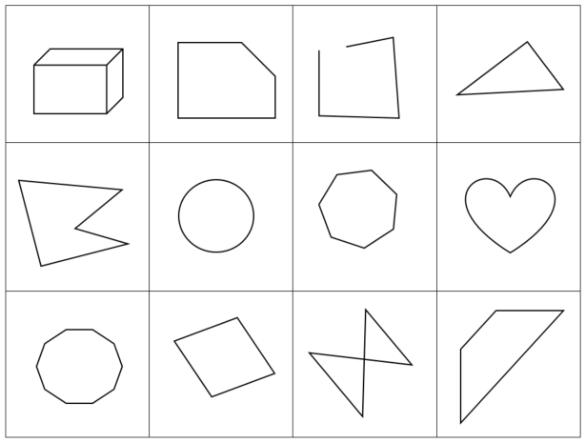
- Look at the table of shapes.
  - Draw 2 shapes from this table that are polygons. Write a sentence that explains why these 2 shapes are polygons.

  - Draw 2 shapes from this table that are not polygons. Write a sentence that explains why these 2 shapes are not polygons.

- On the table of shapes, draw an X on the shapes that are not polygons and circle the shapes that are polygons.

SOL 3.12a - Just in Time Quick Check Teacher Notes
Common Errors/Misconceptions and their Possible Indications
- Look at the table of shapes.
  - Draw 2 shapes from this table that are polygons. Write a sentence that explains why these 2 shapes are polygons.
A student may draw open figures, figures with curves or crossed segments, or three-dimensional figures as polygons. This error may indicate a need for more experience classifying figures with differing attributes. Opportunities to play “What’s My Rule” using a collection of shapes (including polygons and non-polygons) focuses attention on the similarities and differences between polygons and non-polygons. To play, the teacher selects a few shapes that fit a rule he/she has chosen. Without knowing the rule, the student selects a different shape that he/she believes fits the rule and places it in the group. Shapes that fit the rule remain in the group, but the teacher moves shapes that do not fit the rule outside the group. The student describes the rule after sorting all the shapes.
  - Draw 2 shapes from this table that are not polygons. Write a sentence that explains why these 2 shapes are not polygons.
A student may draw polygons instead of figures that are not polygons, which may indicate a need for more experience classifying figures with differing attributes. Opportunities to play “What’s My Rule” using a collection of shapes (including polygons and non-polygons) focuses attention on the similarities and differences between polygons and non-polygons See the teacher notes for #1a for how to play this game.
- On the table of shapes, draw an X on the shapes that are not polygons and circle the shapes that are polygons.
A student may fail to classify concave or irregular figures as polygons. To build understanding, provide the student opportunities to work with figures having a variety of characteristics and include concave figures and irregular figures for the student to consider. Use pictures of figures to allow the student to consider the same figures in different spatial orientations to deepen conceptual understanding. Use geoboards as another useful tool to create figures that are polygons and figures that are not polygons.

