Just in Time Quick Check

Standard of Learning (SOL) 3.11
Strand: Measurement and Geometry

Standard of Learning (SOL) 3.11
The student will identify and draw representations of points, lines, line segments, rays, and angles.

Grade Level Skills:
- Identify examples of points, lines, line segments, rays, and angles.
- Describe endpoints and vertices as they relate to lines, line segments, rays, and angles.
- Draw representations of points, line segments, rays, angles, and lines, using a ruler or straightedge.

Just in Time Quick Check

Just in Time Quick Check Teacher Notes

Supporting Resources:
- VDOE Mathematics Instructional Plans (MIPS)
- Folded Geometry (Word) / PDF Version
- The Point of Geometry (Word) / PDF Version
- VDOE Word Wall Cards: Grade 3 (Word) / PDF
  - Line segment
  - Point
  - Angle
  - Line
  - Ray
Supporting and Prerequisite SOL: N/A

SOL 3.11 - Just in Time Quick Check

- Complete the chart below. Use a ruler to draw your pictures.
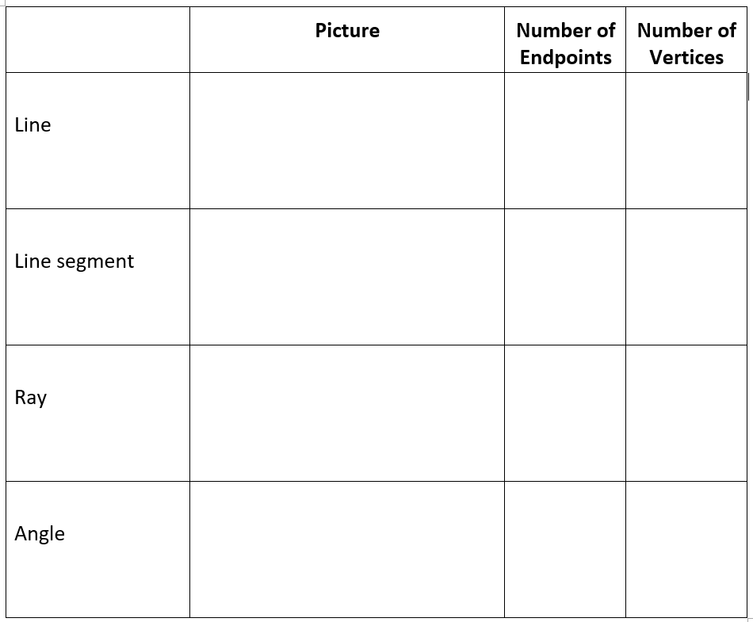
- On each picture you drew:
  - Circle all of the endpoints.
  - Label all of the vertices with a “V.”

SOL 3.11 - Just in Time Quick Check Teacher Notes
Common Errors/Misconceptions and their Possible Indications

- Complete the chart below. Use a ruler to draw your pictures.

Students who confuse these vocabulary terms may need more time identifying and describing the similarities among and differences between these attributes, in isolation as well as within other figures. Teachers are encouraged to provide and discuss examples of lines, line segments, rays, and angles (VDOE Wall Cards can support this work), along with opportunities for students to draw representations using a ruler.
- On each picture you drew:
  - Circle all of the endpoints.
  - Label all of the vertices with a “V.”
Students may confuse endpoints and vertices. This error indicates that while students do understand that each term describes a specific location on certain types of figures, they would benefit from additional experiences differentiating between vertices and endpoints.

