Just in Time Quick Check
Standards of Learning SOL 3.10
Strand: Measurement and Geometry

Standard of Learning (SOL) 3.10
The student will read temperature to the nearest degree.

Grade Level Skills:
- Read Celsius and Fahrenheit temperatures to the nearest degree using real thermometers, physical models, or pictorial representations.
Just in Time Quick Check
Just in Time Quick Check Teacher Notes

Supporting Resources:
- VDOE Mathematics Instructional Plans (MIPS)
  - 3.10 - What’s the Temperature Now? (Word) / PDF Version
- VDOE Word Wall Cards: Grade 3 (Word) | (PDF)
- Celsius
- Fahrenheit
- Difference
- Temperature
- Thermometer
Supporting and Prerequisite SOL: 2.2a, 2.11, 1.1d

SOL 3.10 - Just in Time Quick Check
- Look at the thermometer.
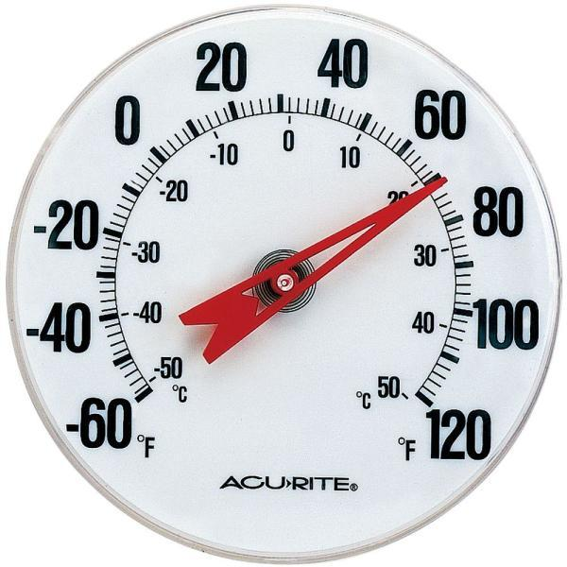
What is the temperature shown on the thermometer in degrees Fahrenheit? ___________ ⁰ F
- Look at the thermometer.
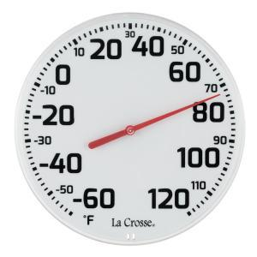
Based on the temperature, Bobby and his brothers plan to play basketball in the park. What is the temperature in degrees Fahrenheit?
____________ ⁰ F

3. Look at the thermometer.
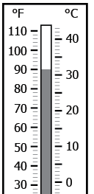
What is the temperature in degrees Fahrenheit? _________ °F
What is the temperature in degrees Celsius? _________ °C

4. Look at the thermometer. Shade the thermometer to show 55⁰F.
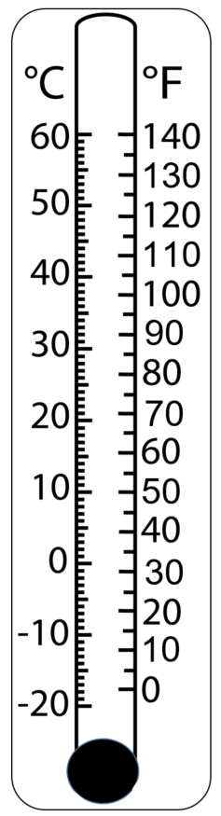
5. Look at the thermometer. Shade the thermometer to show 44⁰C.
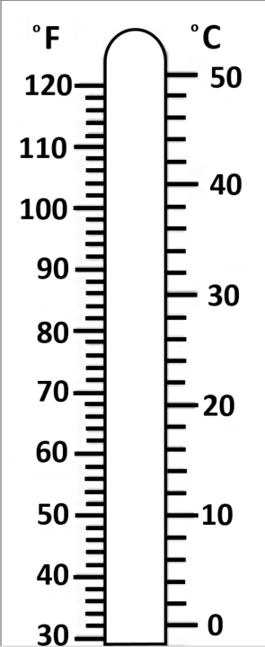

SOL 3.10 - Just in Time Quick Check Teacher Notes
Common Errors/Misconceptions and their Possible Indications

1. Look at the thermometer.
What is the temperature shown on the thermometer in degrees Fahrenheit?
___________ ⁰ F
Students may look at this thermometer and feel it shows a temperature of 66°F. This error may indicate students have not recognized that the scale on this thermometer has increments of 2 and that 70 is not labeled. Some students may need more exposure to circular thermometer models. Students may struggle with the patterns of various thermometers’ tick marks. It will be helpful to have students justify their answers, as encouraging communication will give formative assessment data and allow the teacher a better understanding of students’ thought processes when working with thermometers.

- Look at the thermometer.

Based on the temperature, Bobby and his brothers plan to play basketball in the park. What is the temperature in degrees Fahrenheit?
____________ ⁰ F
Students may read the temperature shown as 71°F. This error indicates students are counting tick marks in increments of 1 instead of 2. Students might also count from the wrong direction and think that the temperature shown is 84°F (counting by one up from 80) or 88°F (counting by 2’s up from 80). Students benefit from work with a variety of thermometer models that require them to first identify the scale used and then to skip count by the appropriate increment, as tick marks (scale) can be in increments of 1 or 2 degrees. Be mindful that temperature can be addressed throughout the instructional day and may be integrated with the Grade 3 Science curriculum (Scientific Investigations). Refer to the Grade 3 Curriculum Framework.
3. Look at the thermometer.
What is the temperature in degrees Fahrenheit? _________ °F
What is the temperature in degrees Celsius? _________ °C
Students may mix up the units and provide an incorrect temperature when moving from Celsius to Fahrenheit and vice versa. As students continue to practice reading the temperature on thermometers, it is important to stress that the unit must be named (i.e., degrees Celsius or degrees Fahrenheit).

4. Look at the thermometer. Shade the thermometer to show 55⁰F.
Students may shade 55°C, which indicates a lack of attention to the unit of measure. Practice with thermometers that measure temperature in both degrees Celsius and degrees Fahrenheit helps students understand the importance of attending to the unit of measure.

5. Shade the thermometers to show 44⁰C.
Students may represent 48°C, which indicates the students do not realize the tick marks are in increments of 2. Some students may represent 44°F, indicating a lack of attention to the unit of measure. During instruction with thermometers, emphasize the unit of measure and have students identify the increment used by the scale, which will give students a focus and foster consistency. In your conversations with students, be sure they associate temperatures with appropriate everyday occurrences.

