Just In Time Quick Check

Standard of Learning (SOL) 3.8b
Strand: Measurement and Geometry

Standard of Learning (SOL) 3.8b
The student will estimate and count the number of square units needed to cover a given surface in order to determine its area.

Grade Level Skills:
- Determine the area of a given surface by estimating and then counting the number of square units needed to cover the surface.
Just in Time Quick Check
Just in Time Quick Check Teacher Notes

Supporting Resources:
- VDOE Mathematics Instructional Plans (MIPS)
  - 3.8ab – Measuring Area and Perimeter (Word) / PDF Version
  - 3.8b – Measuring Surface Area (Word) / PDF Version
- VDOE Word Wall Cards: Grade 3 (Word / PDF)
  - Area: Square Units
Supporting and Prerequisite SOL: 3.8a, 1.1d

SOL 3.8b - Just in Time Quick Check
Note to teacher: Provide the student one-inch tiles for question 2.

- What is the area of the figure shaded on the grid?

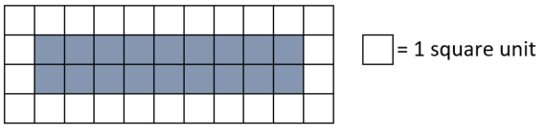

- Use the figure below and one-inch tiles to answer the following questions.

  - Estimate the area of this figure in square inches. _________________
  - Use one-inch tiles to find the area of this figure. ______________

- Create two different figures that each have an area of 12 square centimeters on the grid.
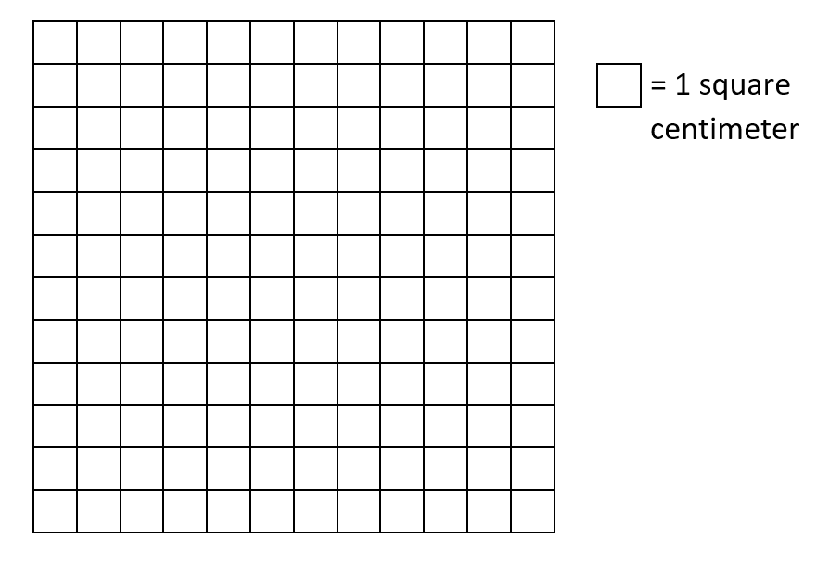

SOL 3.8b - Just in Time Quick Check Teacher Notes
Common Errors/Misconceptions and their Possible Indications

Note to teacher: Provide the student one-inch tiles for question 2.

- What is the area of the figure shaded on the grid?

Students may confuse area and perimeter or they may count all of the square units on the grid. Students who confuse area and perimeter will benefit from experiences that make meaning of area. Activities in which students physically cover a space with square units to find its area will help to build conceptual understanding for area. Hands-on activities in which area is determined in non-standard units may also be helpful. For example, students can find the number of square sticky notes that are needed to cover the top of a desk to determine the area of the desktop in square sticky notes, then use one side of the square sticky note to find the perimeter of the same desktop).
- Use the figure below and one-inch tiles to answer the following questions.
  - Estimate the area of this figure in square inches. _________________
  - Use one-inch tiles to find the area of this figure. ______________
Students whose estimates are unreasonable will benefit from hearing peers’ strategies for estimation, which might include drawing squares that are approximately one-inch by one-inch on the given figure before covering or measuring to determine the actual area. Students may not cover the entire figure, which may indicate confusion and lack of experience with concave polygons and determining area. Students need many opportunities to determine the area of various polygons by covering polygons with tiles and counting the squares to find the area. Students benefit from real-world experiences finding the area of different surfaces in the classroom (ex. name tag, top of desk, notebooks, erasers, etc.) by covering the surface with square tiles or one-inch grid paper. Students who may confuse the unit as linear will benefit from more experience using the vocabulary to describe area (i.e., square inches, square centimeters).
- Create two different figures that each have an area of 12 square centimeters on the grid.
Students may create figures that have a perimeter of 12 centimeters, indicating confusion between area and perimeter. Students may color the entire grid, creating one 12 by 12 figure. For both misconceptions, students will benefit from more experiences creating figures with a given area (as well as figures with a given perimeter). These experiences help students build understanding that figures can have the same area even if their shapes or spatial orientations are different. Classroom discussions during which students compare and contrast figures and their measurements are encouraged.

