Just In Time Quick Check

Standard of Learning (SOL) 3.7b
Strand: Measurement and Geometry

Standard of Learning (SOL) 3.7b
The student will estimate and use U.S. Customary and metric units to measure liquid volume in cups, pints, quarts, gallons, and liters.

Grade Level Skills:
- Estimate and use U.S. Customary and metric units to measure liquid volume to the nearest cup, pint, quart, gallon, and liter.
- Determine the actual measure of liquid volume using U.S. Customary and metric units to measure to the nearest cup, pint, quart, gallon, and liter.
Just in Time Quick Check
Just in Time Quick Check Teacher Notes

Supporting Resources:
- VDOE Mathematics Instructional Plans (MIPS)
  - Measuring Liquid Volume (Word) / PDF Version
- VDOE Word Wall Cards: Grade 3 (Word) / PDF
  - Cup
  - Gallon
  - Liter
  - Pint
  - Quart
Supporting and Prerequisite SOL: 1.10

SOL 3.7b - Just in Time Quick Check

- Henry had an empty jar that holds 4 cups. He poured juice into the jar as shown below.

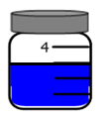

How many cups of juice did Henry pour into the jar?

- Look at this fish tank. The scale beside the fish tank is in liters. About how many liters of water are in this fish tank?

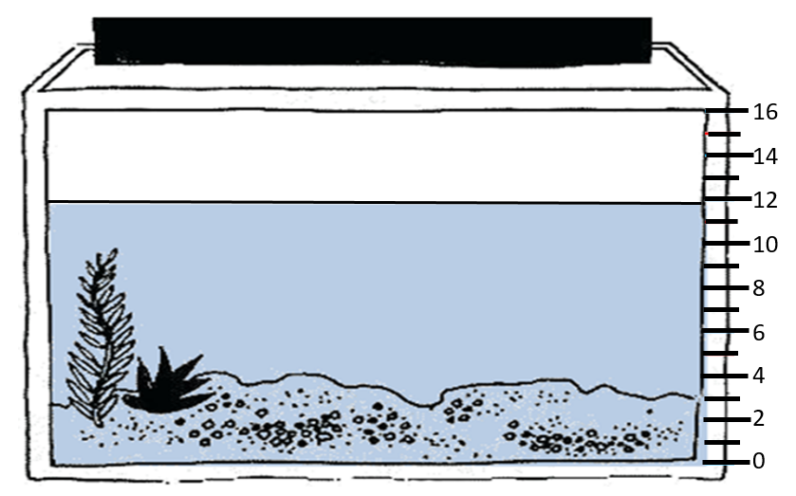

- Each picture shows a container with some liquid inside. Draw a line from each container to the most reasonable estimate for the amount of liquid inside that container.
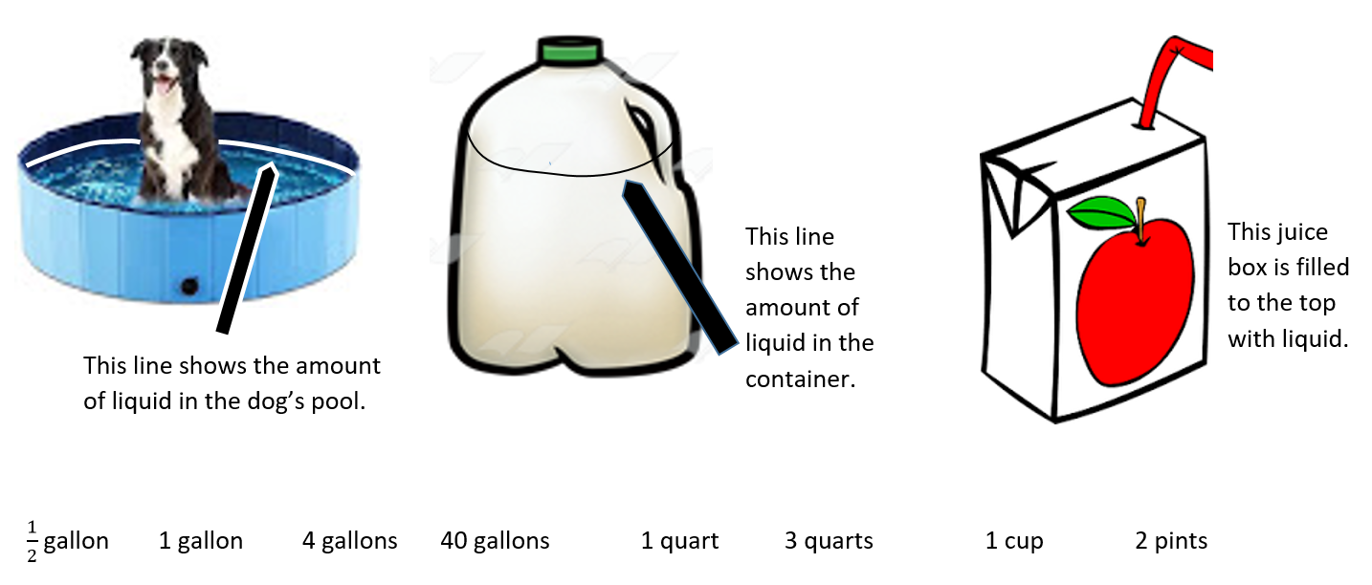

SOL 3.7b - Just in Time Quick Check Teacher Notes
Common Errors/Misconceptions and Their Possible Indications
- Henry had an empty jar that holds 4 cups. He poured juice into the jar as shown below.

How many cups of juice did Henry pour into the jar?
Students may answer 4 cups, since that amount is mentioned in the question and labeled in the figure, or they may answer 2 cups, thinking that each increment represents 2 cups. Students need more experiences measuring liquids with actual measuring cups that have different capacities and scales. Weekly measuring stations provide regular opportunities for students to practice estimation and measuring skills.
- Look at this fish tank. The scale beside the fish tank is in liters. About how many liters of water are in this fish tank?

Students may report that 16 liters of water are contained in the tank since that is the maximum capacity labeled. Students may report that the fish tank holds 11 liters of water since the fill line is slightly below 12. Students would benefit from more experiences measuring liquids in a variety of contexts.
- Each picture shows a container with some liquid inside. Draw a line from each container to the most reasonable estimate for the amount of liquid inside that container.

Students may indicate that the dog’s pool contains 4 gallons, indicating they have not developed an understanding of large volumes of liquid and need more experiences exploring with gallons. Providing opportunities to estimate and then determine the number of gallons needed to fill different large containers will help students understand the magnitude of one gallon. Similarly, opportunities to use one gallon of water to determine the number of smaller containers that can be filled helps build understanding for this unit.
Students may select 1 gallon for the milk container, indicating familiarity with the unit and the type of container but also indicating that students are unsure how the fill line should impact their estimate. Students may select 1 quart for the milk container, indicating that students recognize that the estimate should be less than one gallon but also indicating that students lack understanding of the relationship between quarts and gallons. These students would benefit from more hands-on experiences with quarts and gallons to build understanding of the relationships between these units.
Students may select 2 pints for the juice box, indicating that students need more experiences with this unit of measure. Students may select $\frac{1}{2}$ gallon for the juice box, which may indicate that students understand this container has the smallest capacity of the containers shown and are drawn to $\frac{1}{2}$ while ignoring the unit of measure. These students need more experience with different units of measure to build understanding of the significance of the units represented in a measurement.

