Just In Time Quick Check

Standard of Learning (SOL) 3.6c
Strand: Measurement and Geometry

Standard of Learning (SOL) 3.6c
The student will make change from $5.00 or less.

Grade Level Skills:
- Make change from $5.00 or less.
Just in Time Quick Check
Just in Time Quick Check Teacher Notes

Supporting Resources:
- VDOE Mathematics Instructional Plans (MIPS)
  - Money Counts (Word) / PDF Version
- VDOE Co-Teaching Mathematics Instruction Plans (MIPS)
  - Money and Change (Word) / PDF Version
- VDOE Word Wall Cards: Grade 3 (Word) / PDF
  - Dime
  - Dollar
  - Nickel
  - Penny
  - Quarter
Supporting and Prerequisite SOL: 3.6a, 3.6b, 2.2a, 2.6b, 2.7a, 1.1d, 1.8

SOL 3.6c - Just in Time Quick Check

- Alex is buying an ice cream cone for $1.73. He gives the clerk a five-dollar bill. How much change should Alex receive?
Circle bills and coins to show the amount of change Alex should receive.

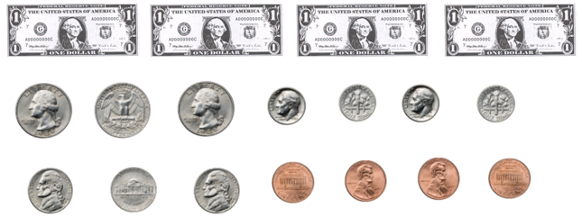

- Luke is buying a candy bar that costs $1.29. He gives the clerk the amount of money shown.

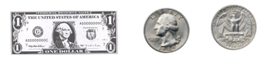
How much change should Luke receive?

- Naomi bought a gallon of milk at the store. She gave the clerk $3.00. The picture shows the change she received.
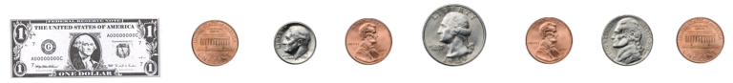

How much did this gallon of milk cost?

SOL 3.6c - Just in Time Quick Check Teacher Notes
Common Errors/Misconceptions and Their Possible Indications
- Alex is buying an ice cream cone for $1.73. He gives the clerk a five-dollar bill. How much change should Alex receive?
Circle bills and coins to show the amount of change Alex should receive.

Students may circle bills and coins with a value of $1.73, the cost of the ice cream cone. This indicates that students can count coins and bills to represent a given amount of money, but it also indicates a lack of understanding of the concept of change or the question itself. Students who struggle with making change may benefit from more experiences with the following strategies:
- counting on to the cost, using coins and bills; and
- counting forward to the next dollar, then counting forward by dollar bills to reach the amount paid.
Students may circle bills and coins having a value of $4.37, which may indicate an attempt to calculate the difference without regrouping. Note that computation with money is not part of this standard. Teachers are encouraged to provide opportunities for students to make change using the strategies above.
- Luke is buying a candy bar that costs $1.29. He gives the clerk the amount of money shown.

How much change should Luke receive?
Students may add the amount of money given in the problem to the amount of money shown by counting on, which indicates a lack of understanding of the question and/or the “making change” context described. These students would benefit from additional experiences in which they act out the context to develop understanding.
Students may recognize this as a subtraction situation and make a calculation mistake when subtracting $1.29 from $1.50. As noted above, computation with money is not part of this standard. Teachers are encouraged to provide opportunities for students to make change using the strategies described in question 1.
Students who have difficulty counting a set of money or counting up to make change would benefit from hands-on practice using coins and bills.
If students can count coins and bills but struggle with making change, they may benefit from more experiences with the following strategies:
- counting on to the cost, using coins and bills; and
- counting forward from the cost to the next dollar, then counting forward by dollar bills to reach the amount paid.
- Naomi bought a gallon of milk at the store. She gave the clerk $3.00. The picture shows the change she received.

How much did this gallon of milk cost?
Student may add on the amount of money shown by counting up from $3.00, which indicates students may not understand what to do when given the change received instead of the original cost. These students would benefit from experiences acting out different contexts that involve making change.
Students who can count coins and bills but struggle with using the change given to find the original cost may benefit from more experiences with the following strategies:
- counting on from the change received, using coins and bills; and
- counting forward from the change received to the next dollar, then counting forward by dollar bills to reach the amount paid.

