Just In Time Quick Check

Standard of Learning (SOL) 3.6b
Strand: Measurement and Geometry

Standard of Learning (SOL) 3.6b
The student will compare the value of two sets of coins or two sets of coins and bills.

Grade Level Skills:
- Compare the values of two sets of coins or two sets of coins and bills, up to $5.00, using the terms greater than, less than, and equal to.
Just in Time Quick Check
Just in Time Quick Check Teacher Notes

Supporting Resources:
- VDOE Mathematics Instructional Plans (MIPS)
  - 3.6abc - Money Counts (Word) / PDF Version
- VDOE Co-Teaching Mathematics Instruction Plans (MIPS)
  - 3.6 - Money and Change (Word) / PDF Version
- VDOE Word Wall Cards: Grade 3 (Word) | (PDF)
  - Penny
  - Nickel
  - Dime
  - Quarter
  - Dollar
- VDOE Rich Mathematical Tasks
- 3.6ab Money in the Piggy Bank Task Template (Word) / PDF Version
- 3.6ab Money in the Piggy Bank Student Version of Task (Word) / PDF Version
- 3.6ab Money in the Piggy Bank Anchor Papers (Word) / PDF Version
- 3.6ab Money in the Piggy Bank Anchor Papers Scoring Rationales (Word) / PDF Version
Supporting and Prerequisite SOL: 3.1c, 3.6a, 2.2a, 2.7a, 1.1d, 1.8

SOL 3.6b - Just in Time Quick Check

Circle the words to compare the sets of money shown.

- Set Y Set M
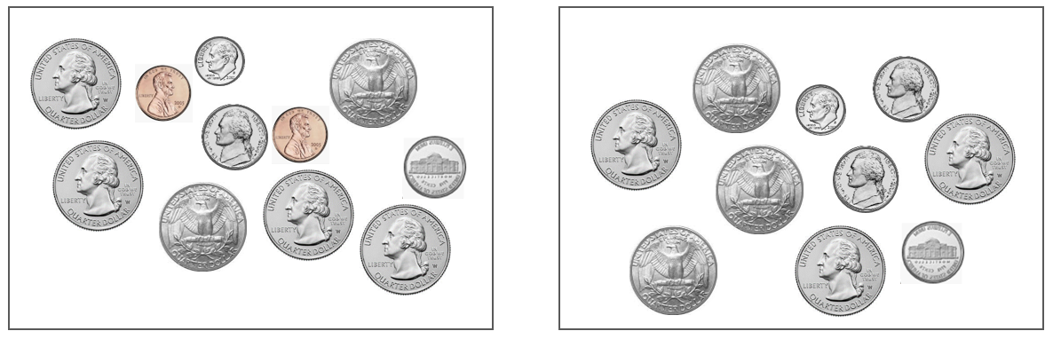

greater than
The value of Set Y is less than the value of Set M.
equal to

- Set T Set X
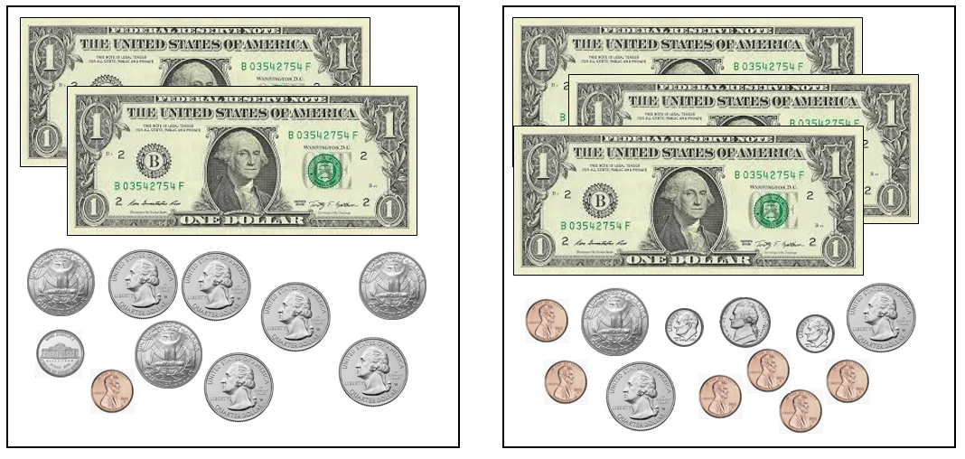

greater than
The money in Set T has a total value less than the total value of Set X.
equal to

SOL 3.6b - Just in Time Quick Check Teacher Notes
Common Errors/Misconceptions and their Possible Indications

Circle the words to compare the sets of money shown.

- Set Y Set M

greater than
The value of Set Y is less than the value of Set M.
equal to
Students may believe that Set Y has the greater value because it has more coins than Set M. These students would benefit from exposure to more strategies for comparing sets of money. Determining the numbers of like coins among the sets may help students decide which set of money has a greater value. For example, Set Y and Set M have the same number of quarters. Also, Set Y and Set M each have exactly one dime. Set Y has 2 nickels, but Set M has 3 nickels. Set Y has 2 pennies, but there are no pennies in Set M. Opportunities to share and practice different methods for comparing the values of sets of coins and bills helps students develop strategies that are both flexible and efficient.
- Set T Set X

greater than
The money in Set T has a total value less than the total value of Set X.
equal to

Students who do not recognize that these sets of money have the same value may be relying on the number of one-dollar bills in each set, focusing only on the largest denomination in each set. In this example, students may think that since Set T has 2 one-dollar bills and Set X has 3 one-dollar bills, Set X must have the greater value. Students may ignore all of the coins in the sets since each individual coin has a value less than one dollar. Other students may believe that Set T has a greater value because it has more quarters than set X, or they may believe Set X has the lesser value because it has more pennies than Set T. Students who have these misconceptions would benefit from more experiences comparing sets of coins and bills. Hearing peers’ strategies for comparing sets of money in which the coins have not been arranged or ordered by value helps students consider different efficient methods. Note that at this grade level, computation is not used to determine the values of sets of money and should not be a focus of instruction.

