Just in Time Quick Check

Standard of Learning (SOL) 3.6a
Strand: Measurement and Geometry

Standard of Learning (SOL) 3.6a
The student will determine the value of a collection of bills and coins whose total value is $5.00 or less.

Grade Level Skills:
- Determine the value of a collection of coins and bills whose total value is $5.00 or less.
Just in Time Quick Check
Just in Time Quick Check Teacher Notes

Supporting Resources:
- VDOE Mathematics Instructional Plans (MIPS)
  - 3.6abc - Money Counts (Word) / PDF Version
- VDOE Co-Teaching Mathematics Instruction Plans (MIPS)
  - 3.6 - Money and Change (Word) / PDF Version
- VDOE Word Wall Cards: Grade 3 (Word) | (PDF)
  - Penny
  - Nickel
  - Dime
  - Quarter
  - Dollar
- VDOE Rich Mathematical Tasks
- 3.6ab Money in the Piggy Bank Task Template (Word) / PDF Version
- 3.6ab Money in the Piggy Bank Student Version of Task (Word) / PDF Version
- 3.6ab Money in the Piggy Bank Anchor Papers (Word) / PDF Version
- 3.6ab Money in the Piggy Bank Anchor Papers Scoring Rationales (Word) / PDF Version
Supporting and Prerequisite SOL: 2.2a, 2.7a, 1.1d, 1.8

SOL 3.6a - Just in Time Quick Check

- Write the value next to each set of money.
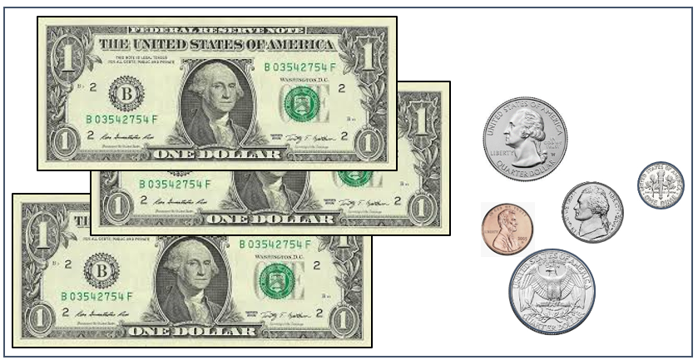
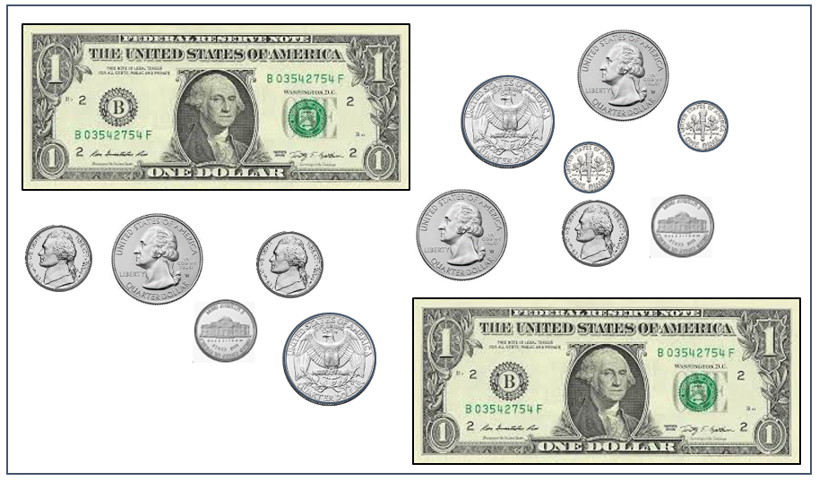

- Using the symbols in the key, draw a set of money with a total value of $4.87.

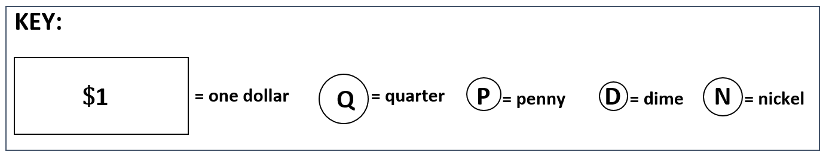

SOL 3.6a - Just in Time Quick Check Teacher Notes
Common Errors/Misconceptions and their Possible Indications

- Write the value next to each set of money.
Students may be unable to recognize the backs of coins, or they may be unable to determine how to count a set of coins in which like coins are not grouped or ordered (e.g., the quarters in this set are not together, and the coins are not arranged from the greatest value to the least). These students will benefit from more practice counting physical sets of coins to allow them to develop strategies for grouping and/or counting on. Opportunities to share and practice strategies with peers may also help students develop efficient methods for counting sets of money.

Students may have difficulty counting the change and crossing over to the next dollar amount. Students may also have difficulty because the coins have not been grouped or ordered according to value. Opportunities to share and practice strategies for counting sets of coins and bills, first using manipulatives and later moving to pictorial representations, may be helpful. More experiences with skip counting by the values of coins and keeping track with a hundreds charts or number line, may also be beneficial.

- Using the symbols in the key, draw a set of money with a total value of $4.87.
Students who are unable to represent the correct value need more experiences with lesser amounts of money. Exposure to peers’ strategies may be helpful.
A variety of correct responses should be expected, but sets of money that do not reflect an understanding of the values of the different coins available should be investigated further (e.g., using 87 pennies to represent the 87 cents rather than a combination of coins). If this occurs, the teacher could ask, “Can you draw another set of money using fewer coins that has the same total value?”

