Just In Time Quick Check
Standard of Learning SOL 3.5
Strand: Computation and Estimation

Standard of Learning (SOL) 3.5
The student will solve practical problems that involve addition and subtraction with proper fractions having like denominators of 12 or less.

Grade Level Skills:
- Solve practical problems that involve addition and subtraction with proper fractions having like denominators of 12 or less, using concrete and pictorial models representing area/regions (e.g., circles, squares, and rectangles), length/measurements (e.g., fraction bars and strips), and sets (e.g., counters).
Just in Time Quick Check
Just in Time Quick Check Teacher Notes

Supporting Resources:
- VDOE Mathematics Instructional Plans (MIPS)
  - Adding and Subtracting Fractions (Word) | (PDF Version)
- VDOE Word Wall Cards: Grade 3 (Word) | (PDF)
  - Fraction: Addition
  - Fraction: Subtraction
  - Fraction: Models for one-half/one-fourth
  - Fraction: Models for two-thirds
  - Fraction: Models for five-sixths
  - Fraction: Models for three-eighths
  - Numerator/Denominator
  - Proper Fraction
  - Improper Fraction
  - Mixed Number
Supporting and Prerequisite SOL: 3.2a, 3.2b, 3.3b, 2.4a, 2.4b, 2.6c, 1.4a, 1.4b

SOL 3.5 - Just in Time Quick Check

- This model is shaded to show 1 whole pizza.
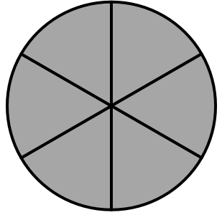

Sid ate $\frac{3}{6}$ of his pizza. Matt ate $\frac{4}{6}$ of his pizza.
This model has $\frac{3}{6}$ shaded. This model has $\frac{4}{6}$ shaded.
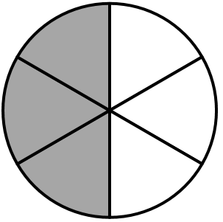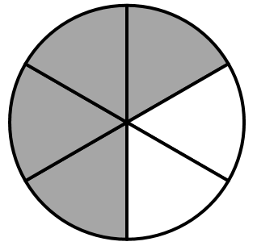

What is the difference between the fraction of a pizza Matt ate and the fraction of a pizza Sid ate?

- Robin and Donna each have a set of seven color tiles. Their tiles are red (R), green (G), and blue (B).
- Robin has $\frac{3}{7}$ red tiles.
- Donna has $\frac{5}{7}$ red tiles.
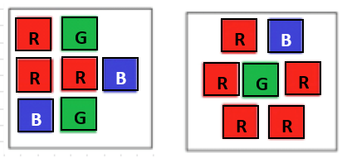
Robin’s Set of Tiles Donna’s Set of Tiles

The difference between the fraction of Donna’s set of tiles that is red and the fraction of Robin’s set of tiles that is red is _______________.

- Casey and Madeline will combine some ribbon to make a bow. The models below show how much ribbon, in feet, they each have.

Casey has $\frac{4}{6}$ foot of ribbon.
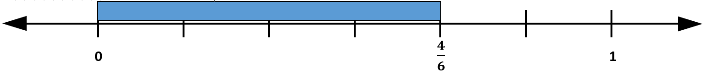

Madeline has $\frac{5}{6}$ foot of ribbon.
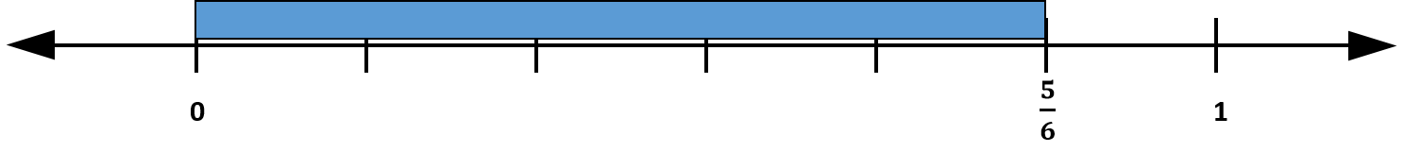
How much ribbon do Casey and Madeline have altogether?

SOL 3.5 - Just in Time Quick Check Teacher Notes
Common Errors/Misconceptions and their Possible Indications
- This model is shaded to show 1 whole pizza.

Sid ate $\frac{3}{6}$ of his pizza. Matt ate $\frac{4}{6}$ of his pizza.
This model has $\frac{3}{6}$ shaded. This model has $\frac{4}{6}$ shaded.
What is the difference between the fraction of a pizza Matt ate and the fraction of a pizza Sid ate?
Students who find the sum instead of the difference need additional opportunities to make sense of the context and the question. Strategies such as ‘three reads’ will help students strengthen their ability to make sense of and solve practical problems. The three reads strategy encourages students to read the problem three times: the first read is to understand the context, the second is to understand the math, and the third is meant to elicit questions based on the scenario. As students solve and explain their thinking and/or strategies during problem solving, listen for opportunities to model this for students.
Students who add and find the sum to be $\frac{7}{12}$ are adding the numerators and the denominators, indicating a need for additional work with hands-on models to find the sums by counting the unit fractions in order to name the sum.
- Robin and Donna each have a set of seven color tiles. Their tiles are red (R), green (G), and blue (B).
- Robin’s set of tiles is $\frac{3}{7}$ red.
- Donna’s set of tiles is $\frac{5}{7}$ red.
Robin’s Set of Tiles Donna’s Set of Tiles
The difference between the fraction of Donna’s set of tiles that is red and the fraction of Robin’s set of tiles that is red is _______________.
Students who find the answer is $\frac{2}{0}$ have subtracted the numerator and the denominator using their understanding of whole number computation. This error could be an indication that students have not yet developed a basic understanding of fractions and will benefit from additional opportunities to create fractions, name the parts, and compare models of fractions using various representations. It will be helpful for students to use concrete models (i.e., fraction bars or fraction circles) to solve subtraction problems and then count the remaining unit fractions to name the result. These students may also benefit from experiences in which peers share their practical problem-solving strategies, use models to represent their thinking, and demonstrate their understanding of fractional operations through mathematical discourse. As students make sense of computing with fractions, it will be helpful to have them consider questions such as: “What do you notice about how fractions are added or subtracted when the denominators are the same? Why do you think that happens?” They will begin to see that if you start with sevenths, take away (or add up sevenths), you will end with sevenths.
Students who find the answer is 2 have used whole number thinking, subtracting the number of red tiles in Robin’s set from the number of red tiles in Donna’s set. These students need additional opportunities to make sense of fractions. The use of concrete models to represent a set and identify each of the fractions that make up the whole set may be helpful in developing students’ understanding of fractions of a set.
- Casey and Madeline will combine some ribbon to make a bow. The models below show how much ribbon, in feet, they each have.

Casey has $\frac{4}{6}$ foot of ribbon.

Madeline has $\frac{5}{6}$ foot of ribbon.
How much ribbon do Casey and Madeline have altogether?
Students who find the answer to be $\frac{9}{12}$ have added the numerator and the denominator. These students may benefit from using estimation as a way to consider the reasonableness of a sum. For these two fractions, since each is more than one-half but less than one, the sum will be between 1 and 2; thus, $\frac{9}{12}$ is not a reasonable total. These students may also benefit from using the number line to count on unit fractions to find the sum. For this problem students could start at $\frac{5}{6}$ and count on the additional four-sixths ($\frac{6}{ 6 }$, $\frac{7}{6}$, $\frac{8}{6}$, $\frac{9}{6}$ ). Students who have difficulty when they reach the “end” of the number line given may need more experiences with number lines that extend past one whole.
Students may answer $\frac{9}{6}$ but struggle with forming a mixed number. While both the improper fraction and mixed number are correct responses for this situation, teachers may want to ask students questions such as: “Does $\frac{9}{6}$ represent less than one foot of ribbon or more than one foot of ribbon?” “Do you know another way to name or write that fraction?”
Students may answer 9, using whole numbers rather than fractions. These students would benefit from more experiences using a variety of length/measurement models (fraction bars and strips or number lines) to solve problems involving fractions with like denominators.
In each of these situations, students will benefit from more exposure to and practice with a variety of practical problem-solving strategies presented by their peers. These experiences may help students develop flexible strategies for computation and problem solving with fractions.

