Just In Time Quick Check

Standard of Learning (SOL) 3.2c
Strand: Number and Number Sense

Standard of Learning (SOL) 3.2c
The student will compare fractions having like and unlike denominators, using words and
symbols (>, <, =, or ≠), with models.

Grade Level Skills:
- Compare a model of a fraction, less than or equal to one, to the benchmarks of 0, $\frac{1}{2}$, and 1.
- Compare proper fractions using the terms greater than, less than, equal to, or not equal to and the symbols (<, >, =, and ≠). Comparisons are made between fractions with both like and unlike denominators, with concrete or pictorial models.
Just in Time Quick Check
Just in Time Quick Check Teacher Notes

Supporting Resources:
- VDOE Mathematics Instructional Plans (MIPS)
  - Comparing Fractions (word)/PDF
- VDOE Co-Teaching Mathematics Instruction Plans (MIPS)
  - Comparing Fractions (word)/PDF
- VDOE Word Wall Cards: Grade 3 (Word/PDF)
  - Fraction: Models for one-half/one-fourth
  - Fraction: Models for two-thirds
  - Fraction: Models for five-sixths
  - Fraction: Models for three-eighths
  - Numerator/Denominator
- VDOE Instructional Videos for Teachers
  - Comparing and Ordering Fractions (Grades 2 and 3)
  - Models for Teaching Fractions (Grades 3-8)
- Grade 3 Mathematics Standards of Learning: Student Performance Analysis 2019
- Desmos Activity
  - Comparing Fractions using Benchmarks and Models
Supporting and Prerequisite SOL: 3.1c, 3.2a, 3.2b, 2.4a, 2.4b, 2.4c, 1.2b, 1.2c, 1.4b

SOL 3.2c - Just in Time Quick Check

- Write a number sentence using >, <, $=$, or $≠$ to compare the fractions shaded in the circles.

- Use the number line to help you decide which symbol to write in the blank: >, <, or $=$.
$\frac{1}{2}$ ________ $\frac{3}{4}$

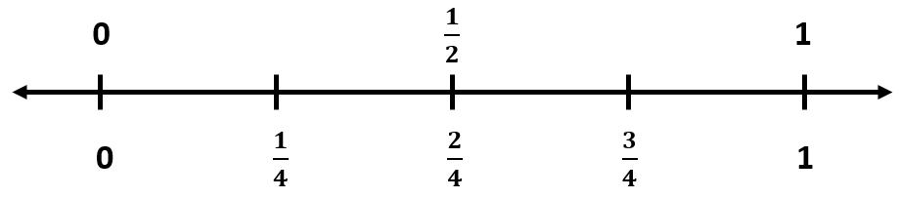

- Look at these fraction models.
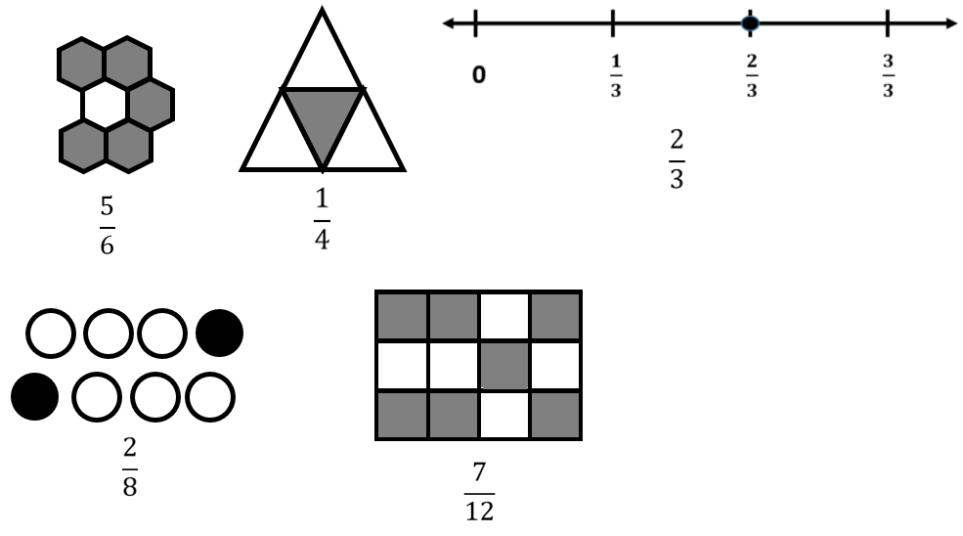
$$\frac{2}{4}$$

- Use the fraction models to identify the fractions that will make each number sentence true in the table below. Write each of these fractions in the table under the number sentence it will make true.
- Circle the fraction in the table that is closest to 1.

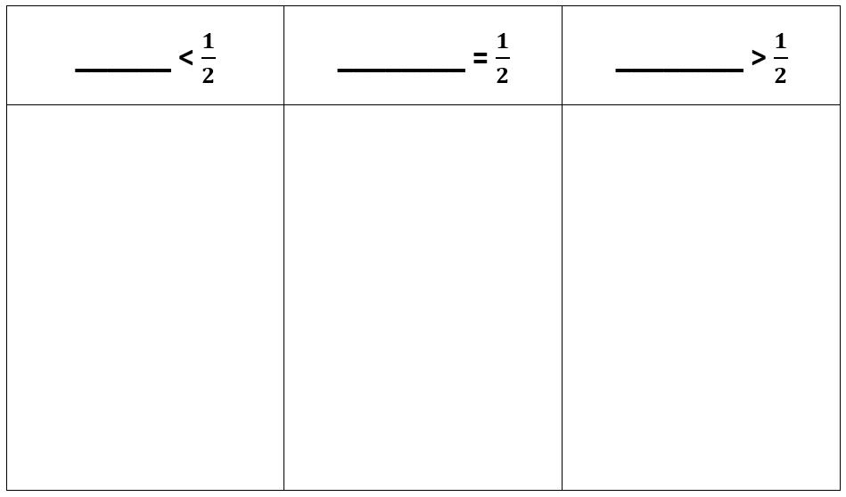

SOL 3.2c - Just in Time Quick Check Teacher Notes
Common Errors/Misconceptions and their Possible Indications

- Write a number sentence using >, <, $=$, or $≠$ to compare the fractions shaded in the circles.

Students may write $\frac{4}{10}>$ $\frac{2}{5}$ . This error may indicate students are counting the number of shaded pieces but not comparing the size of the pieces, using their whole number knowledge that four is greater than two. Students who use the numbers in the denominators to compare may think tenths are larger than fifths since ten is greater than five. These students are not comparing the size of the parts and may not understand that the larger the denominator, the smaller the parts. For each of these errors, experience with manipulatives that students can use to directly compare different fractions of the same whole (pie pieces, bar pieces, pattern blocks, etc.) may be beneficial.
- Use the number line to help you decide which symbol to write in the blank: >, <, or $=$.
$\frac{1}{2}$ ________ $\frac{3}{4}$

Students may confuse the symbolic notation and use $>$ in the inequality, which may indicate students are using a rote procedure for completing the number sentence. Practice reading the complete number sentence aloud may help students connect the symbolic notation with its meaning rather than relying on a procedure (e.g., “point to the smaller number”) that can easily be confused.
Students may be confused with the two sets of numbers on the number line. At this grade level, each fraction should be represented and linear models should be included. Students who have difficulty using a number line to support their thinking may benefit from also representing those fractions using area/region models having the same whole.
Experiences with strips of paper that each represent one whole may help build understanding for more abstract number line models. Paper strips of the same length can be folded, and each fold can be marked as a fraction.
For example:

- Look at these fraction models.

- Use the fraction models to identify the fractions that will make each number sentence true in the table below. Write each of these fractions in the table under the number sentence it will make true.
- Circle the fraction in the table that is closest to 1.

Students may think that the fractions with the greater numbers in the denominators are greater than one-half and those with lesser numbers in the denominators are less than one-half. Students might also think that because 3 and 4 are closer to 1 than the other denominators, $\frac{2}{3}$ and $\frac{1}{4}$ are closer to 1 and therefore both greater than $\frac{1}{2}$ , which is true for $\frac{2}{3}$ but not for $\frac{1}{4}$ . Students may be using whole number understanding rather than fraction thinking and would benefit from opportunities using manipulatives to directly compare fractions with different denominators to $\frac{1}{2}$.
Teachers are encouraged to have students talk about and visualize comparisons to one-half (e.g., “How many eighths would it take to make one-half?” or “Is this fraction more than one-half or less than one-half? Can you draw a picture to show that?”) to build conceptual understanding for using $\frac{1}{2}$ as a benchmark comparison. Paper folding activities (as described in the previous problem) combined with placing the fractions being compared to $\frac{1}{2}$ on the same number line with $\frac{1}{2}$ can help students develop this understanding.

