Just In Time Quick Check

Standard of Learning (SOL) 3.2b
Strand: Number and Number Sense

Standard of Learning (SOL) 3.2b
The student will represent fractions and mixed numbers, with models and symbols.

Grade Level Skills:
- Represent a given fraction (proper or improper) and mixed numbers, using concrete or pictorial set, area/region, length/measurement models and symbols.
- Identify a fraction represented by a model as the sum of unit fractions.
- Using a model of a fraction greater than one, count the fractional parts to name and write it as an improper fraction and as a mixed number (e.g., $\frac{1}{4}$, $\frac{2}{4}$, $\frac{3}{4}$, $\frac{4}{4}$, $\frac{5}{4}$ = 1$\frac{1}{4}$, or 2$\frac{1}{3}$ = $\frac{7}{3}$ ).
Just in Time Quick Check
Just in Time Quick Check Teacher Notes

Supporting Resources:
- VDOE Mathematics Instructional Plans (MIPS)
  - Candy Bar Fractions (word)/PDF
  - Modeling Fractions (word)/PDF
  - Shapely Fractions (word)/PDF
- VDOE Word Wall Cards: Grade 3 (Word/PDF)
- Fraction: Models for one-half/one-fourth
  - Fraction: Models for two-thirds
  - Fraction: Models for five-sixths
  - Fraction: Models for three-eighths
  - Numerator/Denominator
  - Proper Fraction
  - Improper Fraction
  - Mixed Number
- Grade 3 Mathematics Standards of Learning: Student Performance Analysis 2019
- Desmos Activity
  - Fractions on a Number Line [Outside links are still good]
Supporting and Prerequisite SOL: 3.2a, 2.4a, 2.4b, 1.4a, 1.4b

SOL 3.2b - Just in Time Quick Check

- This circle represents one whole.

Draw a model to show $\frac{7}{4}$.

- This set of triangles is one whole.
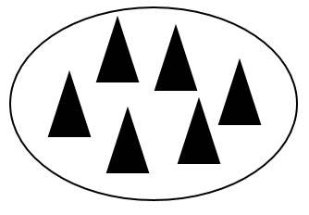
Draw a model of 2 $\frac{2}{6}$ .

- This circle is one whole. Each part of the circle is exactly the same size.

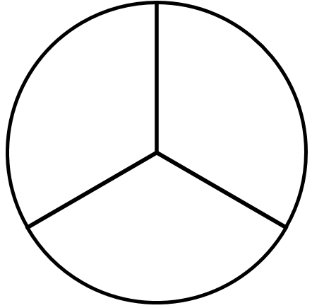
Each of these pieces is a fractional part of the circle. Write an addition sentence to show the sum of these fractional parts.
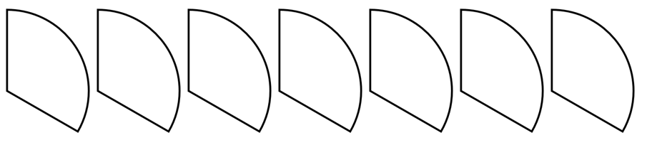

- The locations of 0, 1, 2, and 3 are labeled on this number line. On the same number line, label the location of $\frac{1}{3}$ and the location of $\frac{5}{3}$ .

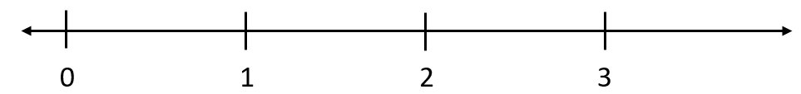

SOL 3.2b - Just in Time Quick Check Teacher Notes
Common Errors/Misconceptions and their Possible Indications

- This circle represents one whole.

Draw a model to show $\frac{7}{4}$.
Students may think that you cannot have $\frac{7}{4}$ because the numerator is larger than the denominator. They may draw the fourths in one circle but only shade in the four-fourths of the first circle to represent a whole. They may not know how to represent the other 3 parts that are needed to make $\frac{7}{4}$ . Students may benefit from experience with manipulatives that include counting fractions past one whole to a given improper fraction.
Some students may draw one circle with 7 parts and shade 4 of the parts. They may do this because they are more familiar with $\frac{4}{7}$, using their knowledge of proper fractions. These students may benefit from opportunities to name paired models of proper and improper fractions in which the numerator and denominator are reversed (i.e., reciprocals, such as $\frac{7}{4}$ and $\frac{4}{7}$).
Some students may draw 11 whole circles and shade 7, while others may draw 7 circles and shade 4. This may indicate the students are considering the numerator and denominator as whole numbers. Additional opportunities to name given models and to create models of fractions greater than one may be helpful.

- This set of triangles is one whole.
Draw a model of 2 $\frac{2}{6}$ .
Students may draw a model of $\frac{2}{6}$ because they are unsure how to represent the whole number. Other students may draw the 2 whole sets but not know how to show the $\frac{2}{6 }$. Students may benefit from experiences with set models, first identifying the number of pieces in the whole and then counting like-size pieces past the whole to represent and name an improper fraction and its equivalent mixed number.

- This circle is one whole. Each part of the circle is exactly the same size.

Each of these pieces is a fractional part of the circle. Write an addition sentence to show the sum of these fractional parts.
Students who write the addition sentence $1+1+1+1+1+1+1=7$are counting each fractional piece as one whole. These students would benefit from opportunities to count fractions on a number line, counting past one, using fraction vocabulary when counting (e.g., one-third, two-thirds, three-thirds, four-thirds, five-thirds, six-thirds, seven-thirds). Anchor charts that provide models of pictorial representations of fractions and a corresponding addition equation using unit fractions are a helpful support as students develop this idea and notation.
Students may name the sum as 2 with 1 left over, seeing that the first two sets of 3 pieces can each be combined to make 2 whole circles, but they may be unable to name the one piece remaining as one-third of the circle. Students may need more experience with counting various fractional pieces having like sizes that can be combined, such as pattern blocks or linking cubes, to create a mixed number and its equivalent improper fraction.

In all of the above tasks, students need opportunities to use models to count fractional parts that go beyond a whole. For instance, if students are counting five slices of cake and building the cake as they count, where each slice is equivalent to one-fourth, they might say “one-fourth, two-fourths, three-fourths, four-fourths, five-fourths.” As a result of building the whole while they are counting, students begin to realize that four-fourths make one whole and the fifth-fourth starts another whole, and they begin to develop flexibility in naming this amount in different ways (e.g., five-fourths or one and one-fourth). Students will begin to generalize that when the numerator and the denominator are the same, there is one whole and when the numerator is larger than the denominator, there is more than one whole. They also will begin to see a fraction as the sum of unit fractions (e.g., three-fourths contains three one-fourths or four-fourths contains four one-fourths which is equal to one whole). This provides students with a visual, as in the example below, for when one whole is reached, and develops a greater understanding of numerator and denominator.

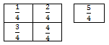 $\frac{5}{4}=$ $\frac{1}{4}+$ $\frac{1}{4}$ $+$ $\frac{1}{4}$ $+$ $\frac{1}{4}$ $+$ $\frac{1}{4}$ and $\frac{5}{4}$ = 1$\frac{1}{4}$
- The locations of 0, 1, 2, and 3 are labeled on this number line. On the same number line, label the location of $\frac{1}{3}$ and the location of $\frac{5}{3}$ .
Students may add a label of $\frac{1}{3}$ below the existing label for 1, which indicates students are using each interval that represents one whole as one-third. These students may benefit from experience adding tick marks between whole numbers on a given number line to create the equal fractional pieces needed. It is important that experiences with number lines extend past the numbers needed. This number line extends from zero to three since thirds are given as the denominator of the fractions that need to be labeled.

