Just In Time Quick Check

Standard of Learning (SOL) 3.1c
Strand: Number and Number Sense

Standard of Learning (SOL) 3.1c
The student will compare and order whole numbers, each 9,999 or less.

Grade Level Skills:
- Compare two whole numbers, each 9,999 or less, using symbols (>, <, =, or ≠) and/or words (greater than, less than, equal to, and not equal to).
- Order up to three whole numbers, each 9,999 or less, represented with concrete objects, pictorially, or symbolically from least to greatest and greatest to least.
Just in Time Quick Check
Just in Time Quick Check Teacher Notes

Supporting Resources:
- VDOE Mathematics Instructional Plans (MIPS)
- 3.1c Comparing and Ordering Numbers (Word) / (PDF)
- 3.1c What's My Number? (Word) / (PDF)
- 3.1c Comparing Numbers (Word) / (PDF)
- VDOE Word Wall Cards: Grade 3 (Word) and (PDF)
- Less Than
- Greater Than
- Equal To
- Place Value Positions
Supporting and Prerequisite SOL: 3.1a, 2.1a, 2.1c, 1.2b, 1.2c

SOL 3.1c - Just in Time Quick Check

- Order these numbers from least to greatest.
9,135 3,915 9,315

- The chart shows two Virginia county populations.
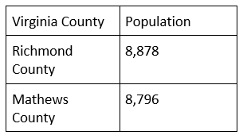
Use the >, <, =, or ≠ symbols to write two different number sentences comparing these two county populations.

- Write a number in each column to match the description.
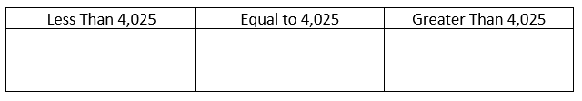

SOL 3.1c - Just in Time Quick Check Teacher Notes
Common Errors/Misconceptions and their Possible Indications

- Order these numbers from least to greatest.
9,135 3,915 9,315
The most common error when ordering numbers from least to greatest is ordering the numbers from greatest to least. Students making this mistake show an understanding of ordering, but they would benefit from strategies that focus attention on the type of ordering required.
When considering numbers that have the same digits but not the same values, students may not notice the order of the digits and believe 9,135 and 9,315 are the same number. Concrete manipulative experiences help students develop conceptual understanding for comparing and a methodical approach based on the place value structure.
If students are struggling with numbers that have the same digits, using numbers that have different digits (368, 720, 981) may be beneficial. Some students may need additional practice with two-digit numbers. Again, experiences with place value manipulatives helps students understand the magnitude of the number and allows for direct comparison of the values of the digits.
- The chart shows two Virginia county populations.
Use the >, <, =, or ≠ symbols to write two different number sentences comparing these two county populations.
When comparing numbers, students frequently confuse the > and < symbols. Students will often know which number is greater and which number is less, but they may not know which symbol should be used to make the number sentence correct. Students benefit from practice reading these comparisons aloud to make sure the correct vocabulary is used with the correct symbol.
- Write a number in each column to match the description.
Students may struggle with understanding numbers that have a zero in a place value position. They may understand that the zero means the number has 0 ones, or 0 tens, or 0 hundreds, but they may not understand that the number that comes before that decade would have 9 ones or before that century would have 9 tens. Students who have difficulty crossing backwards over the decade numbers and century numbers would benefit from representing the given number with concrete and/or pictorial representations and then using those representations to generate a number is greater than or less than that number.

