Just In Time Quick Check
Standard of Learning (SOL) 2.9
Strand: Measurement and Geometry

Standard of Learning (SOL) 2.9
The student will tell and write time to the nearest five minutes, using analog and digital clocks.

Grade Level Skills:
- Show, tell, and write time to the nearest five minutes, using an analog and digital clock.
- Match a written time (e.g., 4:20, 10:05, 1:50) to a time shown on a clock face to the nearest five minutes.
- Match the time (to the nearest five minutes) shown on a clock face to a written time.
Just in Time Quick Check
Just in Time Quick Check Teacher Notes

Supporting Resources:
- VDOE Mathematics Instructional Plans (MIPS)
  - 2.9 - Check the Time (Word) / PDF Version
- VDOE Word Wall Cards: Grade 2 (Word) | (PDF)
  - Clock: Time
Supporting and Prerequisite SOL: 2.2a, 1.9a

SOL 2.9 - Just in Time Quick Check
- Write the digital time for each analog clock.
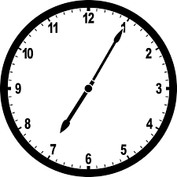 ___________________________

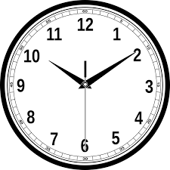 ___________________________

- Circle the digital time that matches the time shown on the clocks below.
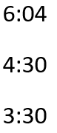
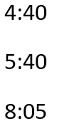
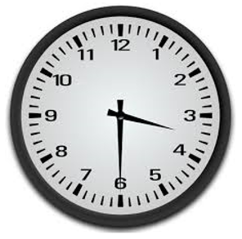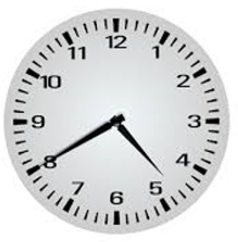
- Show the time 4:10 on the clock.
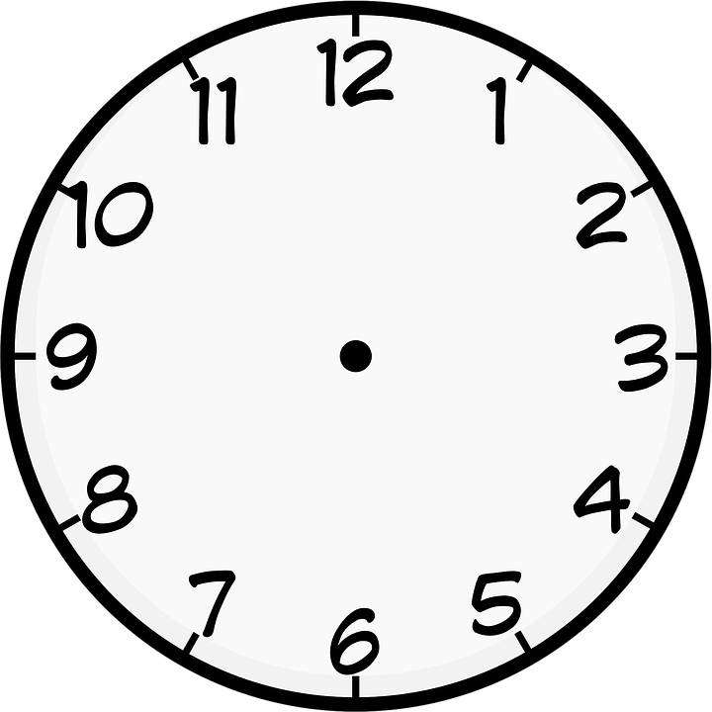

- Show the time 11:45 on the clock.
SOL 2.9 - Just in Time Quick Check Teacher Notes
Common Errors/Misconceptions and their Possible Indications
- Write the digital time for each analog clock.
___________________________
Students may struggle to write the correct time represented by the clocks. They may write the time as 7:5, having an understanding of the hour and minute hands but struggling with the notation used to record time when the number of minutes is represented by a single digit. These students will need additional opportunities to practice writing the time represented on clocks. Having students read and record the time on the classroom clock throughout the day will be beneficial in developing the ability to record various clock times.
___________________________
A common error that students make when reading time on a clock is to confuse the hour and minute hands. These students may write 2:10. For these students, it may be beneficial to spend time using only the hour hand and talking about things that happen at certain hours of the day and then have students notice where the hour hand is pointing. The use of ‘geared clocks’ can also be beneficial as it illustrates how the position of the hour hand changes as the minute hand progresses around the clock.

- Circle the digital time that matches the time shown on the clocks below.
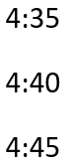
Students may incorrectly choose 4:30 for the first clock, suggesting that they are struggling to identify the correct hour when the hour hand is between two numbers (e.g., between the 3 and 4 in this example). These students would benefit from hearing their peers’ describe the time and their reasoning to support their answer. Using a ‘gear type’ clock will help students see all of the times that come between 3:00 and 4:00 and how the position of the hour hand changes as time moves forward (i.e., recognizing that it is the three o’clock hour because the minute hand has not made it around the clock to reach four o’clock).
Students who are still struggling to count by fives may miscount or may choose 4:35 or 4:45 for the second clock because they failed to start counting by fives at the 1. These students need additional opportunities to develop their skills in counting by fives and in making sense of each five minute interval on the clock. Activities such as counting around the room by fives (i.e., the number of fingers on each hand) will benefit these students.
- Show the time 4:10 on the clock.
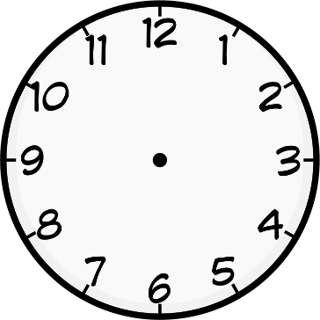
A common error that students make when recording time on a clock is to confuse the hour and minute hands. These students may place the minute hand on the 4 and the hour hand on the 10. These students may benefit from telling and recording time by only using the hour hand and talking about things that happen at certain hours of the day. Other students may correctly place the hour hand, but place the minute hand on the 10.
- Show the time 11:45 on the clock.
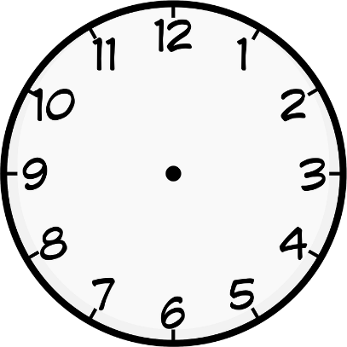
Some students may correctly place the hour hand near or between the 11 and the 12 but struggle to correctly place the minute hand on the 9 to represent 45 minutes past 11. These students may place the minute hand between the 4 and 5, using the numbers in 11:45 literally versus thinking about 45 minutes past 11, or they may miscount by fives when counting around the clock, thereby placing the minute hand on the 8 or the 10. These students likely need additional opportunities to count by fives, and in particular, practice counting by fives around the clock.
Telling time is a skill that develops over an extended period of time. Students will benefit from opportunities to read and record the time shown on a clock during different intervals throughout their day. Students should record the time on their paper/assignment, practice reading the time, and explain how they know the time. Referring to the time shown on the clock throughout the day will help students to develop meaning for telling time and provide practice within the context of their day.

