Just In Time Quick Check

Standard of Learning (SOL) 2.16
Strand: Patterns, Functions, and Algebra

Standard of Learning (SOL) 2.16
The student will identify, describe, create, extend, and transfer patterns found in objects, pictures, and numbers.

Grade Level Skills:
- Identify a pattern as growing or repeating.
- Describe the core (the part of the sequence that repeats) of a given repeating pattern.
- Describe how a given growing pattern is changing.
- Create a growing or repeating pattern, using objects, pictures, or numbers.
- Extend a given pattern, using objects, pictures, or numbers.
- Transfer a given growing or repeating pattern from one form to another using objects, pictures, or numbers.
Just in Time Quick Check
Just in Time Quick Check Teacher Notes

Supporting Resources:
- VDOE Mathematics Instructional Plans (MIPS)
- Exercising Patterns (Word) / PDF Version
- VDOE Word Wall Cards: Grade 2 (Word) / PDF
  - Pattern: Repeating and Growing
  - Transferring a Repeating Pattern
  - Transferring a Growing Pattern
Supporting and Prerequisite SOL: 1.13, 1.14, K.12, K.13

SOL 2.16 - Just in Time Quick Check

- Create a repeating pattern using the shapes shown below.
- You do not have to use all of the shapes.
- You may use a shape more than one time.

- Carson used number cards to make this growing pattern. Extend Carson’s pattern to show how it is growing.

____ ____ ____ ____ ____ ____

- Look at this pattern.

- Circle the core of this pattern.
- Use letters instead of shapes to show the core of this pattern.

- Create this same repeating pattern using numbers.
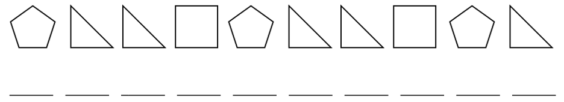

SOL 2.16 - Just in Time Quick Check Teacher Notes
Common Errors/Misconceptions and their Possible Indications

- Create a repeating pattern using the shapes shown below.
- You do not have to use all of the shapes.
- You may use a shape more than one time.

Some students may confuse repeating and growing patterns and create a growing pattern. These students may benefit from opportunities to compare and contrast repeating and growing patterns. Classroom discourse about examples of growing patterns and practice extending them will be helpful.
- Carson used number cards to make this growing pattern. Extend Carson’s pattern to show how it is growing.
____ ____ ____ ____ ____ ____
Students may write 4, or 4, 5 or 4, 5, 6. Others may fill in all of the blanks with 4’s. These errors may indicate that students recognize this is a growing pattern but do not understand how the pattern is growing or how to extend it. Students may benefit from instruction that includes analyzing growing patterns, discussing what stays the same and what changes in a given growing pattern, and extending those patterns.
- Look at this pattern.

- Circle the core of this pattern.
- Use letters instead of shapes to show the core of this pattern.
Some students may not understand what it means to find the core of a pattern. These students would benefit from instruction that requires them to find the core of different patterns. Teachers are encouraged to use the terminology associated with patterns in everyday class discussions to help students acquire this vocabulary in a meaningful context.
- Create this same repeating pattern using numbers.

Students may copy the pattern because they do not know how to transfer a pattern into a different form, or this may indicate students are unable to identify the core of the repeating pattern. These students need more opportunities to identify and describe the core of a repeating pattern and use the description to transfer the pattern into a different form. All students may benefit from sharing different numbers that students selected to represent the same pattern.

