Just In Time Quick Check

Standard of Learning (SOL) 2.15b
Strand: Probability and Statistics

Standard of Learning (SOL) 2.15b
The student will read and interpret data represented in pictographs and bar graphs.

Grade Level Skills:
- Read and interpret data represented in pictographs and bar graphs with up to 25 data points for no more than six categories (represented horizontally or vertically). State orally and in writing (at least one statement) that includes one or more of the following:
– Describes the categories of data and the data as a whole (e.g., adding together all data points will equal the total number of responses);
– Identifies parts of the data that have special characteristics; including categories with the greatest, the least, or the same;
– Uses the data to make comparisons; and
– Makes predictions and generalizations.
Just in Time Quick Check
Just in Time Quick Check Teacher Notes

Supporting Resources:
- VDOE Mathematics Instructional Plans (MIPS)
- 2.15ab - Real Data! (Word) / PDF Version
- 2.15ab - What Does the Data Tell Us? (Word) / PDF Version
- VDOE Word Wall Cards: Grade 2 (Word) | (PDF)
  - Table
  - Bar Graph
  - Pictograph
Supporting and Prerequisite SOL: 2.15a, 1.12a, K.11a

SOL 2.15b - Just in Time Quick Check

- The pictograph shows the number of animals on a farm. Use the graph to answer the questions. 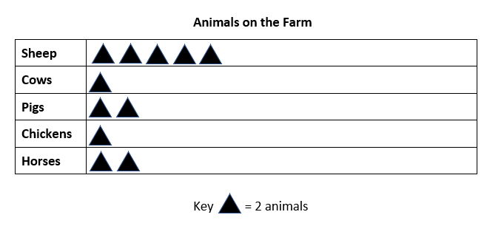

- What is the total number of animals on the farm? ____________

- Exactly how many more sheep are on the farm than horses? _________

- The farm has the fewest of which animal? _______________________

- Use the bar graph to answer the questions.

- What is the total number of daisies and tulips in the garden? __________

- Write a sentence comparing the number of sunflowers to another type of flower in this garden.
_______________________________________________________________________________________________________________________________________

- Steven created a pictograph to keep track of how many minutes he was watching his favorite cartoons. Use the pictograph to answer the questions.
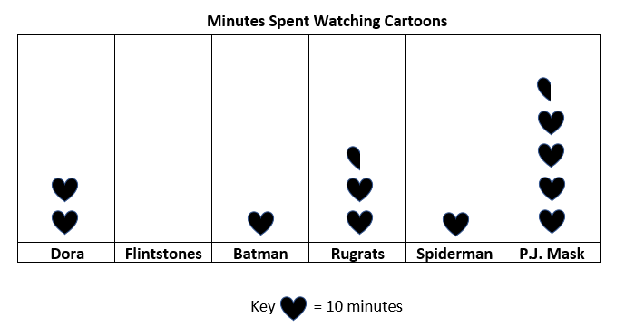
- Which cartoons did Steven watch for the same number of minutes? _____________________________________________________________
- The cartoon Steven watched the most was ________________________. He watched this cartoon for exactly __________minutes.
- Predict: Which cartoon do you think Steven will watch tomorrow? Explain your thinking.

SOL 2.15b - Just in Time Quick Check Teacher Notes
Common Errors/Misconceptions and their Possible Indications

- The pictograph shows the number of animals on a farm. Use the graph to answer the questions.
- What is the total number of animals on the farm? ____________
Students who answer 11 animals are counting by ones and not attending to the key. These students would benefit from more experiences creating pictographs in which the symbol represents more than one item.
- Exactly how many more sheep are on the farm than horses? _________
Students may add the number of sheep and horses together because they see the word “more.” This may indicate students are using a “key word” strategy. These students may benefit from more exposure to peers’ strategies for interpreting information presented in pictographs and to a variety of comparison story structures. Refer to the Grade 2 Curriculum Framework for descriptions and examples of problem types for addition and subtraction.
- The farm has the fewest of which animal? _______________________
Students may not recognize that there is more than one correct answer and only choose chicken or cow. These students would benefit from more experiences interpreting data with categories that have equal amounts.

- Use the bar graph to answer the questions.

- What is the total number of daisies and tulips in the garden? __________
Students may only write the value of either the daisies or the tulips, which may indicate that students are not using the complete context to answer the problem. These students would benefit from experiences generating questions that can be answered by interpreting a graph. Incorporating different types of graphs and discussions that depict results of regular classroom routines (e.g., the number of students who brought lunch or bought different foods for lunch, etc.) allows time to develop the ability to analyze, interpret, and summarize data.
- Write a sentence comparing the number of sunflowers to another type of flower in this garden.
_______________________________________________________________________________________________________________________________________
Students who are unable to write a sentence comparing two categories would benefit from determining if given statements comparing data categories represented in a graph are true and from hearing discussions in which peers justify their reasoning about those statements. Scaffolding in the form of sentence frames (e.g., The number of ________ is [# more than/ # less than] the number of ______, etc.) may help students develop the ability to compose statements comparing data categories.

- Steven created a pictograph to keep track of how many minutes he was watching his favorite cartoons. Use the pictograph to answer the questions.

- Which cartoons did Steven watch for the same number of minutes? _____________________________________________________________
Students may only record one category, which may indicate students need more experiences interpreting data with categories that have equal amounts. Opportunities to discuss and describe data that are the same and different and using the graph to justify those statements will be beneficial.

- The cartoon Steven watched the most was ________________________. He watched this cartoon for exactly __________minutes.
Students may select Dora as the cartoon watched the most because it is the tallest row with no half hearts. These students would benefit from more experiences constructing and interpreting graphs in which data is represented by halving the symbol in the key.
Students who select P.J. Mask but answer that Steven watched the cartoon for 5 minutes may have counted the hearts by ones instead of by tens and disregarded the half heart. These students would benefit from more experiences collecting data, creating pictographs, and interpreting graphs in which a partial symbol has been used to represent data.
Students who select P.J. Mask but answer that Steven watched the cartoon for 50 minutes may not know what to do when there is a half heart. These students may benefit from instruction in doubling and halving, as well as more experiences creating pictographs in which the symbol represents more than one item.
- Predict: Which cartoon do you think Steven will watch tomorrow? Explain your thinking.
Students who do not predict that Steven will watch P.J. Mask may not understand how data are used to make predictions or generalizations. More opportunities to hear classmates’ predictions involving data that have been previously discussed, and the explanations for those predictions, will help students build this understanding.

